Contents

[1 Summary of tabs 5](#_Toc196809505)

[2 Introduction 6](#_Toc196809506)

[2.1 Intro to the Intro 6](#_Toc196809507)

[2.2 New Staff To Do List 6](#_Toc196809508)

[2.3 Important Links 11](#_Toc196809509)

[2.4 Annual Review 12](#_Toc196809510)

[3 Periphyton 13](#_Toc196809511)

[3.1 Introduction to Freshwater Slimy Stuff 13](#_Toc196809512)

[3.2 Scientist stuff 15](#_Toc196809513)

[3.3 PLAN - Vehicles, Staffing 16](#_Toc196809514)

[3.4 PLAN - Equipment List/Stock take 17](#_Toc196809515)

[3.5 PLAN - Run Guides and Site List 19](#_Toc196809516)

[3.6 PLAN – Survey and Printing Sample Labels 22](#_Toc196809517)

[3.7 No Data vs Flow Dashboard 24](#_Toc196809518)

[3.8 DATA COLLECTION - Survey123 27](#_Toc196809519)

[3.9 DATA COLLECTION - Sending Samples 31](#_Toc196809520)

[3.10 DATA PROCESSING - Lab Data Entry 32](#_Toc196809521)

[3.11 Data + KiEco 33](#_Toc196809522)

[3.12 DATA PROCESSING – QA/QC 33](#_Toc196809523)

[3.13 NEMS compliance 34](#_Toc196809524)

[3.14 Accessing Periphyton data from AGOL 35](#_Toc196809525)

[3.15 Army ID process 54](#_Toc196809526)

[4 56](#_Toc196809527)

[5 Didymo 57](#_Toc196809528)

[5.1 Introduction to Rock Snot 57](#_Toc196809529)

[5.2 Scientist stuff 58](#_Toc196809530)

[5.3 PLAN - Equipment List 58](#_Toc196809531)

[5.4 PLAN - Run Guides and Site List 59](#_Toc196809532)

[5.5 DATA COLLECTION – Sample Collection and Storage 61](#_Toc196809533)

[5.6 DATA PROCESSING - Data Entry 62](#_Toc196809534)

[5.7 DATA ENTRY FOR THE NEW SYSTEM 63](#_Toc196809535)

[5.8 DATA PROCESSING - Sending Samples 65](#_Toc196809536)

[5.9 Temp review 67](#_Toc196809537)

[5.10 Golden clam 69](#_Toc196809538)

[6 Data Requests 70](#_Toc196809539)

[6.1 Periphyton data requests 70](#_Toc196809540)

[6.2 Environmental DNA data requests – imported to new notebook 73](#_Toc196809541)

[6.3 Macroinvertebrate data requests 74](#_Toc196809542)

[6.4 Caitlin working – imported to new notebook 74](#_Toc196809543)

[7 Data – work in progress 87](#_Toc196809544)

[8 CADDIS 88](#_Toc196809545)

[8.1 CADDIS instructions document 88](#_Toc196809546)

[9 Water Quality 89](#_Toc196809547)

[9.1 Water Quality Sampling 89](#_Toc196809548)

[9.2 Scientist Stuff 90](#_Toc196809549)

[10 SoE Biomonitoring (Invertebrates) 92](#_Toc196809550)

[10.1 Intro to bugs and things 92](#_Toc196809551)

[10.2 Scientist stuff 93](#_Toc196809552)

[10.3 NEMS compliance 94](#_Toc196809553)

[10.4 PLAN - Lab Contract, Vehicles, Staffing 96](#_Toc196809554)

[10.5 PLAN - Equipment List and Labels 97](#_Toc196809555)

[10.6 PLAN - Run Guides, Site List, and Creating Samples in CADDIS 106](#_Toc196809556)

[10.7 PLAN – Flow Stats 110](#_Toc196809557)

[10.8 DATA COLLECTION - Sample Collection and Storage 113](#_Toc196809558)

[10.9 DATA COLLECTION - Sending Samples 116](#_Toc196809559)

[10.10 DATA PROCESSING - Field Data Entry 120](#_Toc196809560)

[10.11 DATA PROCESSING - Lab Data Entry 122](#_Toc196809561)

[10.12 DATA PROCESSING - Data QA 122](#_Toc196809562)

[10.13 REPORTING- LAWA and SoE Reporting 122](#_Toc196809563)

[11 Fishing 124](#_Toc196809564)

[11.1 Introduction to fishies 124](#_Toc196809565)

[11.2 Scientist stuff 125](#_Toc196809566)

[11.3 NIWA Fish Passage App 126](#_Toc196809567)

[11.4 Mudfish Fishing 126](#_Toc196809568)

[11.5 SoE Fishing 132](#_Toc196809569)

[11.6 Inanga Fishing 136](#_Toc196809570)

[11.7 eDNA 138](#_Toc196809571)

[11.8 Gear Checks 149](#_Toc196809572)

[12 Contact Rec 152](#_Toc196809573)

[12.1 Scientist stuff 152](#_Toc196809574)

[12.2 Public Health contacts 159](#_Toc196809575)

[12.3 159](#_Toc196809576)

[12.4 LAWA 159](#_Toc196809577)

[12.5 Christmas Shutdown 161](#_Toc196809578)

[12.6 CR staff – general info 163](#_Toc196809579)

[12.7 Sampler - Building Runs 172](#_Toc196809580)

[12.8 Writing the books 174](#_Toc196809581)

[12.9 Run Guides 176](#_Toc196809582)

[12.10 Leaving for the run 177](#_Toc196809583)

[12.11 Data Entry & QA 178](#_Toc196809584)

[12.12 Faecal Source Tracking (FST) 178](#_Toc196809585)

[12.13 Site Photos 180](#_Toc196809586)

[12.14 Re sample notification email 181](#_Toc196809587)

[12.15 Cyanotoxin samples 183](#_Toc196809588)

[12.16 Erecting Health Warning signs 184](#_Toc196809589)

[12.17 Office Jobs 185](#_Toc196809590)

[12.18 Old process - Emailing TAs 186](#_Toc196809591)

[13 KiEco instructions 188](#_Toc196809592)

[13.1 Where to find instructions 188](#_Toc196809593)

[14 Lakes 191](#_Toc196809594)

[14.1 Overview 191](#_Toc196809595)

[14.2 Scientist Stuff 191](#_Toc196809596)

[14.3 Creating Labels 193](#_Toc196809597)

[14.4 Results 197](#_Toc196809598)

[14.5 Sending Samples 198](#_Toc196809599)

[15 Coastal and Estuary 201](#_Toc196809600)

[15.1 Scientist stuff 201](#_Toc196809601)

[16 Health and Wellbeing 202](#_Toc196809602)

[16.1 PLB checks 202](#_Toc196809603)

[16.2 Check-ins 202](#_Toc196809604)

[16.3 PFD checks 203](#_Toc196809605)

[16.4 GetHomeSafe App 203](#_Toc196809606)

[16.5 Required training and PPE 204](#_Toc196809607)

[17 GIS 206](#_Toc196809608)

[17.1 GIS Intro 206](#_Toc196809609)

[17.2 GIS Data 207](#_Toc196809610)

[17.3 Local Maps Public and Internal 208](#_Toc196809611)

[17.4 Learn ArcGIS 208](#_Toc196809612)

[18 eDNA 209](#_Toc196809613)

[18.1 Intro 209](#_Toc196809614)

[18.2 Sample collection 209](#_Toc196809615)

[19 Survey123 Connect 214](#_Toc196809616)

[19.1 How to use Survey123 Connect 214](#_Toc196809617)

[20 Annual Review 218](#_Toc196809618)

[20.1 Things to check off 218](#_Toc196809619)

[20.2 Backup process 219](#_Toc196809620)

# Summary of tabs

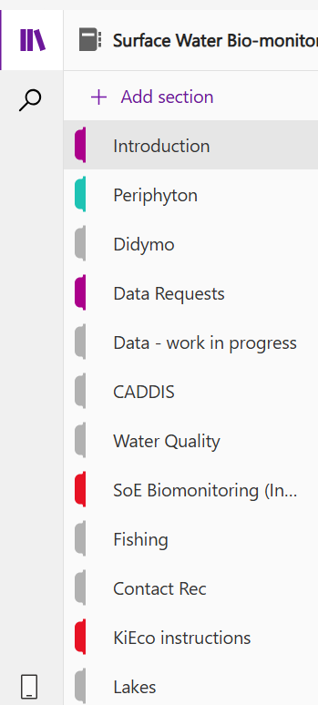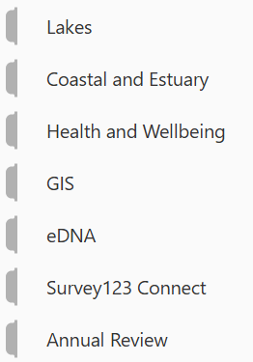

# Introduction

## Intro to the Intro

The purpose of this Surface Water Bio-monitoring handbook is to provide guidance on how we go about our various monitoring activities. This includes timing of various sampling activities, gear lists, data collection, data entry and data QA.

Below is an example of the monitoring/data collection activities that take place during the year noting that summer is the busiest period of the year.

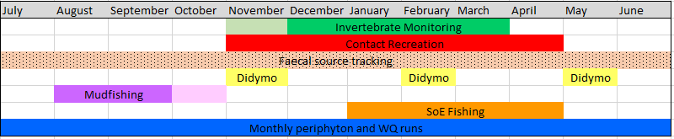

To update the Gantt Chart each year it is found here: \\file\herman\E\WQ\03\05\Handbook\GANTT chart

Relevant science reports and publications can be found here: [\\file\herman\D\SR\01\01\HRC Science Reports and Publications](file://file/herman/D/SR/01/01/HRC%20Science%20Reports%20and%20Publications)

## New Staff To Do List

**Site Inductions**

For some sites on our runs inductions need to be completed to ensure that we comply with Health and Safety protocols of certain farms and STP sites. These are usually forms that are to be read and sometimes a quick meeting with the farm manager.

* Manawatu at Opiki (annually) - Darren will organize this
* STP's in general (Darren) - HMP and SOP's need to be read, Darren usually does this as a little induction when you start at the WQ shed

**Training**

As part of your new role, you will need to complete a few different training courses to make sure that you are able to carry out sampling safely.

Most urgent training:

* Swift Water Training (if there are no courses on at the time you start, Craig Bevan from hydro is able to provide an in-house training which can be valid for up to a year)
* Comprehensive First Aid Certificate
* 4WD Training
* Introduction to using a Personal Locator Beacon (PLB)

Less urgent but still relevant training:

* Electric fishing certificate
* Tactical communications course
* Traffic Management inspector training

**Hazard Management Plans (HMP’s)**

<https://horizonsregionalcouncil.sharepoint.com/SitePages/Working%20at%20Horizons/Health%20and%20safety/Hazard-management-plans.aspx>

* HMP 09 – 4WD vehicles
* HMP 11 – Use of Computer Workstation
* HMP 12 – Working at Night
* HMP 16 – Working on Roadsides
* HMP 17 – Ultraviolet Radiation
* HMP 18 – Working Around Water
* HMP 20 – Motor Vehicles Use
* HMP 22 – Criminal Activities
* HMP 23 – Use of Electrical Appliances
* HMP 24 – Remote or Isolated Work
* HMP 26 – Dangerous Animals
* HMP 28 – Electric Fishing
* HMP 30 – Effluent Sampling
* HMP 34 – Severe Winds
* HMP 35 – Sample Bottle Handling
* HMP 37 – Pandemic – COVID-19

This link also has the “Hazard Management Plan Signature Sheet” right at the bottom for them to sign once they have read and understood all of the relevant HMP’s.

**Standard Operating Procedures (SOP’s)**

* Working in Field/Isolation/Overdue procedures <http://tqm.horizons.govt.nz/Hydrology/SOPs/cd_om_1.4_Working%20in%20Isolation.pdf>
* Working Around Water SOP <http://tqm.horizons.govt.nz/Hydrology/SOPs/cd_om_1.5_Working%20Around%20Water.pdf>
* Working Safely with Hazardous Substances – Water Quality Monitoring <http://tqm.horizons.govt.nz/hydrology/SOPs/cd_om_15.8_Appendix_1_Working%20safely%20with%20hazardous%20substances.pdf>
* Safe Handling of Sample Preservatives <http://tqm.horizons.govt.nz/hydrology/SOPs/cd_om_15.8_Appendix_2_Safe%20Handling%20of%20Sample%20Preservatives.pdf>
* Horizons Health and Safety Policy Statement <http://intranet.horizons.govt.nz/UserFiles/Images/Health%20and%20Safety/Health%20and%20Safety%20Policy%20%28A4%29%20January%2012.pdf>
* Horizons Health and Safety Manual <http://intranet.horizons.govt.nz/UserFiles/Images/Health%20and%20Safety/Health%20and%20Safety%20Management%20Manual.pdf>

**Sampling procedures, run guides etc**

All of the relevant sampling procedures can be found on the Hydro team OMS here <http://tqm.horizons.govt.nz/Hydrology/SOPs/cd_om_0.2_Contents.htm> under ‘Environmental Sampling Programmes’ including

* Sampling procedures – surface water grab <http://tqm.horizons.govt.nz/hydrology/SOPs/cd_om_15.6_appendix_1_surface%20Water%20Sampling.pdf>
* End of day procedures <http://tqm.horizons.govt.nz/hydrology/SOPs/cd_om_15.6_appendix_7_End%20of%20Day%20Procedure.pdf>

The run guides can also be found under this section of the Hydro OMS:

* Periphyton and coastal run guides listed from 15.7app24 to 15.7app42
* Didymo run guides listed from 15.7app60 to 15.7app63

**SoE Biomonitoring Handbook**

The handbook provides an overview of the various monitoring activities we undertake as well as how we go about organising the programmes to ensure everything is completed on time. This can be found in our Surface Water Bio-monitoring Teams page [here](https://teams.microsoft.com/_) or in the OneNote notebook [Intro to the Intro](onenote:#Intro%20to%20the%20Intro&section-id={f0ac5522-ff08-4f7c-9ccd-7a26de318a7b}&page-id={1c423506-7cb6-40e7-b23d-eaa5ca3bd908}&end). May need to sort out access to the Teams page and invite them to the notebook -  which can be done when they get to this point.

**Interesting and useful background information reports**

* 2019 State of the Environment Report <https://www.horizons.govt.nz/CMSPages/GetFile.aspx?guid=a77bc2a4-381f-4660-8ef9-4e2486ac7165>
* [\\file\herman\D\SR\01\01\HRC](file://file/herman/D/SR/01/01/HRC) Science Reports and Publications\ABio\_2008\_A periphyton monitoring plan for the Manawatu-Wanganui Region\_Niwa.pdf
* [\\file\herman\D\SR\01\01\HRC](file://file/herman/D/SR/01/01/HRC) Science Reports and Publications\WQual\_2018\_State and Trends of River Water quality in the Manawatu-Whanganui Region.pdf
* [\\file\herman\D\SR\01\01\HRC](file://file/herman/D/SR/01/01/HRC) Science Reports and Publications\wqual\_2020 Load calculations and spatial modelling of state, trends and contaminant yields.pdf

If they finish all that we can go through the iAuditor/Survey 123 stuff, some CADDIS stuff like getting the runs ready at the start of the month and printing stickers, WQ books and sampler….either way there will be plenty of stuff we can work through.

List of acronyms

STP – Sewerage Treatment Plant

PNCC – Palmerston North City Council

TDC – Tararua District Council

MDC – Manawatu District Council

HDC – Horowhenua District Council

RDC – Rangitikei District Council

WWTP – Wastewater Treatment Plant

WTP – Water Treatment Plant

MCI – Macroinvertebrate Community Index

QMCI – Quantitative Macroinvertebrate Community Index

SQMCI – Semi-Quantitative Macroinvertebrate Community Index

ASPM – Average Score Per Metric

Peri WCC – Periphyton Weighted Composite Cover

WQ – Water Quality

IBI – Index of Biological Integrity

DO – Dissolved Oxygen

NPS-FM – National Policy Statement (Freshwater Management)

NES – National Environment Standards

SoE – State of Environment

FW – Fresh Water

FMU – Freshwater Management Units

TA – Territorial Authority

QA – Quality Assurance

QC – Quality Control/Quality Coding

LAWA – Land Air Water Aotearoa

**LAF – Laboratory Analytical**

NEMS - National Environmental Monitoring Standards

AFDW – Ash Free Dry Weight

SLA – Service Level Agreement

LTP – Long-term Plan (re-done ever 3 years)

AP – Annual Plan

PPE – Personal Protective Equipment

PCBU – Person Conducting a Business or Undertaking

## Important Links

Bookmarks:

**Huia:** <https://horizonsregionalcouncil.sharepoint.com/>

**Lawa:**  <https://www.lawa.org.nz/>

**Lawa sanity checker** (Contact rec season) <http://tqm.horizons.govt.nz/Hydrology/Science/lawa_contactrec_dashboard/LAWA_Contact_Rec.html>

**Local Maps:** <https://gis.horizons.govt.nz/LocalMaps/>

Once on the home page select General maps (Can click anywhere on photo shown below)

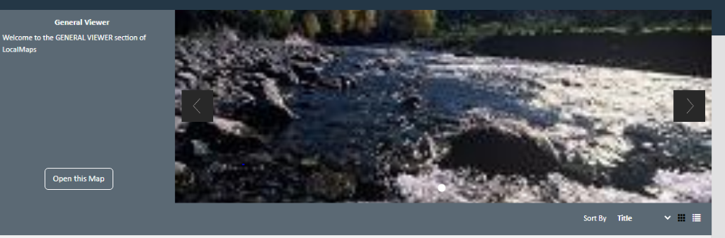

**Horizons Portal:**  <https://theportal.horizons.govt.nz/app/itdesk/ui/requests>

To lodge technological issues/ if you are in need of a solution

**Hydro Ops Manual:** <http://tqm.horizons.govt.nz/hydrology/>

Flood Watch: <http://tqm.horizons.govt.nz/Hydrology/FloodReporting/HRC_Flood_Watch.html>

**Periphyton flow data:** <http://tqm.horizons.govt.nz/Hydrology/Science/PeriphytonSampling/PeriphytonDashboard.html>

**Horizons Webcams:**

<https://www.horizons.govt.nz/flood-emergency-management/web-cams>

**Science Dashboard:**

[http://tqm.horizons.govt.nz/Hydrology/Science/dashboard\_map.html](https://aus01.safelinks.protection.outlook.com/?url=http%3A%2F%2Ftqm.horizons.govt.nz%2FHydrology%2FScience%2Fdashboard_map.html&data=05%7C01%7CIzzie.Hodgson%40horizons.govt.nz%7Cd6bded108dff43cee92c08db7e7fd46c%7C47e86e5354ba4f05b744f7c9d11b4c63%7C0%7C0%7C638242859739736167%7CUnknown%7CTWFpbGZsb3d8eyJWIjoiMC4wLjAwMDAiLCJQIjoiV2luMzIiLCJBTiI6Ik1haWwiLCJXVCI6Mn0%3D%7C3000%7C%7C%7C&sdata=8PJwNwqkSDyxgsAG1XIJPqOFMGSoKjJBtQX0HSuqpMQ%3D&reserved=0)

## Annual Review

|  |  |  |  |  |
| --- | --- | --- | --- | --- |
| **Task** | **Page** | **Date last updated** | **Staff member** |  |
| Check/update the New Staff To Do List | New Staff To Do List | 26/07/2021 | Kelly Le Quesne | 30/05/2022 Alivia Goldfinch |
| Check/update all links in the Introduction section | All pages | 26/07/2021 | Kelly Le Quesne | 30/05/2022 Alivia Goldfinch |

Update the Annual review section and also log any checks/changes in this document:

[\\file\herman\E\WQ\03\05\Handbook\Check and Change log.xlsx](file://file/herman/E/WQ/03/05/Handbook/Check%20and%20Change%20log.xlsx)

# Periphyton

## Introduction to Freshwater Slimy Stuff

**Project Objective:**

To monitor and report on the state of periphyton (algal) growth as an index of river health in relation to nutrients, and the aesthetic and amenity perceptions associated with contact recreation. To develop a regional model or series of catchment based models of the relationship between nutrients, flow regimes, and periphyton growth.

**Context:**

Periphyton is the community of slime and algae that grows on the river bed. Periphyton is believed to proliferate to nuisance levels when there are low flows, suitable velocities, stable substrates, nutrient enrichment, and high sunlight or water temperatures. The aim of the project is to enable modelling of the relationship between nutrient levels, flow regimes, and periphyton growth so as to better direct policies to control nuisance algae levels and to reduce effects of algae on river health and amenity values such as those associated with contact recreation. The project also allows policy effectiveness monitoring to be undertaken with regard to One Plan targets and national policy statement requirements for chlorophyll-a and algae coverage.

Note: This project also includes the regular monitoring of cyanobacteria which occurs simultaneously with periphyton monitoring.

All info can be found here \\file\herman\D\SR\03\01\Rivers\Periphyton monitoring

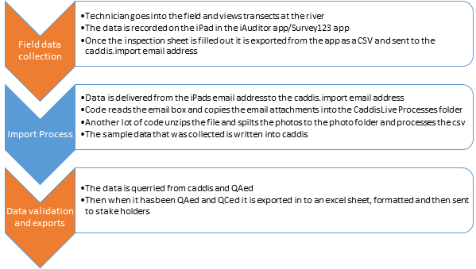

**How we do it**

Monitoring is carried out at predetermined sites on a monthly basis and is timed to coincide with State of the Environment water quality monitoring (that both the Science and Hydro teams conduct).

**SOP:**\\file\herman\E\WQ\03\05\Periphyton monitoring\Periphyton SOP Draft v3.docx

Below is the "usual" timeline we follow for the periphyton programme which is run over two calendar years. This notebook is intended to follow the timeline and all relevant information can be found in the corresponding page.

GANTT chart can be found here [\\file\herman\E\WQ\03\05\Handbook\GANTT chart](file://file/herman/E/WQ/03/05/Handbook/GANTT%20chart)

**Note:**between Dec-April each year, Week 4 is also used to undertake any other fieldwork (e.g. fish and macroinvertebrate monitoring or other projects that arise).

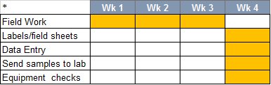

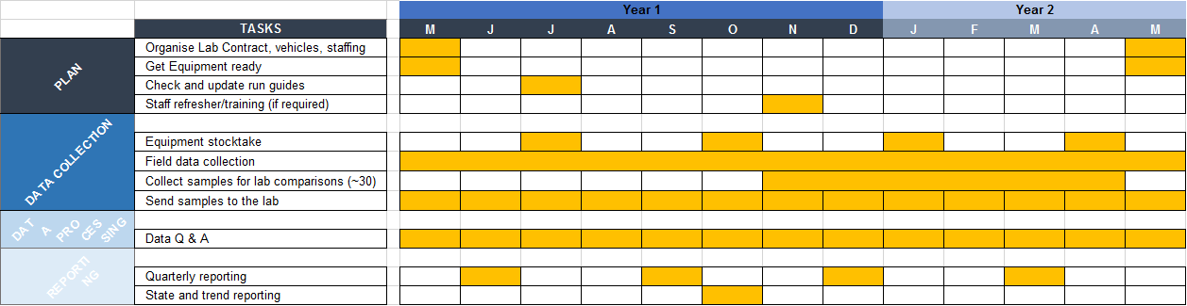

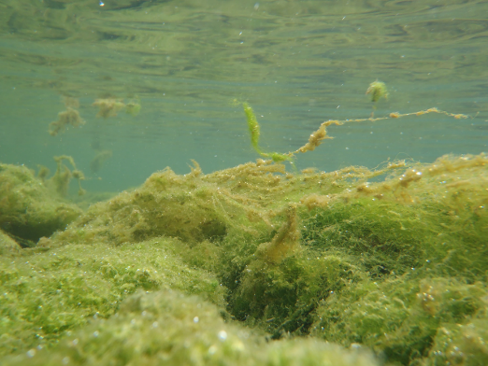

## Scientist stuff

All information regarding this programme can be found here [\\file\herman\E\WQ\03\05\Periphyton monitoring](file://file/herman/E/WQ/03/05/Periphyton%20monitoring)

The periphyton program requires a procurement process for chla sample processing (note this contract includes the monthly peri samples and the annual peri samples collected with invertebrate monitoring). Procurement and contract for the 2023-2024 FY can be found here:

* \\file\herman\D\SR\01\01\Procurement\Rivers and streams\2023 - 2024\periphyton Chl\_a

Penny Harrison from Cawthron is the contact

[Penny.harrison@cawthron.org.nz](mailto:Penny.harrison@cawthron.org.nz)

This purchase order is one big one for the year and receipts are noted in the PO tracking spreadsheet.  2023-2024. The **purchase order number is 1386** and the details of this can be found in datascape.

The scientist makes any PO's needed for extra gear (e.g. bathyscopes, pottles, stickers etc.) but the RA's order this (info on ordering more gear can be found in Plan – Equipment List page.

Every two months we schedule a monitoring meeting (note this info is also in WQ monitoring section) regarding all things monitoring with Darren Bentley-Hewitt, David Brown, Pita Kinaston and the environmental monitoring scientist attending (sometimes the groundwater scientist as well). These are set up and led by the Enviro scientist.

General agenda includes:

* Health and safety
* Lab
* Compliance
* General business
* Follow up anything from the last meeting

Meeting minutes can be found here [\\file\herman\E\WQ\03\05\Monitoring Meeting Minutes](file://file/herman/E/WQ/03/05/Monitoring%20Meeting%20Minutes)

**Run optimisation (note this is also in WQ section)**

Work began in 2022 to optimise the monthly peri/WQ runs that science and hydro undertake. The aim was to reduce CO2 emission (by removing vehicles from the road for those runs, or allowing them to be available for other activities), increasing health and safety by double manning runs and increasing knowledge transfer between hydro and science teams.

Information can be found here [\\file\herman\E\WQ\03\05\Periphyton monitoring\Run Optimisation 2022](file://file/herman/E/WQ/03/05/Periphyton%20monitoring/Run%20Optimisation%202022)

 As of March 2023 run optimisation for the northern runs (Whangaehu, Whanganui and West coast) has not taken place.

## PLAN - Vehicles, Staffing

**Vehicles**

There are two dedicated Science vehicles (Ford Ranger Ute QAD858 & PFS711) which can be used for any fieldwork. Over the summer period, there is a third vehicle available (shared with the Freshwater team who have it over winter (RAE464)). Note: additional vehicles will be necessary for contact recreation over the summer swim period, and should be organised with Assets well in advance.

Book vehicles midway through the month for the next month to ensure that the required vehicles are available on days where there are two runs and two vehicles will be required:

* Lower Rangitikei and East Coast
* Mangatainoka
* Oroua and Foxton Estuary
* Whanganui and West Coast

Vehicles can be booked using the ERoad booking system which can be found in the Horizons Desktop Apps (see below). Usually the extra vehicle needs to be a 4WD vehicle as not all pool cars are suitable for all sites.

**Staffing**

Currently there are three full time research associates (RA's) with one other available more over summer. The environmental Scientist directs works, but is also able to support field work where necessary.

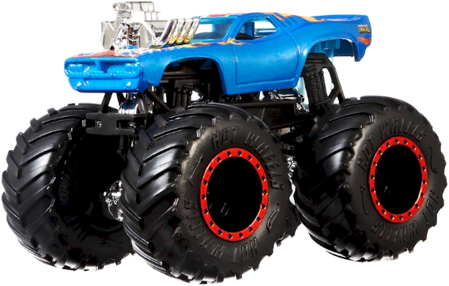

## PLAN - Equipment List/Stock take

If you need to order more equipment (e.g. pottles) our preferred suppliers can be found here \\file\herman\D\SR\03\01\Admin\Supplier List. Essentially just ring the company and order however many things you need to order – make sure to confirm the price including freight and GST so that  Environmental scientist can adjust the PO. Environmental scientist will also provide you with a PO to give to the company. Some things (e.g. toothbrush, scrubbing brush etc) can be purchased from the supermarket using  Environmental scientists work card.

**Periphyton Specific Gear List**

* Bag
* Pottles (large and small)
* Pottle lids (large and small)
* Ice cream container
* Scrubbing brush
* Toothbrush
* Yellow lid
* Washer bottle
* Big lunchbox container
* Sample stickers
* iPad
* Bathyscope
* Chilly bin
* Ice-packs
* Any keys for sites (e.g. 636 key for STP's and Ruapehu STP key)

**General Gear List**

* Waders (chest and/or thigh)
* Gloves
* Disinfectant for waste water samples
* Sampling pole
* High Viz rain jackets, vests, shirts
* PFD
* PLB
* Throw Bag
* Alcohol gel/hand sanitiser
* Shovel
* Spare periphyton pottles
* Spare WQ bottles
* Spare blank stickers
* Paper field sheets/blank paper
* Measuring tape
* Black disc
* Clarity tube
* Paper towels
* Spare pens/pencils/vivids
* 4WD vehicle equipped with a VHF radio
* Sunscreen

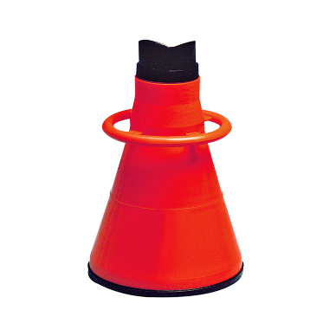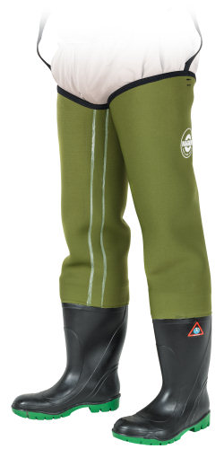

## PLAN - Run Guides and Site List

**Periphyton Run Guides**

These are updated annually (June or July) and are stored in the [Hydro Catchment Data Management System](http://tqm.horizons.govt.nz/hydrology/) which is easily accessible in the field in case you forget your run guide. If you do make any changes outside the annual review be sure to update the version number and send it to Darren Bently-Hewitt know so he can update the OMS. Changes can be made to the Word documents which can be found here \\file\herman\D\SR\03\01\Rivers\Periphyton monitoring\Periphyton run guides\Updated run guides 2024.

**Week 1:**

* Ohau Waikawa Runs (both on the same day)
  + [Ohau Waikawa Run 1](http://tqm.horizons.govt.nz/hydrology/SOPs/cd_om_15.7_appendix_24_SoE%20-%20Ohau%20Waikawa%20SoE%20Run%201.pdf) (which has both periphyton and SoE/WQ components and typically team up with a hydro person for this run)
  + [Ohau Waikawa Run 2 and Ohau Waikawa Estuary](http://tqm.horizons.govt.nz/hydrology/SOPs/cd_om_15.7_appendix_25_SoE%20-%20Ohau%20Waikawa%20SoE%20Run%202.pdf) (which has both periphyton and SoE/WQ components)
* [Upper Rangitikei](http://tqm.horizons.govt.nz/hydrology/SOPs/cd_om_15.7_appendix_30_Periphyton%20-%20Upper%20Rangitikei.pdf)(which has both periphyton and SoE/WQ components)
* [Lower Rangitikei](http://tqm.horizons.govt.nz/hydrology/SOPs/cd_om_15.7_appendix_31_Periphyton%20-%20Lower%20Rangitikei.pdf) (which has both periphyton and SoE/WQ components) ([East Coast](http://tqm.horizons.govt.nz/hydrology/SOPs/cd_om_15.7_appendix_40_Coastal%20and%20Estuary%20-%20East%20Coast.pdf) WQ run on the same day)

**Week 2:**

* Upper Manawatu Runs (both on the same day):
  + Upper Manawatū Run 2 (with hydro; both periphyton and WQ)
  + Upper Manawatū Discharge (aka Run 3) (with special projects; both periphyton and WQ)
* Mangatainoka Runs (both on the same day)
  + Mangatainoka SOE Run (With hydro; which has both periphyton and SoE/WQ components)
  + Mangatainoka cyanobacteria Run (which has both periphyton and SoE/WQ components)
* Pohangina (with hydro; both WQ and periphyton)
* [Oroua](http://tqm.horizons.govt.nz/hydrology/SOPs/cd_om_15.7_appendix_36_Periphyton%20-%20Oroua.pdf) (with hydro)([Foxton Estuary](http://tqm.horizons.govt.nz/hydrology/sops/cd_om_15.7_appendix_42_Coastal%20and%20Estuary%20-%20Foxton%20Estuary.pdf) run on the same day) (both runs have WQ and peri on them)

**Week 3**

* [Whangaehu](http://tqm.horizons.govt.nz/hydrology/SOPs/cd_om_15.7_appendix_37_Periphyton%20-%20Whangaehu.pdf)
* [Whanganui](http://tqm.horizons.govt.nz/hydrology/SOPs/cd_om_15.7_appendix_38_Periphyton%20-%20Whanganui.pdf) ([West Coast](http://tqm.horizons.govt.nz/hydrology/sops/cd_om_15.7_appendix_41_Coastal%20and%20Estuary%20-%20West%20Coast.pdf) WQ run on the same day)

**Week 4**

Office week/pick up any other fieldwork that needs doing outside of periphyton monitoring (e.g. macroinvertebrates, fishing or didymo).

**Site List**

As at December 2022 there are 62 periphyton sites. A full site list for all monitoring programmes can be found here:

\\file\herman\D\SR\03\01\Rivers\Site Metadata

**Single or Double Person Runs**

Below is a list of the runs and the number of staff required for each run. Please note that as at the September 2021 the Whanganui periphyton run has changed from a single person run to a double person run. This change has been implemented due to safety and wellbeing concerns including driving for extended periods of time by themselves, working in remote and isolated conditions and the time pressure to conduct water quality and periphyton sampling at the sites and return back to the office with time to send the samples. Changing this to a two person run enables safer driving conditions and reduces the time pressure to return back to the office by making sampling a little quicker.

|  |  |  |  |
| --- | --- | --- | --- |
| **Run Name in Sampler** | **How many people** | **How many Aquatrolls** | **Approx starting time** |
| SOE - Ohau Waikawa Run 1 | Double (1x Sci and 1x Hydro) | 1 - Freshwater | 8am |
| SOE - Ohau Waikawa Run 2 (and Estuary - Ohau Run) | Single (1x Sci) | 2 – Coastal and Freshwater | 8am |
| Periphyton - Rangitikei (Upper Rangitikei) | Single (1x Sci) | 1 - Freshwater | 7:30am |
| Periphyton - Lower Rangitikei | Single (1x Sci) | 2 – Coastal and Freshwater | 8am |
| Coastal - East Coast | Single (1x Sci) (WQ only) | 2 – Coastal and Freshwater | 8am |
| SOE - Upper Manawatū Run 2 | Double (1x Sci and 1x hydro) | 1 - Freshwater | 8am |
| Discharge - Upper Manawatū Run 3 | Double (1x Sci and 1x Special projects) | 1 - Freshwater | 8am |
| Cyanobacteria - Mangatainoka Cyanobacteria Run | Double (2x Sci) | 1 - Freshwater | 8am |
| SOE - Mangatainoka Run | Double (1x Sci and 1x hydro) | 1 - Freshwater | 8am |
| SOE - Pohangina | Double (1x sci and 1x hydro) | 1 - Freshwater | 8am |
| SOE - Oroua | Double (1x Sci and 1x hydro) | 1 - Freshwater | 8am |
| Estuary - Foxton Estuary | Single (1x Sci) | 2 – Coastal and Freshwater | 8am |
| Whangaehu (periphyton only, not in sampler) | Double (2x Sci) | None | 7:30am |
| Periphyton - Whanganui | Double (2x Sci) | 1 - Freshwater | 6:30am |
| Coastal – West Coast | Single (1x Sci) (WQ only) | 1 - Coastal | 8am |

In 2022, we undertook an exercise to optimize WQ and peri runs with hydro with the aims of reducing CO2 emissions (by either removing vehicles entirely from runs or by shuffling sites to prevent teams visiting the same site on the same day), double-man runs, and increase hydro/sci cross pollination of information and knowledge. Information can be found here: \\file\herman\D\SR\03\01\Rivers\Periphyton monitoring\Run Optimisation 2022

## PLAN – Survey and Printing Sample Labels

Generating QR codes for samples

With the end of CADDIS, generating QR codes requires using this link: <https://qrcodegenerator.horizons.govt.nz/>

This app looks at KiEco for the selected sampling programmes, so monitoring programmes must be entered into KiEco before QR codes can be generated.

The client code is usually HRC, but can be added if different (e.g. TDC).

The survey code can be confirmed with the relevant scientist (WQU – for Periphyton), and the month is the sampling month rather than the generating month (I.e. making QR codes in January for sampling in February, the month will be February).

The most likely error will be selecting the wrong sampling programme, as it pulls all monitoring programmes from KiEco. Missing sites from a programme will need to be added manually in KiEco. Selecting "print" will print the sticky labels.

**Printing Periphyton Sample Labels**

Damaged or lost stickers can be replaced by selecting "reprint" in the top-left menu. Re-enter the relevant dates, etc to access the same monitoring programme, and select the sites you need to re-print. You can also select the printing position of the labels in a subsequent page to save using a whole label sheet for only one or two labels.

When printing the stickers scroll to the bottom of the page and hit print

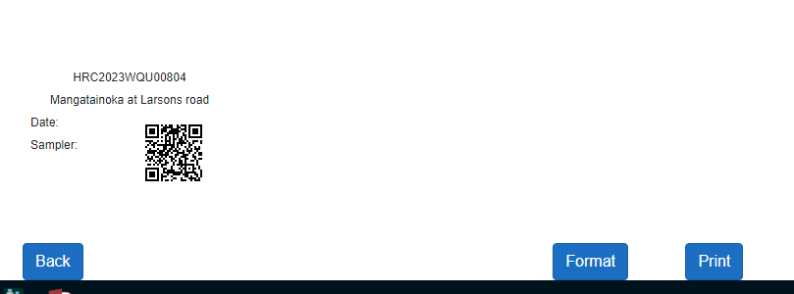

DO NOT PRINT DOUBLE SIDED!

You will need to go into printing preferences select printer either Arena level 2 or science copier (at regional house) in put tray need to be changed to bypass Tray. The stickers need to be loaded face down onto the tray

Tip: Print stickers with setting 'actual size' to avoid the sample numbers being cut off at the top

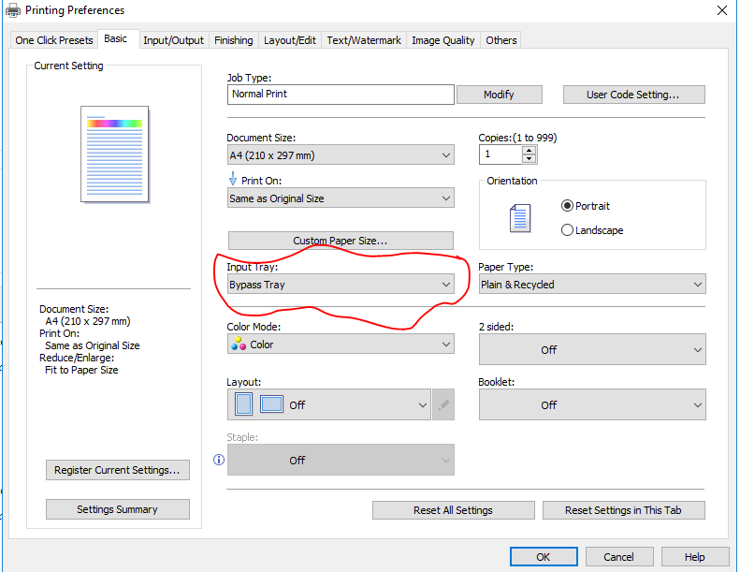

## No Data vs Flow Dashboard

As of January 2023 the No Flow Dashboard can be used to make decisions about which periphyton sites can and cannot be gone to. This dashboard was created to help reduce the amount of driving around un-necessarily (mainly over the winter months) when we are unable to take a periphyton sample because the rivers are high. This dashboard sets out which sites are on which runs and helps us to make decisions about which runs that we don’t have to go to.

Link to the dashboard:

<http://tqm.horizons.govt.nz/Hydrology/Science/PeriphytonSampling/PeriphytonDashboard.html>

 Below is the link to the memo which has been written up to help make our decisions and give background information on why this has been created:

\\file\herman\D\SR\03\01\Rivers\Periphyton monitoring\No data vs flow dashboard

**Decision making**

The memo sets out how decision making will take place using the new dashboard. When all sites on a run are red, it is acceptable to not go on the run and in the comments explain that due to the dashboard being all red you didn’t have to go on the run and fill out the survey with no data's. If the run has some sites that are maybe and some sites that are red, you are able to go on the run and get the sites that you are able to. And obviously if there are sites that are green you can go on the run and sample!

 Below is a screenshot of the main dashboard when you first open it. The run names are along the top, with each of the sites on that run listed below it. You are able to click on each site to bring up a more detailed record of the flow levels at that site and all previous sampling events.

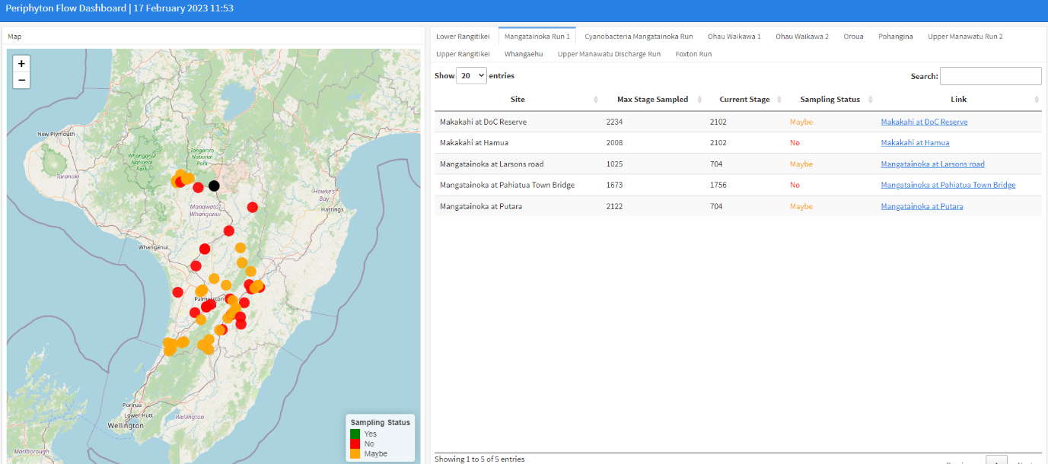

Here is the more detailed record of Makakahi at DoC Reserve which shows that it is currently in the maybe range of sampling. There have been a couple of samples taken at the current flow (most probably outliers), but also some no datas, so best off to go to the site and see if you are able to get a sample.

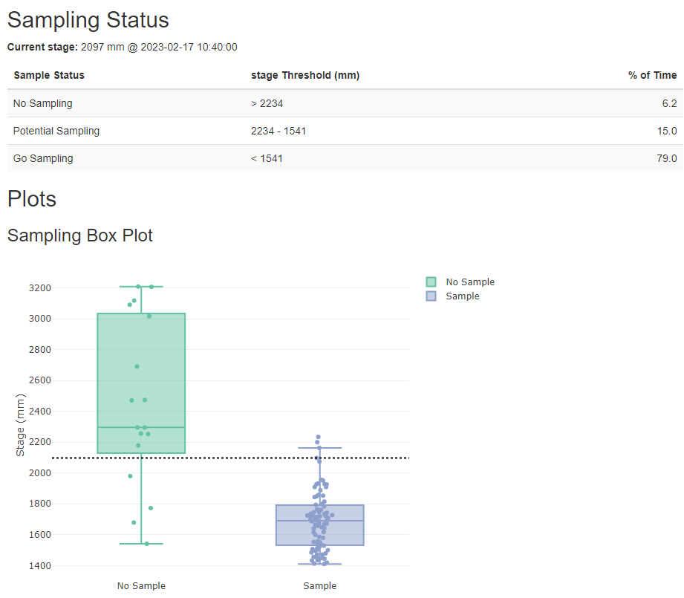

Due to the fact that most runs are now double manned with hydro, if after a rainfall event you are unable to get into any sites, hydro may just be able to go out by themselves to get the WQ samples. This decisions needs to be made in conjunction with the hydro team so that everyone is on the same page. Sometimes when the river levels are really high and we can't get into any of our periphyton sites, we may still be required to go out with hydro to double man the run for safety reasons. An example of this was sampling during Cyclone Gabrielle, when we couldn’t get any samples but still double manned all runs for safety.

**Making Changes to the Periphyton Dashboard**

What changes can we make?

1. Add monitoring sites
2. Add or remove periphyton runs
3. Change site or run names
4. Put sites into different runs

Firstly you will need R-studio on your computer. If you have TS-Farm talk to IT about your options. Otherwise you may need a PC to run R-studio.

If you are not adding a new run or changing the run name R-studio won't be needed.

Follow the instructions Amy has laid out here:

[\\ares\Science\PeriphytonSampling\Code\Instructions\_Periphyton Sampling Flow Threshold Dashboard.docx](file://ares/Science/PeriphytonSampling/Code/Instructions_Periphyton%20Sampling%20Flow%20Threshold%20Dashboard.docx)

You will also need these documents open to make your changes   
[\\ares\Science\PeriphytonSampling\Code\Site\_Switch\_2.csv](file://ares/Science/PeriphytonSampling/Code/Site_Switch_2.csv)

[\\ares\Science\PeriphytonSampling\Code\PeriphytonDashboard.Rmd](file://ares/Science/PeriphytonSampling/Code/PeriphytonDashboard.Rmd)

## DATA COLLECTION - Survey123

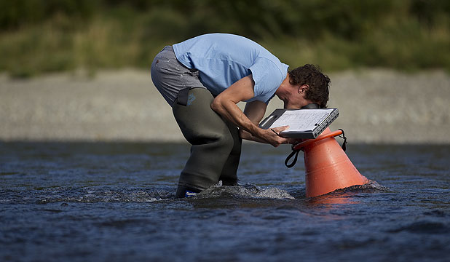

**Before Leaving the Office**

Double check you have all the right gear before you leave.

Make sure you have a check-in buddy that knows what run you are doing/sites visiting (and where to access the run guide) and what time you will be back. Please remember to txt them when you return safely.

Also start the GetHomeSafe App to track your location throughout the day. Log into [GetHomeSafe](https://www.gethomesafe.com/" \t "_blank) to see your activities. Along with setting up GetHomeSafe, take an InReach unit with you. Another app, Earthmate can be downloaded alongside the InReach units, which can be used to send messages to people to let them know you are ok or alternatively not.

As of May 2022 we switched from using IAuditor to using Survey 123 to record all of our periphyton data.  To fill out and send a survey in Survey123 you will need a ArcGIS login, this can be set up with IM.

**Instructions on how to fill out a survey in Survey123**

1. Open survey 123 app and sign in. Download arcgis-survey123://?portalUrl=https://www.arcgis.com&itemID=259004608f994fafb8bea21375635167. Select collect survey
2. Scan the QR code associated with your site
3. enter the following details on the form, including who is sampling, the date/time, weather conditions and flow state. You will also need to choose yes or no for 'visuals done'.

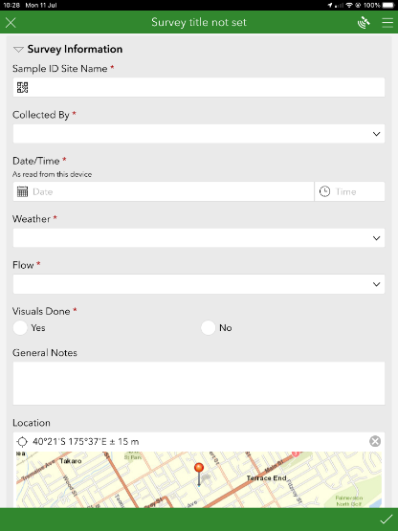

1. Enter any notes into the general notes section. For example if the river was too high for a survey to be carried out you might put 'River flooded, no views or chl a collected'.
2. The map will generally pinpoint the location by itself
3. Photos need to be taken looking both up and downstream, to add a photo select the plus button and then press on the camera icon.

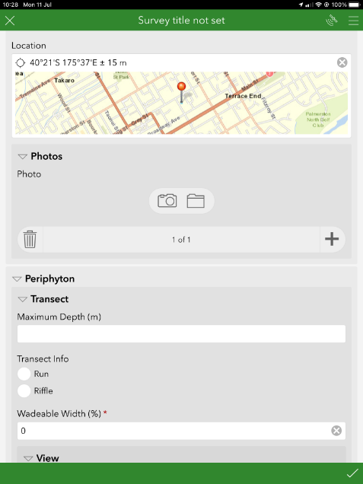

1. Doing the periphyton survey – first enter the maximum wading depth of the stream (this should be no greater than 0.6. Select if you are sampling in a run or riffle and under 'wadable width' you will need to enter an estimate of how far you can get across the stream at a depth of no greater than 0.6m
2. Then enter the periphyton cover estimates for your first view in the fields below, this must add to 100. If you previously selected 'no' for 'Visuals Done' 100% will automatically be entered into the 'No Data' field.
3. To start the next view press the top plus button, once all 5 views have been completed for the first transect select the bottom plus button and this will start a new transect. (There should be 4 transects with 5 views in each).

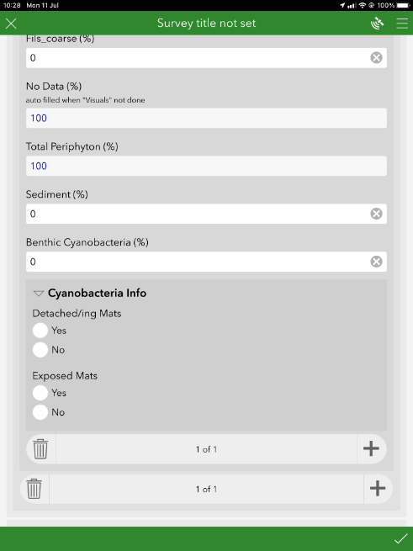

1. When doing the periphyton cover estimates, you will also need to estimate the sediment cover for each view and enter this into the 'Sediment (%)' field.
2. Any benthic cyanobacteria will need to be entered as well in the 'Benthic Cyanobacteria (%)' field.
3. Reach Info – we always select 'No' under 'Sample Taken' (we only select 'yes' if you have taken a sample of cyanobacteria which is only taken in extreme cases when there is a large amount), enter the reach length and total % cyanobacteria cover in the appropriate fields, the rest can be left blank.

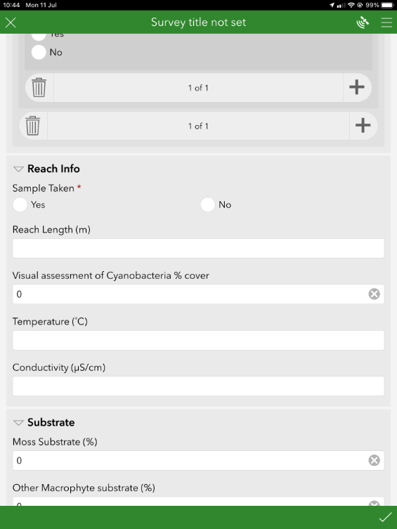

1. Substrate – Enter the estimated percentage of bed substrate for the whole reach, this must add up to 100. If you chose 'No' for 'Visuals Done', 'No Data' will automatically be selected. You will also need to choose the embeddedness

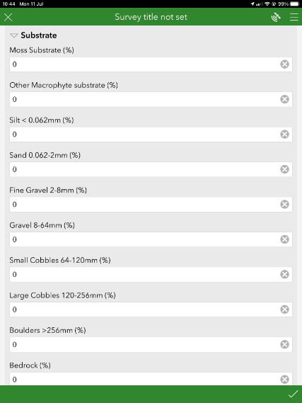

1. Once done press the tick in the bottom right corner and send the survey. If you are out of range it will save in the *Outbox* so remember to send the surveys once you are back in the office otherwise you might lose them!
2. In the *Outbox* and *Sent* folder you can see the surveys you have completed and edit those if necessary just make sure to resend them afterwards.

**Adding/Removing names of collectors in Survey123**

Changes to the survey can be made in Connect, this software can only be used on a computer and not TSFarm.

Using the Shared biomonitoring log in:

ScienceBioMonitoring

Fish\_are\_Friends\_2022

## DATA COLLECTION - Sending Samples

Try to send all samples in the afternoon so that they don’t sit outside all day and defrost. Make sure to ask Print requests for an overnight courier to either Cawthron (Nelson) or NIWA (Christchurch) and put plenty of slikka pads into the chilly bin. DO NOT send samples on a Thursday, Friday or before a public holiday in case they don't make it to the lab.

Get a purchase order from the Environmental Monitoring Scientist – enter it in the correct field ('order')

2023-2024 (financial year) PO# is 1386

2024-2025 (financial year) PO# is 10225

1. When printing monthly samples a checklist is made including Site ID and site name.
   * Sample checklist is download at the time of QR code creation and is stored here:
     + [\\file\herman\D\SR\03\01\Rivers\Periphyton monitoring\Monthly](file://file/herman/D/SR/03/01/Rivers/Periphyton%20monitoring/Monthly) stickers
   * Print out,
   * Use checklist to go through frozen samples filling in the dates.
   * Add dates into spreadsheet.

1. Copy and paste the first 3 columns into the Excel sheet (Cawthron Submissions template) \\file\herman\D\SR\03\01\Rivers\Periphyton monitoring\Cawthron Submission\Submission 2024

You will need to change 'SampleType' and 'Analysis required' for any sites that haven't been sampled. Delete 'Water' and 'Chyl a' and write 'No Sample'.

1. Copy and Paste all 5 Columns into the word document (Cawthron Submissions template)

\\file\herman\D\SR\03\01\Rivers\Periphyton monitoring\Cawthron Submission\Submission 2024

1. Print a copy of both word document and excel sheet, these need to go in the chilly bin (in a Ziplock bag) with the samples.
2. Email Cawthron ([lab@cawthron.org.nz](mailto:lab@cawthron.org.nz)) to let them know that the monthly samples have been sent and that they should expect them the next day. Attach both the relevant spreadsheet and word document to the email.
3. Visit the printing room with this address: \\file\herman\D\SR\03\01\Rivers\Periphyton monitoring\Cawthron Submission

To print a courier ticket. Will be a small/medium chilly bin size. Overnight postage. - (summer – large bin – 15kgish)

## DATA PROCESSING - Lab Data Entry

Cawthron and NIWA will email you the results from you samples and each of the labs results is entered into CADDIS differently. In general they send the results when they are finished with them, but this is meant to be within 2 weeks. This is loosely held to and not followed up on but in future we may need to enforce this a little more so that data is here and ready to go when we want it to be.

**Cawthron**

Save all of the attached documents (pdf, txt and csv) as *Month Year* (e.g. February 2020) into the relevant years folder (make a new folder for the correct year if it isn't already there) [\\file\herman\D\SR\03\01\Rivers\Periphyton monitoring\Periphyton](file://file/herman/D/SR/03/01/Rivers/Periphyton%20monitoring/Periphyton) Sample Results

## Data + KiEco

1. <http://tqm.horizons.govt.nz/Hydrology/Science/dashboard_map.html>
2. Go to KiEcoTools
3. Prepare Data for Entry tab
4. Monthly periphyton monitoring
5. Field Data

\\file\appdata\Wiski\LIVE

1) The first is an Aquatic biomonitoring user log in. This one can view everything in the database and (I think) export data at a later date, but cannot edit anything:

Username: AB\_user

PW: Fish\_are\_Friends\_2022

2) The second is aquatic biomonitoring data admin. This user can view all data but only edit the aquatic biomonitoring data (i.e. they can’t accidentally edit the EcoBase biodiversity data).

Username: data\_admin\_ab

PW: 2022\_Just\_Keep\_Swimming

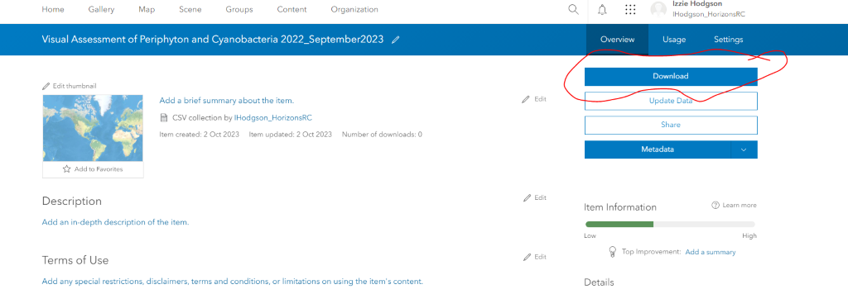

## DATA PROCESSING – QA/QC

At the end of every month in the 'off' week, the data that was collected during that month needs to be QA'd and QC'd. The instructions are found in the CADDIS instructions document here [\\file\herman\E\WQ\03\10\CADDIS guides\Current CADDIS guides](file://file/herman/E/WQ/03/10/CADDIS%20guides/Current%20CADDIS%20guides).

Fill in a "*QA form – periphyton*" at the end of each month to show that the data has been QA'd and where (if any) mistakes were and if they were corrected. This form can be found here [\\file\herman\E\WQ\03\10\Caddis Outputs\Data QA](file://file/herman/E/WQ/03/10/Caddis%20Outputs/Data%20QA)

The data is QC'd according to the Periphyton NEMS

**Emptying CADDIS inbox when surveys not being sent**

At the end of every month its also a good idea to check the CADDIS email to make sure the inbox isn't too full and the surveys are actually making their way to the "Live Processes" folder in appdata here [\\file\appdata\caddis\LIVE\_Processes\iAuditInputFolder](file://file/appdata/caddis/LIVE_Processes/iAuditInputFolder)

To do this log into [remote.horizons.govt.nz/OWA](http://remote.horizons.govt.nz/OWA) in Chrome. It will bring you to an Outlook log in page.

Log in using Domain\username "servers\caddisimport" and get the password from IT (its very long and complicated; password: **Note:**you may also need to be given permission by your manager to have access to the import email).

Go through and delete all of the Visual Assessment surveys (make sure you aren't deleting anything else as some Hydro guys use this email as well).

## NEMS compliance

As part of the new Periphyton NEMS, there are a few things that need to be changed within the periphyton program to make it compliant with the new regulations. We have to create a Periphyton field and office manual, add a transect to picking up rocks, add sediment views, add flow into our surveys and get covers for the bathyscopes to make sure they don’t get scratched.

All of these changes have been put into the field and office manual for periphyton and can be found in the link below:

\\file\herman\E\WQ\03\05\Periphyton monitoring\NEMS 2020 guidelines\Periphyton Office and Field Manual.docx

The file below is where we have saved all of the documents that have to do with the change in NEMS regulations:

Monday 11/07/2022

NEMS compliant changes have now been made to ensure we reach QC600

These changes include:

* Collecting 10 rocks over two transects
* Including wadeable width in our survey
* Extending the reach length to 50m for every site (within reason)
* Cover for the bathyscope to prevent damage to the viewer
* Estimate the flow state (low, medium or high) for each site
* Percentage of sediment estimate for each view

The Office and Field Manual can be found here:

\\file\herman\E\WQ\03\05\Periphyton monitoring\NEMS 2020 guidelines

## Accessing Periphyton data from AGOL

**NOTE: further down towards the bottom of this page includes how to get photos out of survey123 if you ever need them**

**Downloading survey 123 data from Arc GIS online (AGol)**

1. In google search engine go to the arc gis online website login page
2. Click “sign in”
3. Use the horizons login url: “horizonsrc.maps.arcgis.com
4. Sign in using the corporate login

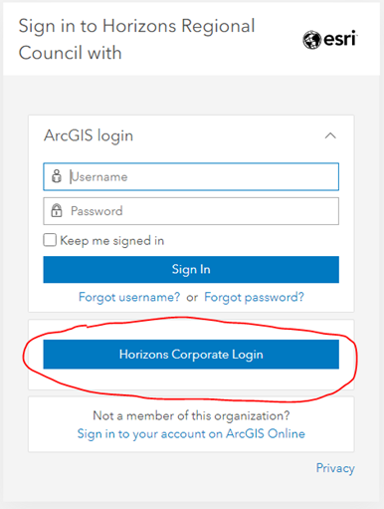

To access survey 123 periphyton data:

1. Click on the “content” link at the top of the page
2. Click on the “My Organization” link in the blue banner
3. In the search bar type in what you are looking for, so if it is periphyton data, type in: “Visual Assessment of Periphyton and Cyanobacteria”
4. For data in May 2022, you want to select the feature layer created on Jun 22, 2020. However this May data is already downloaded and formatted, saved here: \\file\herman\E\WQ\03\05\Periphyton monitoring\Survey123 Agol outputs\May2022 Data
5. For data after May 2022, you want to select the feature layer created on the 3rd of June 2022
6. Data from June 2022 to May 2022 is formatted and saved here: \\file\herman\E\WQ\03\05\Periphyton monitoring\Survey123 Agol outputs\June2022\_to\_May2023

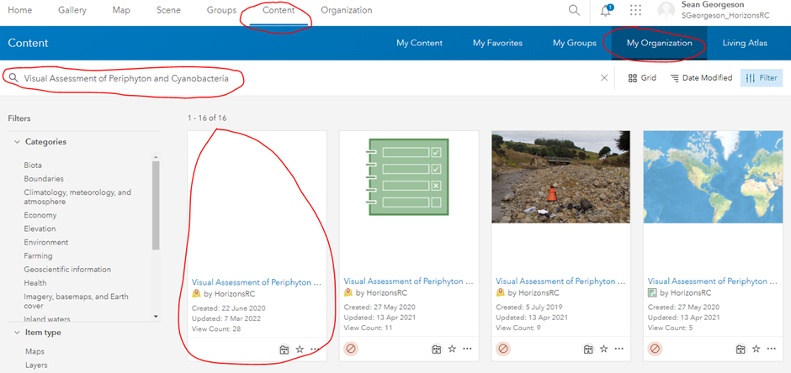

1. Once you have selected the file you are after select “export data” on the right hand side of the page
2. Click the drop down and select “export to CSV file”

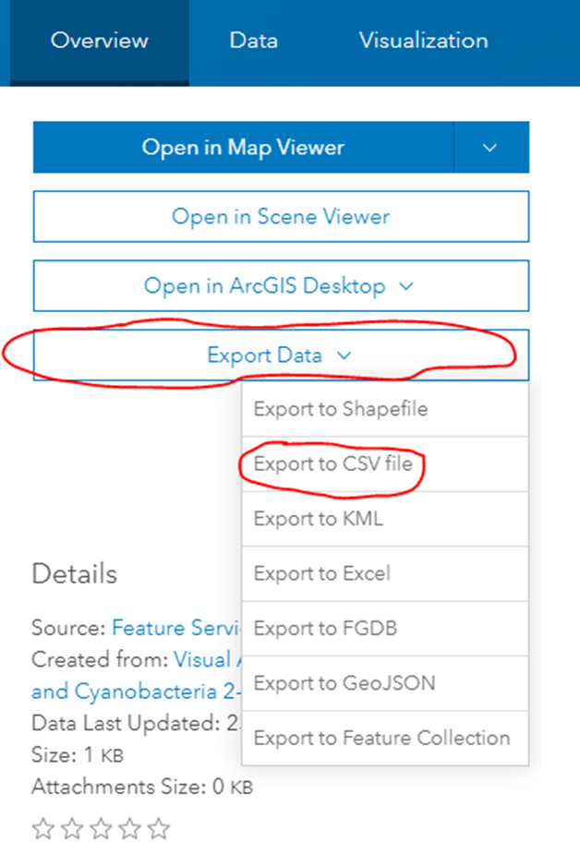

**Note:** If exporting for the first time this will work, however if exporting again you will need to change the title of the file to export, by adding the present date to the end of the title. For example: If the original file is named “Visual Assessment of Periphyton and Cyanobacteria 2-1\_stakeholder” name it “Visual Assessment of Periphyton and Cyanobacteria 2-1\_stakeholder20220520 (or whatever date you are accessing it at the time), and this should allow you to export an updated csv, enabling a download.

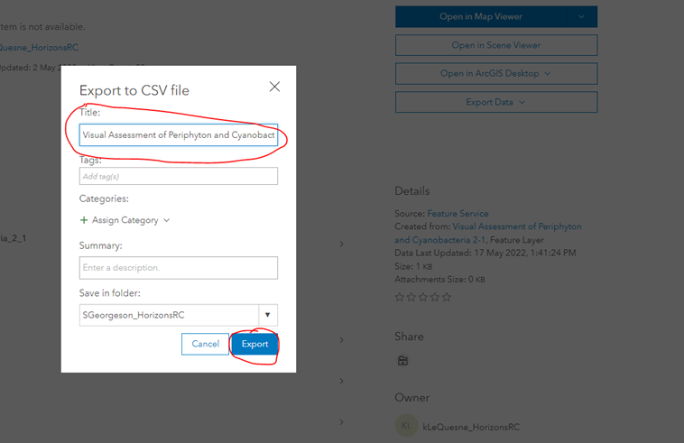

Once exported, you will be able to find the download option directly from the "content" tab in the white banner at the top of the page.

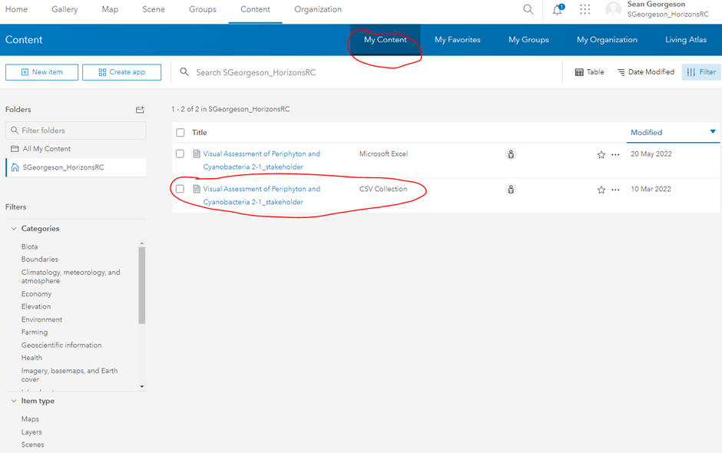

1. Export the data and the menu will change, now select “Download” (This will create a zip file of the visual assessment of periphyton information).

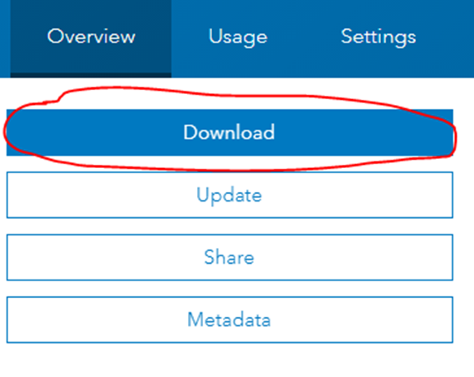

1. The zip file should contain the following information for you to access:

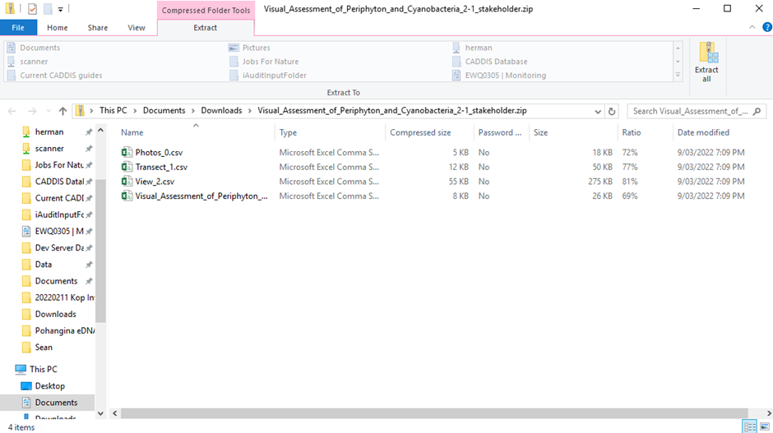

Extract all and save to [\\file\herman\E\WQ\03\05\Periphyton monitoring\Survey123 Agol outputs](file://file/herman/E/WQ/03/05/Periphyton%20monitoring/Survey123%20Agol%20outputs/20220520)  In a new folder (named as date in format: year/month/day e.g 20220520)

1. In excel you can delimit the data

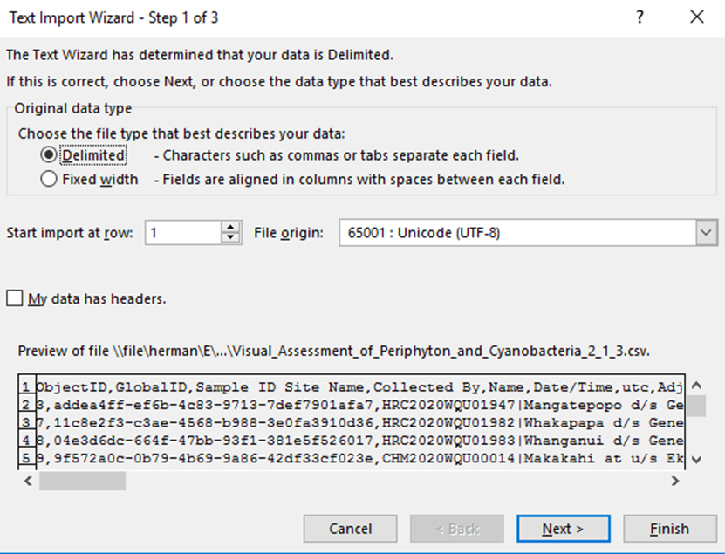

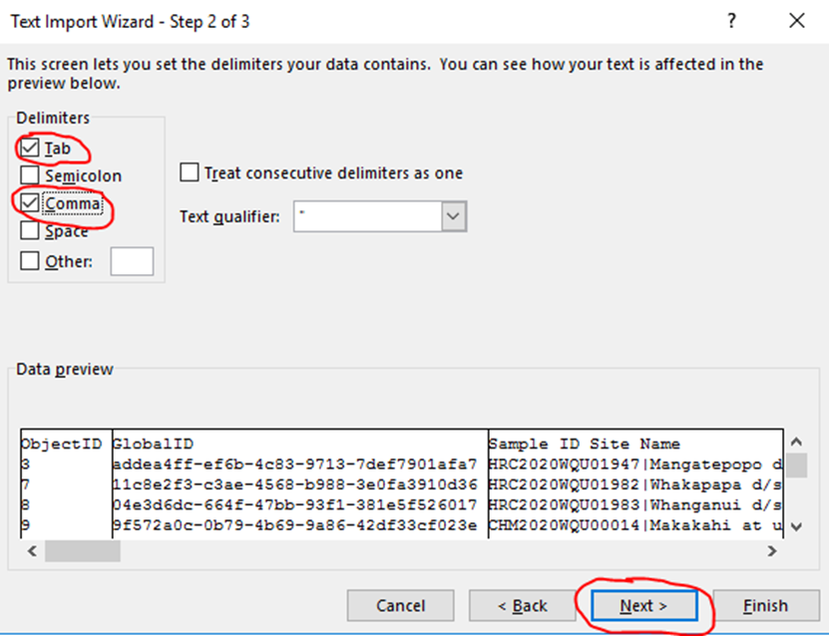

Click next and then “finish” in step 3/3.

 Most columns will be separated correctly, however some may still be connected:

![1 objectlD GloballD 
Sample ID Site Name 
- HRC2020WQU019471 Mangatepopod Genesis Intake 
3 addea4ff 
HRC2020WQU019821 whakapapa d/s Genesis ntake 
7 11c8e2f3. 
HRC2020WQU019831 Whanganui d/s Genesis Intake 
8 04e3d6dc 
9 9f572aoc. CHM2020WQU000141 Makakahi at u/s Eketahuna STP 
CHM2020WQu000151 Ngatahaka at u/s Makakahi confl 
10 9e80c548 
HRC2020WQU020221 ohau at u/s Makahika confluence 
11 acefc703. 
HRC2020wQu019871 Ohau at Gladstone Reserve 
12 S4ccf450- 
lohau at SHI 
13 b960c 
HRC2020wQu0198810hau at Haines Farm 
14 81f32342- 
15 aaboaa 
HRC2020WQU020001Manakau at s.H.1 Bridge 
16 e7e1918e HRC2020WQu020411waikawa at North Manakau Road 
17 468477af- HRC2020WQU020301porewa u/s Hunterville STP 
18 5c5096c6. HRC2020WQU020291 Porewa d/s Hunterville STP 
19 7915df4c- HRC2020WQU020131Rangitikei at Mangaweka 
20 15496f6a. HRC2020WQU020321Rangitikei at Pukeokahu 
21 a40e82bf 
HRC2020WQU020181 atwaiouru 
22 df55c94a. HRC2020WQU020171Rangitikei at McKelvies 
HRC2020WQu020231 Rangitikei at onepuhi 
23 96ed 
24 of9e9226. HRC2020WQU020351 Kumeti at Te Rehunga 
29 
HRC2020wQu020381Mangapapa at Troup Road 
25 f0690822- 
HRC2020WQU0202710ruakeretaki at SH2 
26 974f490c. 
HRC2020wQu020111 Mangatera d/s Dannevirke STP 
27 4cd73 
28 b005ef6c. HRC2020WQU020121Mangatera u/s Dannevirke STP 
HRC2020WQu020441Manawatu at Weber Road 
29 8c8352a3- 
HRC2020WQU01991 IManawatu at Hopelands 
30 5aeae2e 
HRC2020WQU019901 Tamaki at Hartridges 
31 78b40f87. 
32 dcf12ece 
- HRC2020WQU020331 Tamaki at Stephensons 
HRC2020WQU020341 Tamaki at Reserve 
33 4f1cbc99. 
34 8225768f- HRC2020WQU020081Mangatainoka at u,'s Pahiatua STP 
HRC2020WQU019931 Mangatainoka at Larsons road 
35 b17b979f 
HRC2020WQU02031 IMangatainoka at Putara 
36 40587963 
HRC2022WQU0010210hau at Haines Farm 
37 03388319 
38 df612acd- HRC2022wQu001551waikawa at North Manakau Road 
39 619d891e HRC2021WQUm7401Mangapapa at Troup Road 
HRC2021wQu00693 IManawatu at Hopelands 
40 f2488969- 
HRC2021WQUm72910ruakeretaki at SH2 
41 2a811561 
HRC2021wQuM7371Kumeti at Te Rehunga 
42 2f7a6edf- 
phyton 
Collected Name 
lanHurst 
IanHurst 
lanHurst 
KellyLeQuesne 
KellyLeQuesne 
KellyLeQuesne 
KellyLeQuesne 
KellyLeQuesne 
KellyLeQuesne 
IanHurst 
IanHurst 
KellyLeQuesne 
KellyLeQuesne 
lanHurst 
KellyLeQuesne 
KellyLeQuesne 
IanHurSt 
lanHurst 
KellyLeQuesne 
KellyLeQuesne 
KellyLeQuesne 
KellyLeQuesne 
KellyLeQuesne 
KellyLeQuesne 
IanHurst 
IanHurst 
lanHurst 
IanHurst 
KellyLeQuesne 
KellyLeQuesne 
KellyLeQuesne 
Other 
Other 
Other 
Other 
Other 
Other 
Alivia Goli 
Olivia Rey 
Sean Geot 
Sean Geot 
Sean Geot 
Sean Geot ](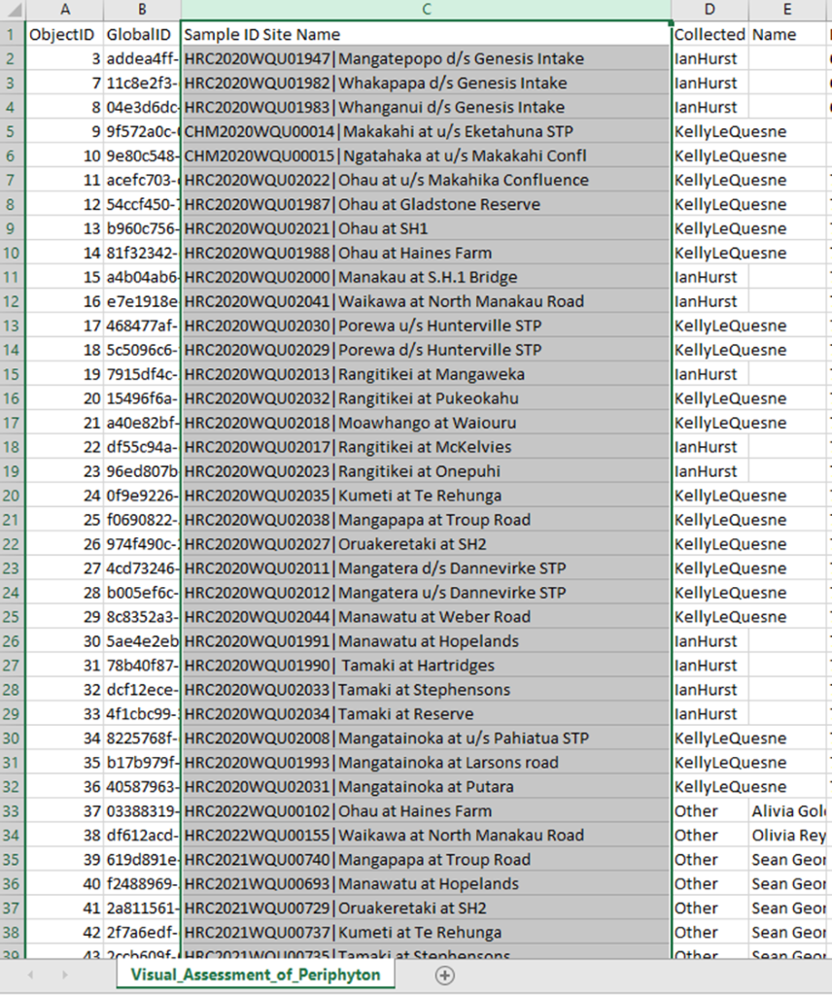)

This is an easy fix, just highlight the column in question and select “data” from the top banner. From here select “Text to Columns”

The "convert text to columns" wizard will appear, click next.

In step 2 of 3 select “other” and type in the character that is separating your desired columns, in this case “|”

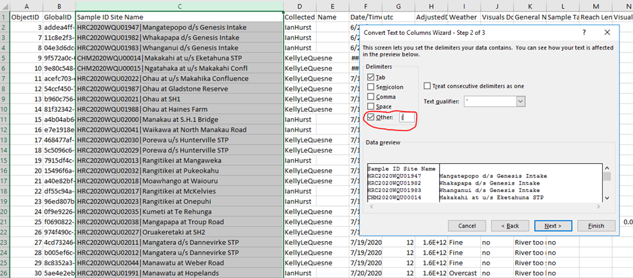

Select “next” and then “finish” and the column should separate into two, with the desired values in each.

**How to read the periphyton view data correctly:**

 When the data from agol is pulled there should be 4 different files:

1. Form\_15 (could also be called visual assessment of periphyton data) which contains the survey ID and site name as well as the substrate data and general comments
2. Transect\_(either 1, 2 or 3) which contains Global ID, Maximum depth, transect and ParentGlobal ID
3. View\_(either 1, 2 or 3) which contains the view data for each site and the Global and ParentGlobal ID's
4. A Photos sheet (don’t need to use this one

When data is pulled from agol it is pulled out in three spreadsheets which are all linked by the GlobalID and ParentGlobalID numbers. When we are doing peri visuals there are essentially two different levels to the survey. 1 level being the transect information and the other being the view itself. This information gets pulled into separate spreadsheets and is linked by these 'ID' numbers. It can be overwelming to look at first but it will eventually make sense. We are going to merge the spreadsheets into one and average the view data so that it will fit into our data request template.

Step 1:

* Delete the photos csv, you don’t need this
* Rename form\_15 to SubstrateData
* Rename Transect\_(either 1,2 or 3) to RunRiffleData
* Rename View\_(either 1,2 or 3) to ViewData

Step 2:

* Open the substrate data sheet, follow the steps above to delimit the data.
* Merge the 'Weather' and 'General notes' columns together. To do this create a new column and use the equation =(weather)&(General Notes) to add them into your new column. Name this column 'Observations'. You can then delete the 'Weather' and 'General Notes column'.

Step 3:

* Now you are ready to merge sheets
* Open the data tab at the top of the spread sheet and choose 'New Query', From here select 'Combine Queries' and then select 'Launch Query Editor'

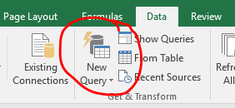

* A new window will pop up, in the top bar choose 'New Source' then choose 'File' and then finally choose 'Text/CSV'

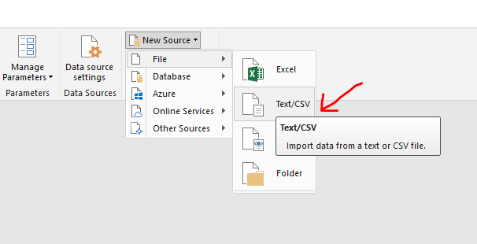

* Locate the folder where your three excel spreadsheets are, and import them all following the same steps. You should now have the three spreadsheets under the Queries tab to the left.

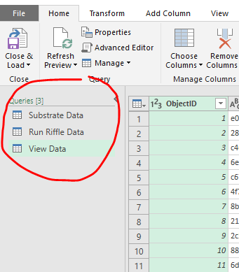

* Open view data from the queries tab. Under 'Home' in the top toolbar, select 'Group By'
* A new window will pop up. Selected advanced. In the 'Group by' drop down box, select 'ParentGlobalID'
* In the next section you want to change 'Operation' to 'Average' and under 'Column' Select 'Clean (%)' You then need to add a new column name this can be 'Av\_Clean'.
* Repeat this for each periphyton type column that needs to be averaged. You will have 9 new columns total, these will be; Clean, Film, Sludge, Mat, Fils\_Slimy, Fils\_Coarse, No Data and Sediment.

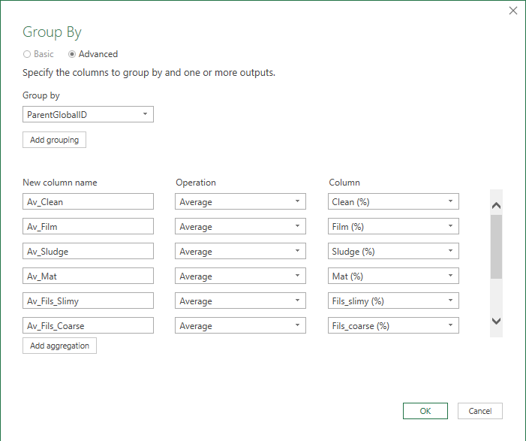

* Once you have done this click 'OK'
* The green columns in the sheet now show you the averaged periphyton values for each transect. We now want to merge this data into the 'Run Riffle Data' sheet and average the values again so that we have one value for each site.
* Open the 'Run Riffle Data' sheet under the Queries tab. In the top tool bar select 'Merge Queries'
* A new window will pop up.
* Under 'Run Riffle Data' select the 'GlobalID' column. In the drop down box, choose 'View Data' and select the 'ParentGlobalID' column.
* If a warning pops up check the 'ignore privacy levels' box and choose 'Save'
* At the bottom of the box there should be a green tick and a message telling you that excel has matched the rows. If not you may have chosen the wrong sheets to merge.

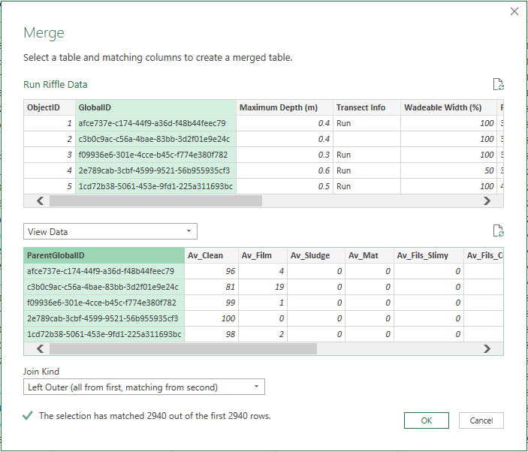

* You can now click 'OK' to close the box
* Scroll to the far right of your sheet, you will see a green column named 'View Data' In the top right corner of this column click on the double arrow symbol. Unselect 'ParentGlobalID' from the list as you already have that column in the current spreadsheet and click 'OK'

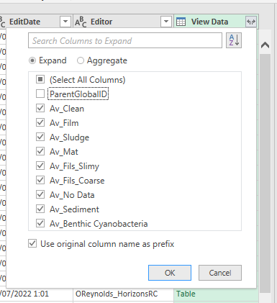

* This imports the view data into our 'Run Riffle Data' sheet.

Step 4

* Now that you have averaged the data for each transect we need to average it again for each site and add it into the 'Substrate Data' sheet so that you can match the view data to the site name and date.
* Open the 'Run Riffle Data' sheet from the left panel
* Select 'Group By' again in the top bar
* A new window will pop up, you want to follow the same steps as before, grouping the data byl 'ParentGlobalID'
* As well as averaging the view data, we also want to average the Maximum depth, Transect Info and Wadeable width so that we have one value for each site.
* Note: for Transect Info you want to choose median under the 'Operation' drop down box instead of average.
* Here is how it should look:

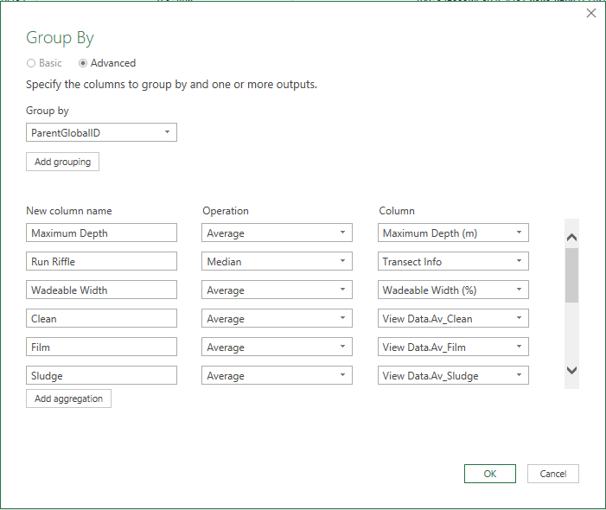

* Click 'OK' and the spreadsheet will now show you the averaged data for each site.
* Now you want to merge this sheet into the 'Substrate Data' sheet.
* Open the 'Substrate Data' sheet from the left bar
* Click on 'Merge Queries' in the top bar
* Under 'Substrate Data' and select the GlobalID column
* In the drop down box choose 'Run Riffle Data' select the ParentGlobalID column

* Click 'OK"
* Scroll to the far right and click on the double arrow symbol at the top of the green 'Run Riffle Data' column.
* Unselect 'ParentGlobalID' then click 'OK'
* Congrats! You now have one spreadsheet with data for each site in a much more readable format.

Step 5

* Make sure that you save your work, under file, select 'Close & Load'

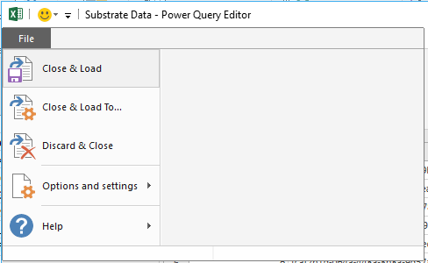

* This will open three new tabs in your 'Substrate Data' sheet. Find the tab that contains all of the data matched with the site name and name it something you will remember.
* Now you can use this data to fill out those data requests, have fun!

Accessing Photos in AGOL

To access photos from AGOL/Survey123 you need to log into ArcGIS per the instructions that are listed at the start of this section.

1. At the top of the ArcGIS login page, next to your user name you will see the square with all of the clear dots (in the image below). It will bring up a list of other online programs. Scroll down until you see Survey123 and click on it.

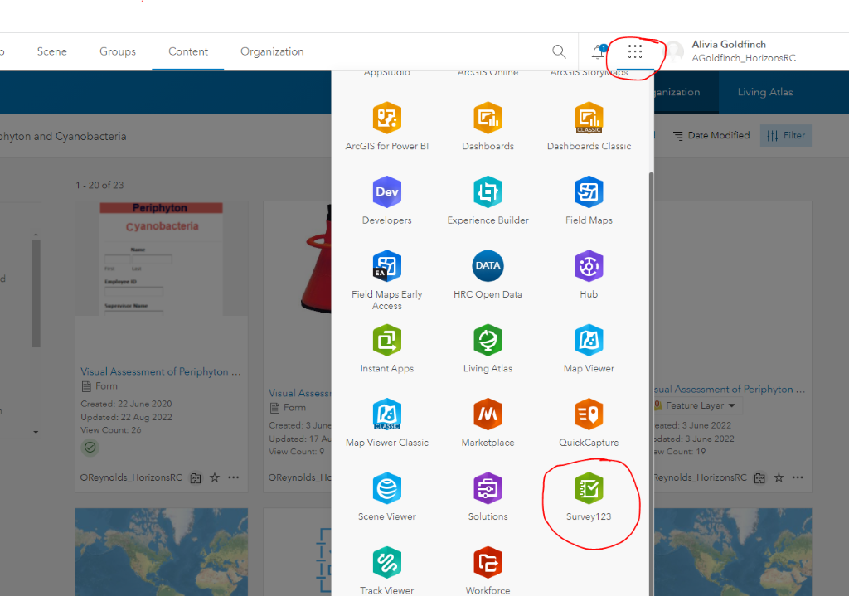

1. A page with all of the current survey123 forms will come up. Click on the Visual Assessment of Periphyton and Cyanobacteria survey, which has the same picture as the one in AGOL.

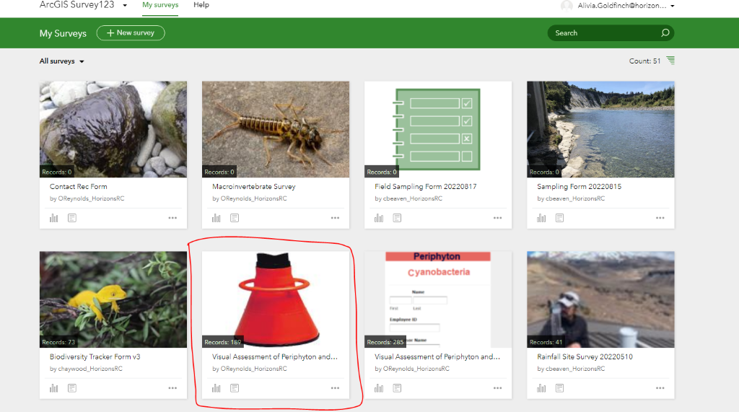

1. When the next page opens up showing a graph of when surveys were submitted, in the top right below your email/login details click on 'Data'

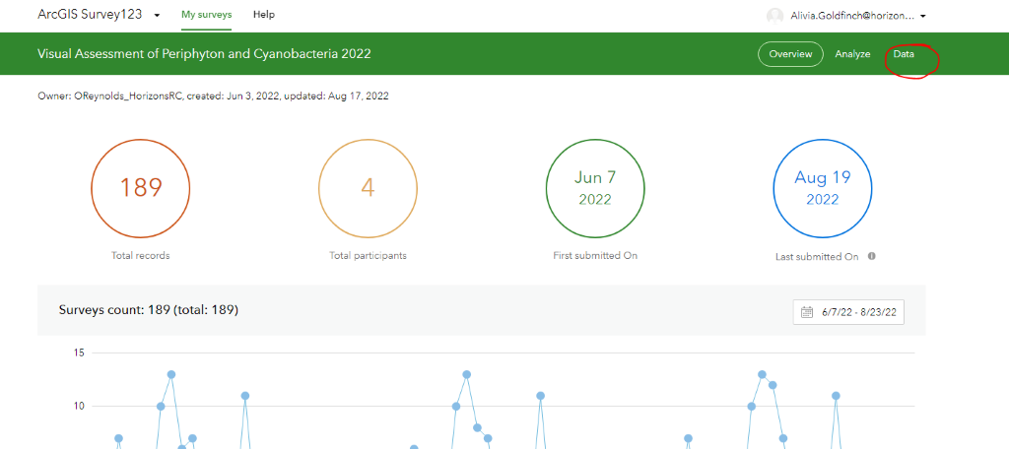

1. A map will then appear with all of the sites we have done surveys at. Click on 'filter' up the top left of the map. You can then filter for sites that you need by Sample ID, Site Name, Collector or date. Next to the filter option is also a date range which can be used to filter sites that way if you prefer (may be easier in some cases). Or you can simply click on a site on the map. There are many options.

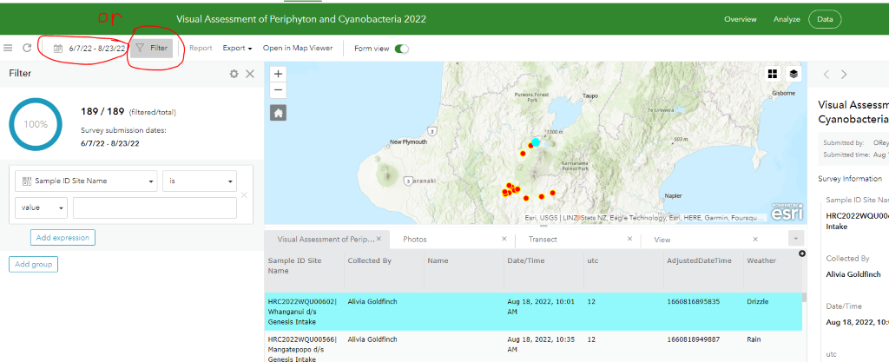

1. Once you have selected the site that you want, a little pop-out will come out of the right hand side of the screen showing the survey details including all the views done. If you scroll down in this pop-out you will see the photos for the site. You will be able to click on them to enlarge them. When you do this there will be a download button on the top right of the picture. Click this to download, which will take you to another tab, you can then right click and click 'save image as..', it will download the picture. Click the upwards arrow and then click 'show in folder'. You will then be able to rename it and save it wherever you need to!

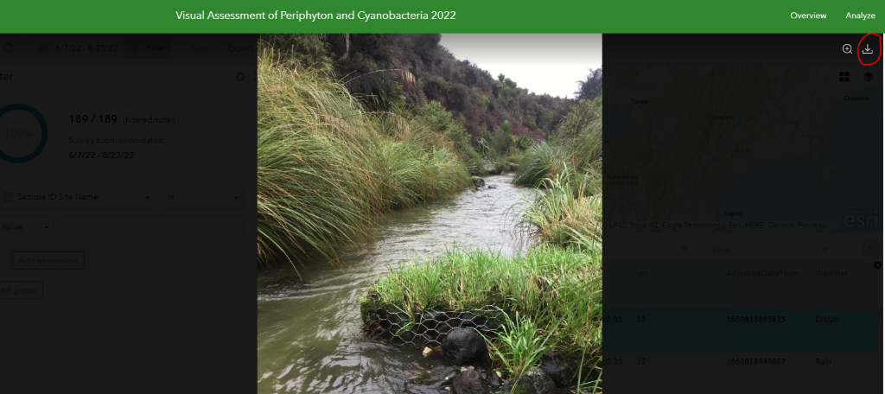

## Army ID process

For Moawhango at Waiouru we enter the Waiouru Defence Force Training area. Each month either the Friday or Monday prior to sampling, we call Range Control to see if we can sample on our sample day. Range Control oversee and organise all of the army training activities in the training area and they give us permission to enter. If permission is granted then we are able to sample on our proposed sampling date and if permission is denied then we try and arrange another sample time within the month.

Range Control phone number can be found in Teams <https://teams.microsoft.com/_#/tab::c7f095de-f312-433b-b78c-5cac0f05d22b/General?threadId=19:6dc901ead6384c909351b43c24f29f59@thread.tacv2&ctx=channel>

Part of the requirements of entry is that we need to be Blinds Trained by Range Control. You need to be blinds trained once before entering the training area so for any new staff make sure to arrange this when you are visiting.

We also arrange to have Defence Site Clearance (DSC) with DEI (Defence Estate and Infrastructure) who are another team that act as our sponsors (I.e. if anything untoward happens they are ultimately responsible for us). This is typically an ID card which is valid for 12 months and allows us to enter into the Defence force area without signing in at the front gate and without the need for an escort. The process for the Defence force ID card application/renewal is below:

Email [DEIWAISecurity@nzdf.mil.nz](mailto:DEIWAISecurity@nzdf.mil.nz) to get the correct documents.

Fill in the relevant documents (all forms of ID that are scanned are required to be signed off by a Justice of the Peace which is easily done at the PN District Court).

Send the relevant documents back to the email above with your next planned visit date and rough ETA so that hopefully you can get your ID card(s) printed while you are there.

Someone from DEI will respond and arrange a time to get your ID cards and explain the rest of the process from there.

**NOTE: It is important to begin this process approximately 1-2 months prior to your current ID expiry date to ensure that you don't need an escort when you arrive to do your sampling as this is a hindrance to both DEI and Range Control and is one of the reasons we were able to get ID cards in the first place.**

Application information is saved here \\file\herman\D\SR\03\01\Rivers\Periphyton monitoring\Moawhango at Waiouru Army ID

JP services at PN District Court <https://justiceofthepeace.org.nz/Page/Search?Location=palmerston+north&Surname=>

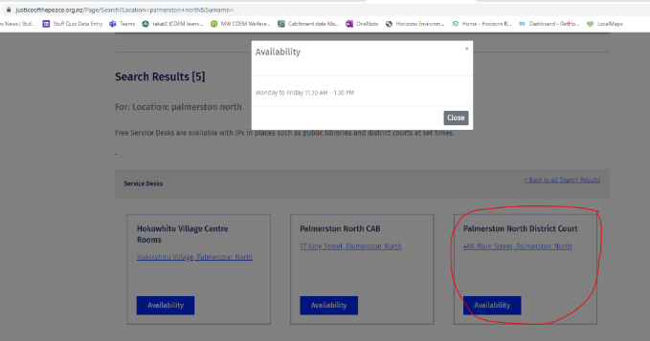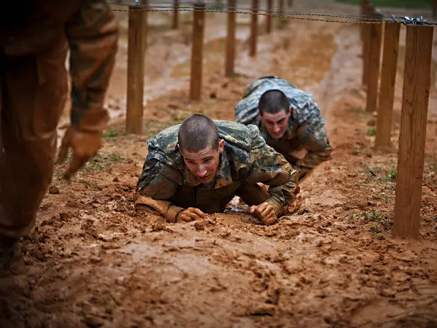

# Didymo

## Introduction to Rock Snot

*Didymosphenia geminata,* is a diatom more commonly known as didymo or 'rock snot' which can produce nuisance growths in freshwater rivers and streams. This typically occurs in freshwaters with cold water temperatures and low nutrient levels. The purpose of this monitoring is to identify the presence or absence of this species throughout the Manawatu-Whanganui region.

All info can be found here [\\file\herman\E\WQ\03\05\Didymo](file://file/herman/E/WQ/03/05/Didymo)

Samples are taken in November, February and May each year and are sent to the University of Waikato for DNA analysis. The data is entered into MPI's didymo database.

In 2022 the National Didymo database was created (<https://didymodb-mpi.hub.arcgis.com/> ) which has access to all previous didymo records in every river in New Zealand. This can be used to look at didymo results and enter results (but the lab usually does this for us). Instructions can be found on how to use the new database here (use the latest version of document):

[file:///\\file\herman\E\WQ\03\05\Didymo\2022%20new%20database%20information\2022%20Didymo%20Database%20User%20Guide%20v2.1.docx](file://file/herman/E/WQ/03/05/Didymo/2022%20new%20database%20information/2022%20Didymo%20Database%20User%20Guide%20v2.1.docx)

MPI can add new users to the Didymo database via AGOL. The invites must be accepted within 14 days or they expire and need to be sent again.

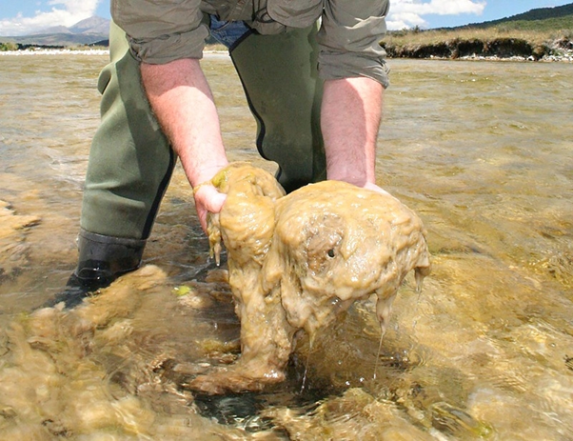

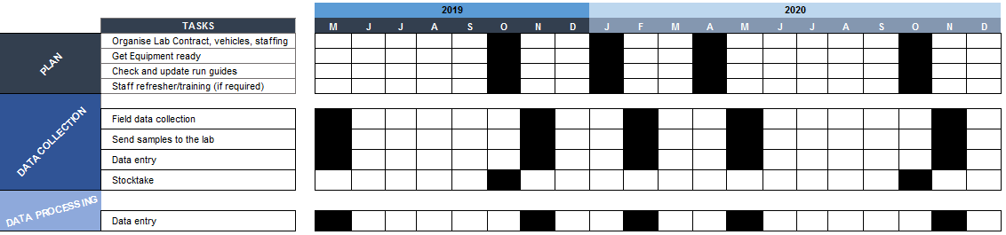

## Scientist stuff

All info can be found here [\\file\herman\E\WQ\03\05\Didymo](file://file/herman/E/WQ/03/05/Didymo)

Didymo time is coded to WQM100\_623

All other didymo costs are charged to Biodiversity and Craig Davey or Michael Beech is the contact for that.

He will provide a PO number for sample processing and any equipment that is required.

## PLAN - Equipment List

If you need to order more equipment (e.g. pottles) our preferred suppliers can be found here [file:///\\file\herman\E\WQ\03\05\Supplies\Supply%20costs%2020120529%20costs.xls](file://file/herman/E/WQ/03/05/Supplies/Supply%20costs%2020120529%20costs.xls). Essentially just ring the company and order however many things you need to order – make sure to confirm the price including freight and GST so that Kelly can adjust the PO. Kelly will also provide you with a PO to give to the company. Some things (e.g. bleach, zip lock bags etc.) can be purchased from the supermarket using the New World Card from Finance (still need a PO).

Sample preservative (70% ethanol)

Wash bottle with screw cap lid

Funnel

Plastic clip-lid box

Pen/pencil (sharpened)/sharpie (fine tip)

Falcon tube stand (container with hole in lid for falcon tube)

Travel box to contain everything

Net handle (3 parts that screw together)

Net and mesh cap to screw onto bottom of net

Bucket for decontamination between sites

Bleach for decontamination between sites

2x wing nuts (plus 2x spares)

2 x screws (plus 2x spares)

Slikka pads and chilly bin

Waders

PFD

**Consumables**

Falcon tubes

Parafilm strips to wrap tightly around cap junction

Rubber bands

Small zip lock bags

Paper towels

Rubbish bags

Gloves

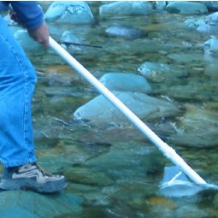

## PLAN - Run Guides and Site List

These are updated annually (June/July) and are stored in the [Hydro Catchment Data Management System](http://tqm.horizons.govt.nz/hydrology/) which is easily accessible in the field in case you forget your run guide. If you do make any changes outside the annual review be sure to update the version number and send it to Darren Bently-Hewitt know so he can update the OMS. Changes can be made to the Word docs which can be found here [\\file\herman\E\WQ\03\05\Didymo\Run Guides](file://file/herman/E/WQ/03/05/Didymo/Run%20Guides)

* [Manawatu Didymo](http://tqm.horizons.govt.nz/hydrology/SOPs/cd_om_15.7_appendix_60_Didymo%20-%20Manawatu.pdf)
* [Mangatainoka Didymo](http://tqm.horizons.govt.nz/hydrology/SOPs/cd_om_15.7_appendix_61_Didymo%20-%20Mangatainoka.pdf)
* [Ohakune Didymo](http://tqm.horizons.govt.nz/hydrology/SOPs/cd_om_15.7_appendix_62_Didymo%20-%20Ohakune.pdf)
* [Rangitikei Didymo](http://tqm.horizons.govt.nz/hydrology/SOPs/cd_om_15.7_appendix_63_Didymo%20-%20Rangitikei.pdf)

Some of these runs align with periphyton runs and can be done simultaneously.

There are 14 sites that we take didymo samples from:

* Manawatu River at Weber Road
* Manawatu at Upper Gorge
* Manawatu at Teachers College
* Pohangina River at Raumai
* Ohau River at SH1
* Mangawhero River at Pakihi Road – people don't get in above this site, could move d/s but not much point
* Makotuku River at Raetihi – people don't get in above this site, could move d/s but not much point
* Rangitikei River at Pukeokahu
* Rangitikei River at Mangaweka
* Rangitikei River at Onepuhi – unlikely to be forming mats here
* Rangitikei River at McKelvies – unlikely to be forming mats here
* Kawhatau River at Potaka Road
* Makuri River at Tuscan Hills
* Mangatainoka River at SH2 Mangatainoka
* Owhango
* Whakapapa Footbridge

Programme review: are we looking at detecting mat formation (a problem of proliferation and aquatic ecology) or presence/absence (innoculation, more relevant for the Check, Clean Dry programme). If proliferation, look at Kilroy 2012 to see which sites are likely to support proliferation. If the latter, sites with high people traffic should be prioritised. The current programme is a bit of a balance of these ideas. $4k budget. Didymo Dave: Ruatiti zdomain, Owhango

## DATA COLLECTION – Sample Collection and Storage

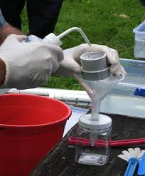

**Before Leaving the Office**

Double check you have all the right gear before you leave.

Make sure you have a check-in buddy that knows what run you are doing/sites visiting (and where to access the run guide) and what time you will be back. Please remember to txt them when you return safely.

Also start the GetHomeSafe App to track your location throughout the day. Log into [GetHomeSafe](https://www.gethomesafe.com/" \t "_blank) to see your activities. Along with setting up GetHomeSafe, take an InReach unit with you. Another app, Earthmate can be downloaded alongside the InReach units, which can be used to send messages to people to let them know you are ok or alternatively not.

**Sample collection**

Samples are collected in November, May and February of each year.

The "*Field guide for didymo DNA sample collection 2007*" can be found in the didymo monitoring folder

The main points are:

* Make sure to wear gloves when handling all of the equipment to reduce contaminating the sample with your DNA
* Put the net together and stand in the water with the net upstream of you and facing upstream
* Allow the water to flow through for 10 minutes
* After 10 minutes, take the net out of the water and allow sample to drain to cod end
* Try to remove as much water as possible from the filter (I.e. shake the cod end to filter water through – be careful not to lose any of the sample)
* Transfer the sample into a falcon tube by rinsing with 70% ethanol preservative
* Put the cap on the falcon tube and wrap parafilm strips around the cap for a tight seal and prevent contamination
* Label and wrap in a paper towel to prevent any degradation from light
* Put in a labelled zip lock bag and store in the chilly bin/fridge until you send the samples (DO NOT FREEZE the samples)

## DATA PROCESSING - Data Entry

All the didymo samples taken each month need to be recorded in an individual site visit form. The site form can be found here:   
\\file\herman\E\WQ\03\05\Didymo\2022 new database information\2022 Didymo database site visit from.docx

The Drift net number that is normally used is 032

Make sure that NO is ticked for 'is didymo visible' and tick YES for 'Run-Drift net' under which habitat types were sampled.    
You can also tick NO for 'Benthic Biomass Taken?' And 'DNA taken?'.

The site and visit numbers can be found in this excel spreadsheet that also will need to be filled out for each batch of didymo samples being set   
[\\file\herman\E\WQ\03\05\Didymo\Didymo Sampling.xls](file://file/herman/E/WQ/03/05/Didymo/Didymo%20Sampling.xls)

Make sure to print each site visit form and put them in a zip lock bag to send with the samples.

Below is an example of what information should be in the site visit forms.

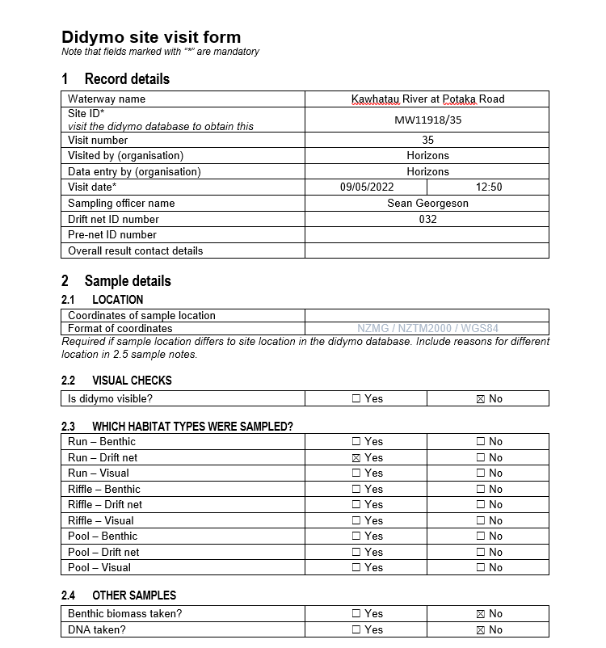

## DATA ENTRY FOR THE NEW SYSTEM

In 2022 the national didymo database was created so that it was easier for different sampling groups to add sampling events, see previous sampling events and in general manage their didymo samples in a more coherent way, being able to see the whole countries sampling efforts. The video below gives a run through of how to enter data into the new database and how to use general functions.

\\file\herman\E\WQ\03\05\Didymo\2022 new database information\Didymo database demo.mp4

There is also a user guide which has step by step instructions on how to perform different functions and the spreadsheet that we follow: \\file\herman\E\WQ\03\05\Didymo\2022 new database information\2022 Didymo Database User Guide v1.docx

**Here is the link to the new didymo database:**[**https://didymodb-mpi.hub.arcgis.com/**](https://didymodb-mpi.hub.arcgis.com/)

The homepage of the new database has the links to the main functions that the database is used for, which makes it easy to navigate to the places for the functions that you want to perform.

* To add a new visit results to the database click on Record visit at existing site.
* This will take you to the map where you can select the site that you want to add the results to.
* You can get to the site by either panning to it on the map or searching for the site ID in the search bar.
* Before you enter the sampling visit into the database you will have to wait for the results to come back from the lab. Record all of the information for a site on the didymo field record form
* Once you find the site, click on 'Record a new visit at this site'
* This will take you to a survey123 form where it auto generates a new visit number and it will show 4 sections where data needs to be entered
* In the Record Details click the little arrow to expand the options
* Enter all of the information which should also be recorded on the field record form as well
* Go onto the next section Sample Details and enter all the relevant information (remember to complete all compulsory sections)
* Next enter the Lab Results section
* Enter the Overall result of the site, there is also a no sample taken option which would occur with any sort of issue with the sample. There shouldn’t be many (if any) times that we need to enter a no sample taken option
* Once every section has been filled in click the 'Submit' button and then exit the tab
* To check that the information has been entered properly go back to the main dashboard and refresh the map which should then show the sampling event that you have just added
* If everything is looking correct then job done! If not then see if you can go back and edit that entry (will see if we can do this once we have become more familiar with the database)

We only have to enter the data directly into the database if there is no sample taken due to high flows etc. Otherwise you do not need to fill in the form on the website directly as the lab will do this for us. When sending samples to the lab, remember to email with the filled in field visit forms attached and to put a chain of custody form into the chilly bin too.

**Editing data**

If results/surveys or site details need to be edited. Email MPI at [didymo@mpi.govt.nz](mailto:didymo@mpi.govt.nz) detailing what needs to be changed.

Note: There is the ability to change anything from site details to the visit results/info itself. Generally I don't think we will have many changes to make. However, there may be some scenarios where we do need to change data. Eg:

* If visit results have been entered wrong by the lab
* If the site location isn't quite right (particularly relevant for setting up a new site)
* If we decide to move a site – we will create a new location (as per instructions) but the old site could have the 'site location description' edited to say site is no longer active due to slip/access issues/flooding etc.
* If we accidentally created a site this can be deleted.

## DATA PROCESSING - Sending Samples

* Get PO number from Craig Davey
* Check that all samples have a visit number on them
* Site visit forms are saved here: \\file\herman\E\WQ\03\05\Didymo\2023 Site Visit Forms\Feb 2023
* There is an excel spreadsheet named 'Didymo Sampling.xls' that you can use to determine what site visit number you need, saved here: \\file\herman\E\WQ\03\05\Didymo
* Check that all samples have parafilm and are wrapped in a paper towel
* Check that all sample bags have a visit number on them
* Put the sample sheets into a plastic bag
* Put samples and sample sheets into a chilly bin with slikka pads
* Celotape on the laminated address sheets
* Let Simon know that these need to be sent to Hamilton on an overnight courier (DO NOT send samples on a Thursday, Friday or before a public holiday)
* Email Roanna Richards-Babbage ([roanna.richards-babbage@waikato.ac.nz](mailto:roanna.richards-babbage@waikato.ac.nz)) to let her know that the samples are on the way and to give her the PO number. In the email make sure to attach all of the site visit forms.

The laminated address to be celotaped onto the chilly bin is on the back shelf near Lizzies office. Make sure the return address cards are in the chilly bin for Roanna to send the chilly bin back.

Alternatively the address is below:

**Address –**can be found here [\\file\herman\E\WQ\03\05\Didymo\Didymo\_processing\_address.docx](file://file/herman/E/WQ/03/05/Didymo/Didymo_processing_address.docx)

**Roanna Richards-Babbage**

The Didymo Processing Service

Care of Thermophile Research Unit

University of Waikato

Gate 9, Hillcrest Road

Hillcrest 3216

Hamilton

Ph: 027 693 0268

## Temp review

Budget is now $4k but 2023 quote for 14 samples 3x/yr = $5250.00

Move sampling to 2x (Dec, April) and expand sites (add Owhango, Manganui o te Ao, Cherry Grove)

17 sites 2x/yr = 34, $125/sample = $4250 +GST

Final budget:

125 + 15% GST = 143.75/sample

4000/143.75 = 27 sampling iterations, /2 sampling rounds = **13 sites max for 2024**

$12.25 shortfall for 14 sites twice a year; **with 13 sites twice a year, the total is $3737.50/year**.

|  |  |  |  |
| --- | --- | --- | --- |
|  | **Site** | **Latitude & longitude** | **Justification** |
| Retained sites | Manawatu River at Upper Gorge | -40.335185, 175.813678 | Frequent fishing use |
|  | Manawatu River at Teachers College | -40.373559, 175.628102 | Frequent fishing use |
|  | Pohangina River at Raumai | -40.209907, 175.790361 | Frequent fishing use |
|  | Ohau River at SH1 | -40.670941, 175.240949 | Frequent fishing use, camping |
|  | Rangitikei River at Pukeokahu | -39.627470, 176.044869 | Frequent fishing use |
|  | Rangitikei River at Mangaweka | -39.811876, 175.806475 | Frequent fishing use |
|  | Kawhatau River at Potaka Road | -39.785476, 175.889893 | Frequent fishing use |
|  | Mangatainoka River at SH2 Mangatainoka | -40.421509, 175.862773 | Frequent fishing use |
| Removed sites | Manawatu River at Weber Road | -40.240425, 176.114067 | Riverbed changes reduce likelihood of sampling/health and safety for staff |
|  | Makuri River at Tuscan Hills | -40.522792, 175.931721 | Little public access to allow didymo release |
|  | Mangawhero River at Pakihi Road | -39.430727, 175.322523 | No river entry by the public above this point |
|  | Makotuku River at Raetihi | -39.421292, 175.282256 | No river entry by the public above this point |
|  | Rangitikei River at Onepuhi | -40.076060, 175.475982 | Nutrients potentially too high to form mats (low detection likelihood) |
|  | Rangitikei River at McKelvies | -40.278474, 175.297337 | Nutrients potentially too high to form mats (low detection likelihood) |
| Added sites | Whakapapa River at Footbridge | -39.117775, 175.465605 | Low nutrients may promote mat formation/higher detection likelihood |
|  | Whakapapa River at Owhango | -38.996422, 175.398655 | Low nutrients and frequent fishing activity |
|  | Manganui o te Ao at Ruatiti Domain | -39.313529, 175.199953 | Frequent fishing activity |
|  | Mangahao River at Marima Domain | -40.503211, 175.711193 | Frequent fishing activity |
|  | Whanganui River at Cherry Grove | -38.892609, 175.254762 | Frequent fishing activity |

## Golden clam

Wilderlab kits,  3x in December, March and August. Technical report of clam ecology: <https://www.mpi.govt.nz/dmsdocument/59086-Technical-Advisory-Group-Report-Biosecurity-Response-to-Corbicula-fluminea-in-the-Waikato-River>

|  |  |  |
| --- | --- | --- |
| **Site** | **Latitude/longitude** | **Reason for inclusion** |
| Lake Otamangakau | -39.006064, 175.619158 | Heavy boat traffic and fishing, close to Waikato region |
| Manawatu at Whirokino | -40.509995, 175.265659 | Heavy boat traffic, popular for events |
| Rangitikei at Bulls Bridge | -40.186677, 175.391345 | Occasional boat traffic, frequent fishing |
| Lake Wiritoa | -39.972348, 175.090735 | Popular for boating and watersport events |
| Whanganui at Pipiriki | -39.480428, 175.044591 | Frequent boat traffic with tourists |

 Biosecurity equipment:

|  |  |
| --- | --- |
| **Didymo** | **Clam** |
| Clip top bucket w water in it (or 5% bleach pre-mixed) | Empty clip-top bucket |
| Spray bottle with 5% bleach | Spray bottle/s with 10% bleach |
|  | Spray bottle/s with tap water (waders, maybe some equipment rinse) |
| Paper towels as scrub brush | Paper towels as scrub brush |
| Rubbish bags | Rubbish bags |
| Cow gloves | Cow gloves |
|  |  |

# Data Requests

## Periphyton data requests

See caddis instructions under section Quarterly outputs/Data requests to get periphyton data out of CADDIS [\\file\herman\E\WQ\03\10\CADDIS guides\Current CADDIS guides](file://file/herman/E/WQ/03/10/CADDIS%20guides/Current%20CADDIS%20guides)

The template to data requests is found here:

\\file\herman\E\WQ\03\10\Caddis Outputs\Quarterly outputs

These are usually allocated to the RA's as the come through The Portal.

2023:

\\file\herman\E\WQ\03\05\Periphyton monitoring\Data Requests

CHECK THAT THE VIEWS AVERAGES ADD TO 100 FOR EACH ROW

Interim Procedure

As the data migration to KiEco continues, data requests are temporarily (possibly for a while) following an interim guide.  Data prior to May 2022 is still pulled from CADDIS using the guide above.  Data after May 2022 is being pulled from a [master spreadsheet](file://file/herman/E/WQ/03/05/Periphyton%20monitoring/Data%20Requests/PeriphytonDataMay2022-Present.xlsx). Data for requests is only pulled from here, and if the spreadsheet isn't updated in time for a request, you need to ask people to update the master spreadsheet rather than pulling data from other folders. The process is outlined below and also written [here](file://file/herman/E/WQ/03/05/Periphyton%20monitoring/Data%20Requests/data_requests_working_methods.txt).

https://horizonsrc.maps.arcgis.com/home/item.html?id=09e768a1299d4d629216f003a089632d#overview

* Kieco tools
* Prepare data for entry
* Follow prompts

To get data into the master spreadsheet

Views:

1) monthly views download from AGOL, save to

2) downloaded files from (1) get processed through KiEco Tools on http://tqm.horizons.govt.nz/Hydrology/Science/dashboard\_map.html ("Prep data for entry")

3) the processed files downloaded from (2) can then be saved here: \\file\herman\E\WQ\03\05\Periphyton monitoring\Data Requests\periphyton\_views, in the year/month folders

4) copy the appropriate rows from (3) into the master spreadsheet: \\file\herman\E\WQ\03\05\Periphyton monitoring\Data Requests\PeriphytonDataMay2022-Present.xlsx

 Chl-a (COPIED INTO SW BIOMONITORING DATA):

5) lab csv will be saved here: \\file\herman\E\WQ\03\10\Results from Lab\Periphyton Samples\2023\Need to be entered

6) lab csv is put through KiEco Tools on http://tqm.horizons.govt.nz/Hydrology/Science/dashboard\_map.html ("Prep data for entry")

7) output from (6) is saved here: \\file\herman\E\WQ\03\05\Periphyton monitoring\Data Requests\Chl-a\_monthly\_results

8) the chl-a data from (7) is copied out into \\file\herman\E\WQ\03\05\Periphyton monitoring\Data Requests\PeriphytonDataMay2022-Present.xlsx

Everything is copied from \\file\herman\E\WQ\03\05\Periphyton monitoring\Data Requests\PeriphytonDataMay2022-Present.xlsx

DATA ONLY COMES FROM HERE, NOWHERE ELSE APART FROM CADDIS.

Copying data from the lab spreadsheet to the master spreadsheet (VOID)

So you've downloaded the data, and now you're ready to do some data requests. But wait, young Padawan, for there is still one more task to do.

1) Find the appropriate results output here: \\file\herman\E\WQ\03\05\Periphyton monitoring\Data Requests\Chl-a\_monthly\_results

2) Copy these results into a new sheet in the master spreadsheet.

3) In the "periphyton" tab in the master spreadsheet, filter by date for relevant month

4) in "ug/sample" column: =VLOOKUP(A14, Sheet1!$A$1:$G$55, 7, FALSE), with "Sheet1" name subbed with the tab of the new data, and the number (e.g. 7) checked to make sure it matches the # of columns

5) in "chl-a mg/L": =VLOOKUP(A39, Sheet1!$A$1:$G$55, 5, FALSE)

6) in "chl-a mg/sample" column: =H14/1000, where H14 is the ug/sample column

7) in "chl-a mg/m2" column: =0.05\*H14, where H14 is the sample column

8) check some random numbers to make sure it's worked correctly

9) copy the relevant values, right click and paste by values. This removes the formula and lets us delete the lab results tab we copied in earlier.

10) delete the copied in tab, putting the total number of tabs in the PeriMay22 spreadsheet back down to 4

KiEco

KiEco is available here:  [\\file\AppData\Wiski\LIVE](file://file/AppData/Wiski/LIVE)

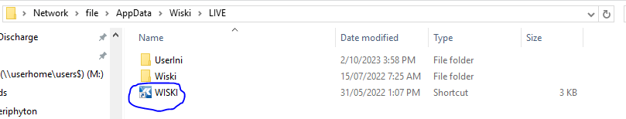

Click on the highlighted icon above, and then "Run"

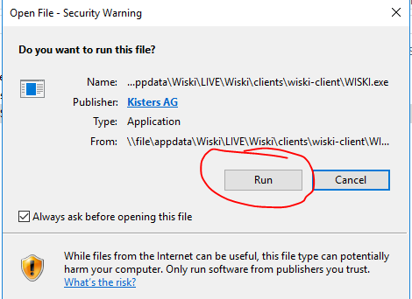

The log-ins are:

1)      The first is an Aquatic biomonitoring user log in. This one can view everything in the database and (I think) export data at a later date, but cannot edit anything:

**Username:** AB\_user

**PW:** Fish\_are\_Friends\_2022

2)      The second is aquatic biomonitoring data admin. This user can view all data but only edit the aquatic biomonitoring data (i.e. they can’t accidentally edit the EcoBase biodiversity data).

**Username:** data\_admin\_ab   
**PW:**2022\_Just\_Keep\_Swimming

 We mostly use the second log-in. Click "connect".

## Environmental DNA data requests – imported to new notebook

1) Go to the eDNA viewer in the internal science dashboards: <http://172.29.100.109:8505/>

2) Click on "view eDNA data", and choose "tables".

3) Download all four tables (maybe not geospatial; depends on what the people want)

4) Merge all four spreadsheets into one, with each spreadsheet being a new tab.

5) Use filtering to remove the data the clients do not want.

6) Check the Client Sample ID column; sometimes site names are replaced with other comments. Fix any janky site names.

Client Sample ID is having some issues, Caitlin and Luke to follow up.

## Macroinvertebrate data requests

Habitat data, relevant peri data, invert species data etc etc

Most of the habitat and periphyton/sediment deposited data is kept in the SOE Biomonitoring folder under the relevant year folder.

Updated Procedures (KiEco)

Template still being used: [\\file\herman\E\WQ\03\10\Caddis Outputs\Quarterly outputs\Macroinvertebrate Template Sheet 2022.xlsx](file://file/herman/E/WQ/03/10/Caddis%20Outputs/Quarterly%20outputs/Macroinvertebrate%20Template%20Sheet%202022.xlsx)

## Caitlin working – imported to new notebook



 Data requests are now done through KiEco, with three basic steps:

1) Getting the data from KiEco

2) Sense check and delete some columns

3) Attach metadata if it's missing, and send

There should be a lot of screenshots in this page, but if they're not loading, refer to here:

\\file\herman\E\WQ\03\05\Periphyton monitoring\Data Requests\periphyton\_data\_request\_instructions2023\_KiEcoTools.docx

Getting the data

1) Go to KiEco Tools: <http://172.29.100.109:8515/>

2) Select Aquatic Biomonitoring, and then click on 'GET SITE DATA':

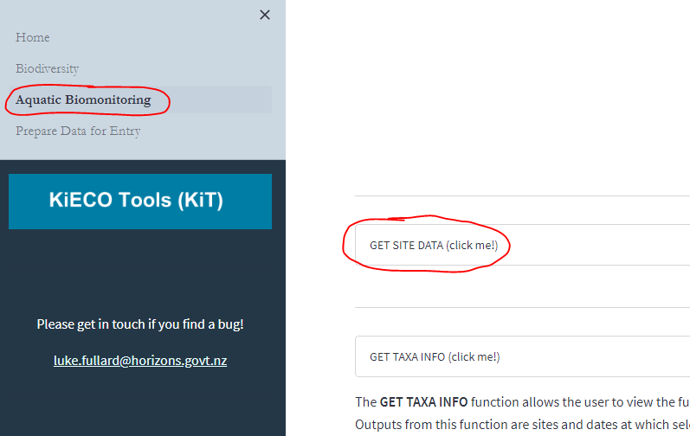

3) The periphyton programme is set up each year as its own thing, e.g. Periphyton 2008, Periphyton 2015. Therefore, you have to select all the periphyton programmes for the years you want data for. Remember the periphyton year runs December to November, so December 2020 will be in the Periphyton 2021 programme, while December 2021 will be in the 2022 programme. Tick the box for all the periphyton programmes you want, and click "update" when you're happy. You might have to scroll through the programme list (arrow, bottom right in the red circle below) to get to the periphyton programmes.

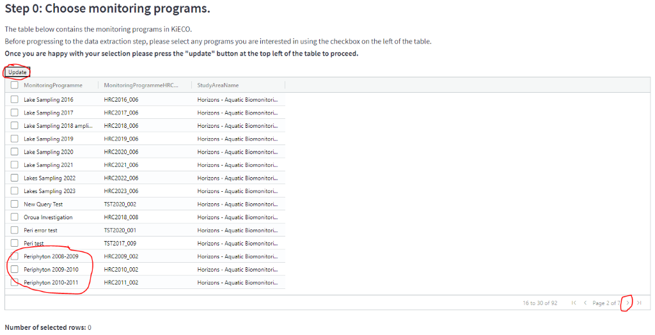

4) Next is selecting the sites. Choose how you want to select your sites. "From a list" is probably the easiest, but maps and shapefiles are also an option.

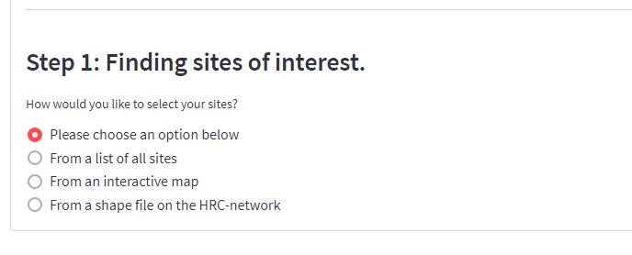

Tick the sites you want, and click "update". Again, you might have to go through a few screens to get to all the sites:

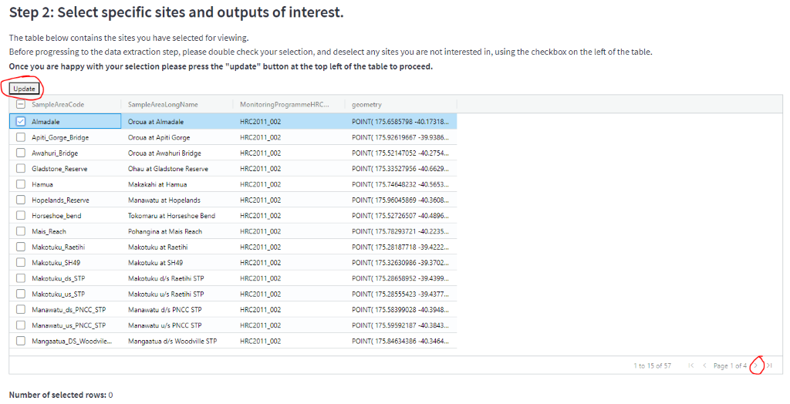

5) Finally, select your outputs. Untick "output map" if you don't need one (you probably don’t for a data request), and make sure "output site data" is selected (third option down). You can enter your start date if you want, but you'll only get data from the programmes you selected earlier. Then click on "finished, get my data" below the end date.

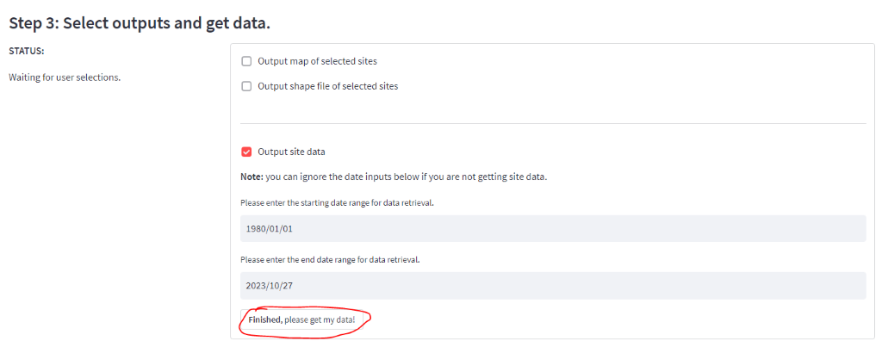

The tool will run and pull the data from KiEco. You'll know it's running when the symbols in the top right change, and the "finished" button is red. You can see the progress in the left hand area under "status". You can stop the process by clicking "stop" in the upper right hand corner:

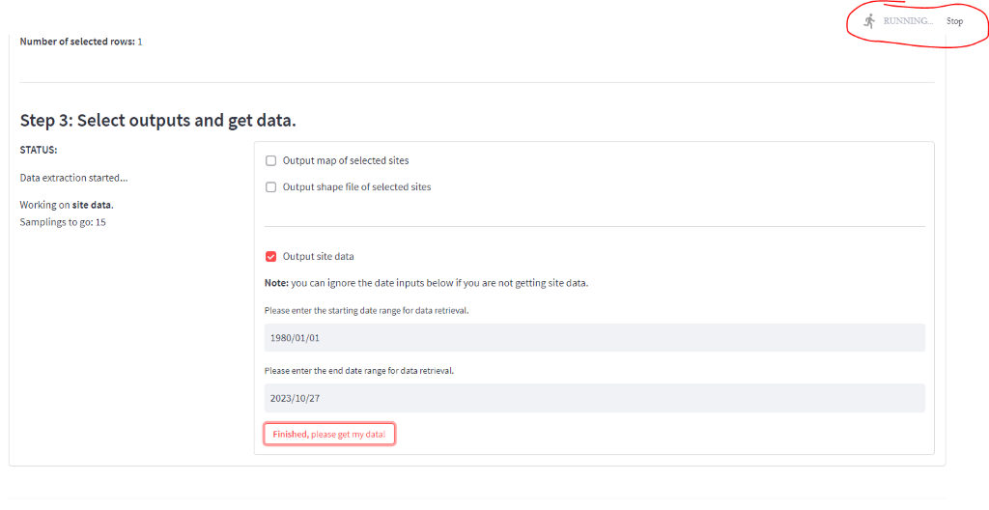

The tool is finished when the "download data" button appears in the bottom left, and you get a time in seconds under the "finished, get my data" button. Click on the "download data" button, and you should start downloading a zip file to your downloads.

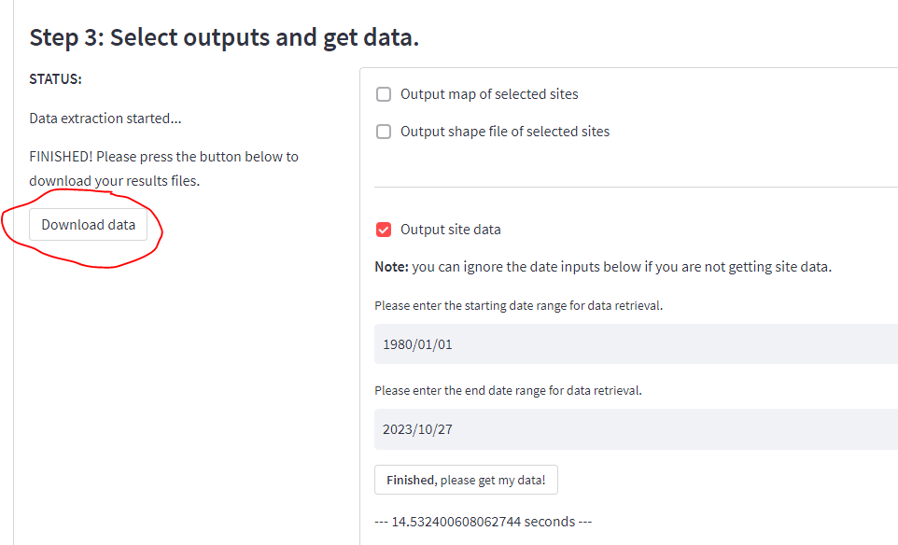

6) The data will download as a zip folder to your downloads. Copy this to the data request working folder, and rename it with the date, data request info (module id) and something like "raw\_peri\_data". This info should be available from the data request folder that Luke makes. Extract the files to the folder:

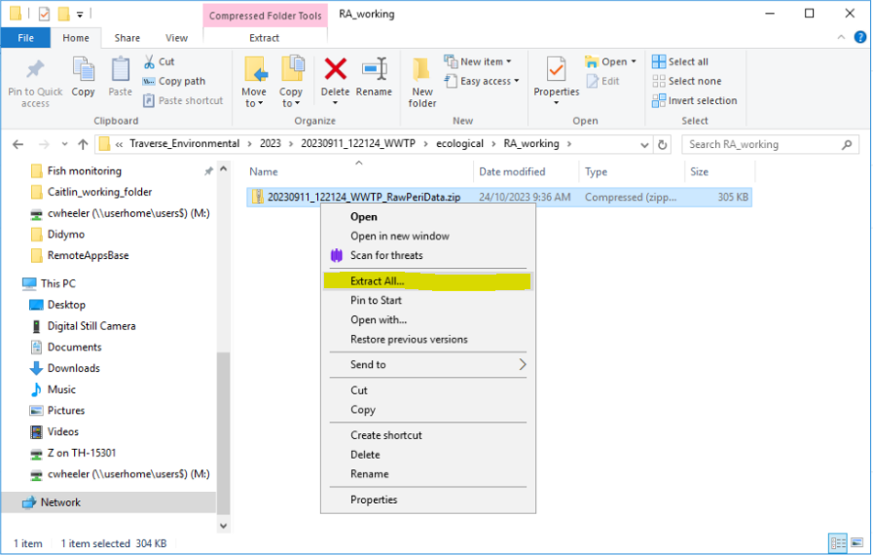

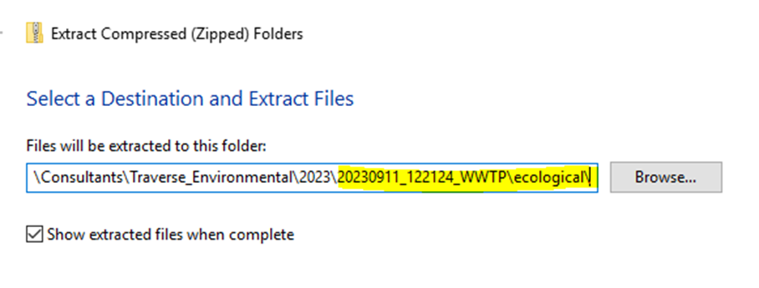

7) Check that the KiECO results spreadsheet is in the newly extracted folder, and rename it with the date, data request info and "periphyton":

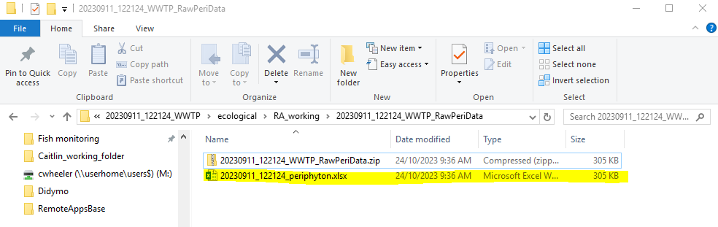Leave the original zip folder in the data request folder (just make sure it's associated with the data request and not in your personal drive that no-one else can access).

 Sense check the data

Your data spreadsheet should have eight tabs (maybe 9 if there's another metadata tab included):



8) Open the spreadsheet, and check that the correct site names are in the "site metadata" tab. You should have repetitions of site names if you're taking from multiple years of data, because you're technically querying multiple periphyton programmes. Delete any duplicates to provide a neat summary of the contained sites:

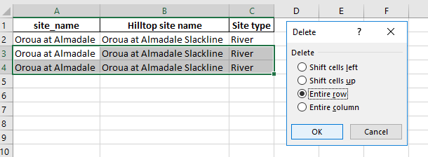

9) Check the site spatial location is there for all the sites you've downloaded. There shouldn't be any site name duplicates here. If there are, compare the coordinates and notify Luke or Ian if they are different between the sites.

10) Click on the "Unit and Spot Data" tab, and set a filter (ctrl + shift + L) on the "spot" column. If it's entirely empty, you can delete this column ONLY IN THIS TAB. Remove the filter after you're done.

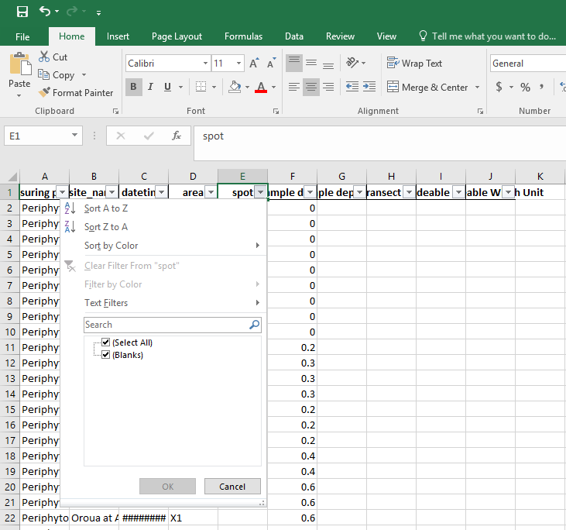

11) Click through the other tabs to make sure data is there. Check that all the site names and years are there (don't worry about every date and time). You can use the filter function to do this quickly, just remove the filters after you're done. You can also expand all the columns so that it looks nicer.

12) On the chlorophyll-a tab, filter by "units" (ctrl + shift + L) and then look through the data value numbers for each unit to see if the numbers are relatively similar/sensical. You can also highlight them all with your cursor and check the mean isn't crazy. If you get a high result (e.g. 3000 mg/L), check the views data or the chl-a of a paired site (e.g. u/s and d/s of an STP) to see if the number makes sense for that sampling instance. If there are crazy numbers, tell Ian and you can check the other data to see if the value makes sense. Remember to remove the filter once you're done (ctrl + shift + L).

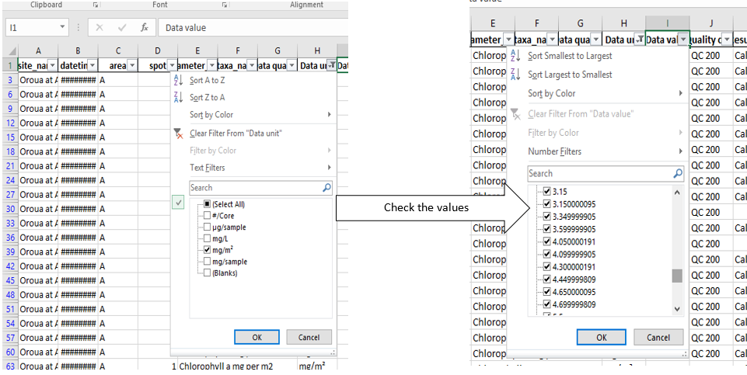

Attaching the metadata

13) If there's no "Welcome" tab, add a new tab, drag it to the far left before all the others and rename it to "Welcome". Copy this spreadsheet into the Welcome tab (click on the red circled arrow below and press ctrl + c):  [\\file\herman\E\WQ\03\05\Periphyton monitoring\Data Requests\2023\_KiEco\_metadata.xlsx](file://file/herman/E/WQ/03/05/Periphyton%20monitoring/Data%20Requests/2023_KiEco_metadata.xlsx)

MAKE SURE YOU AREN'T PASTING OVER DATA.

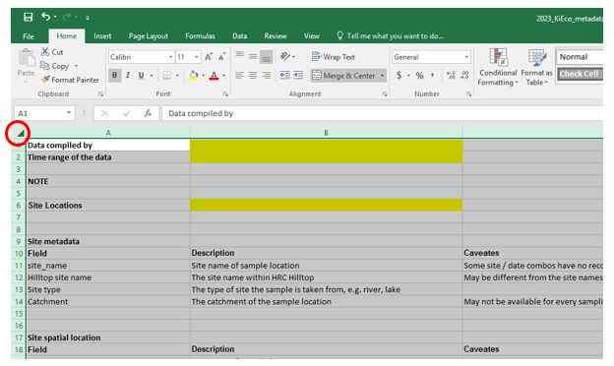

14) Fill in your name, the time range the data covers (e.g. May 2021 - May 2023), and copy in the site names to the Welcome tab:

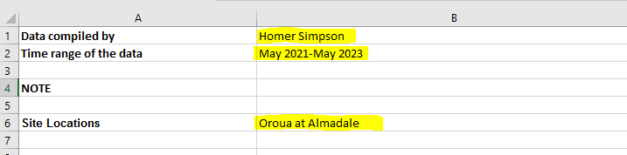

 Save your periphyton data spreadsheet.

15) You will also need to fill in a ‘data disclaimer’ sheet and save this in the same file path that the data request has been saved. This just lets the requester know that the data we have provided is true to the best of our knowledge and we cannot be held liable if it is not true.

The disclaimer is saved here: [\\ares\Environmental Data Requests\1\_Request Template\Disclaimer Supply of Environmental Data\_SmallRequests.docx](file://ares/Environmental%20Data%20Requests/1_Request%20Template/Disclaimer%20Supply%20of%20Environmental%20Data_SmallRequests.docx)

This document is for small data requests only and large periphyton requests use a different disclaimer. You only have to fill out the person who has completed the request and where you got the data from. The date should auto fill.

For "source", type "KiEco".

To get the request ID, click the back arrow in Portal:

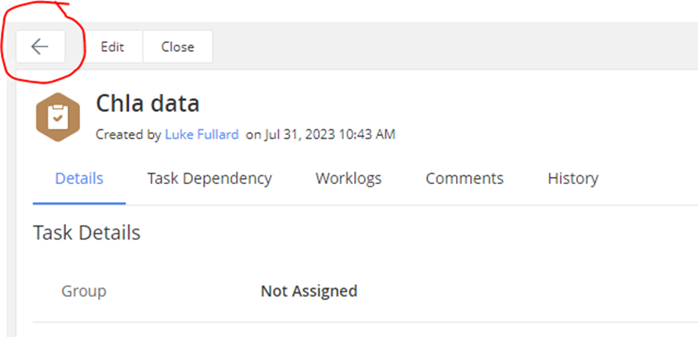

Or click on the data request (you’re most likely just working on a task within the data request):

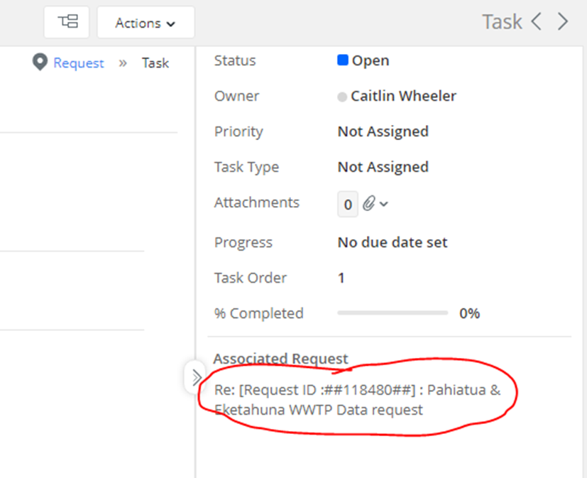

And then copy in this number:



Update the footer file path with the one for the data request:

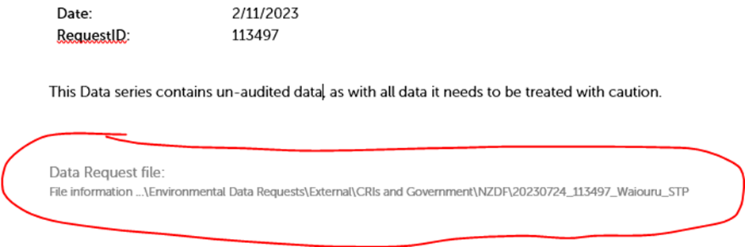

Save a copy of the disclaimer in the data request folder you're working in, and then export it as a PDF to the same folder. You should end up with two versions, but we only send the PDF:

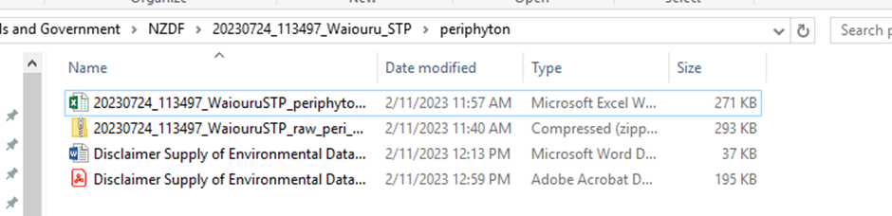

Save this in the file pathway that you have been given to save the data.

16) For sending data, refer to main data page (coming soon).

MAIN PAGE  - HERE'S THE PORTAL, HERE'S HOW IT WORKS, HERE'S HOW WE SEND DATA, CHECK WITH SIVEE AND LUKE BEFORE SENDING?

# Data – work in progress

Empty

# CADDIS

## CADDIS instructions document

CADDIS is now (and will forever be) in READ ONLY mode as at 27 May 2022. We now use KiEco.

The CADDIS instruction document can be found here [\\file\herman\E\WQ\03\10\CADDIS guides\Current CADDIS guides](file://file/herman/E/WQ/03/10/CADDIS%20guides/Current%20CADDIS%20guides)

This document provides information about creating new projects and surveys, importing data from NIWA and Cawthron, and QA steps for the periphyton and macroinvertebrate monitoring programmes.

CADDIS Database can be found here [\\file\appdata\caddis\CADDIS Database](file://file/appdata/caddis/CADDIS%20Database). Select "Caddis\_Fly 2.0.mdb" or if someone else is using this then select "Caddis\_Fly 2.0\_Backup.mdb.

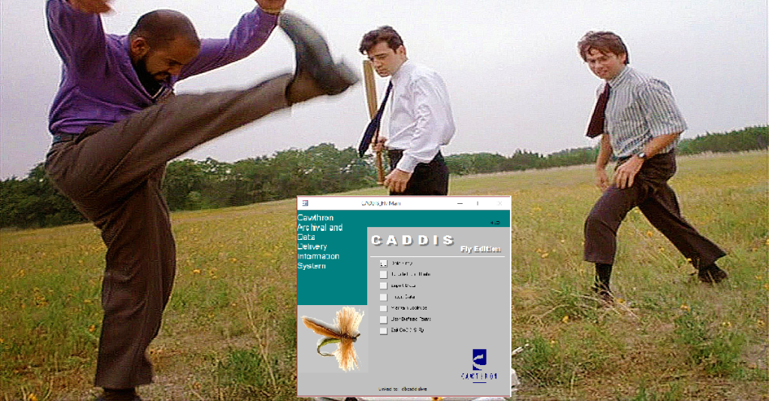

# Water Quality

## Water Quality Sampling

All of the water quality sampling is run by the ED/Hydro team and most of the information can be found in their Catchment Data Management Manual here <http://tqm.horizons.govt.nz/Hydrology/SOPs/cd_om_0.2_Contents.htm>

**Sampler**

We use Hilltop Sampler to generate a sample number for each new sample taken at a site. The instructions for this can be found here:

<http://tqm.horizons.govt.nz/hydrology/SOPs/cd_om_15.9_appendix_4_Hilltop%20Sampler%20use%20-%20how%20to%20make%20a%20run.pdf>

After the sample numbers have been generated, the sample stickers can be collected from the Hydro team.

**WQ Books**

Once the sample numbers have been generated, the site names and sample numbers need to be recorded in a water quality book associated with the correct run. These books are used to record general site observations and SmarTroll readings when taking samples.

A Laboratory Request form also needs to be filled out which is sent with the samples.

These books are kept in the Science team office (new ones can be found in the Hydro team office).

**Bottles**

The document below provides information about taking surface water grab samples and well as which bottles are used for the various water quality runs

<http://tqm.horizons.govt.nz/hydrology/SOPs/cd_om_15.6_appendix_1_surface%20Water%20Sampling.pdf>

**Black Disc and Clarity Tube**

Below are the hydrology operation manuals for black disc and clarity tube respectively. The below manuals outline sampling procedures and should be read before sampling occurs.

Black disc <http://tqm.horizons.govt.nz/hydrology/SOPs/cd_om_15.6_appendix_9_Black%20Disc%20Procedures.pdf>

Clarity tube <http://tqm.horizons.govt.nz/hydrology/SOPs/cd_om_15%206_appendix_10_Clarity%20Tube%20Procedures.pdf>

**Site Photos**

At each water quality site (that hydro doesn’t visit the same day) take some photos of the river upstream and downstream and put them in the site folder with the sample date here [\\ares\Hydrology\Water Quality Sites](file://ares/Hydrology/Water%20Quality%20Sites)

**End of Day**

All of the white forms (laboratory request and WQ book ones) are sent with the samples to the lab. All of the yellow forms are put in the Hydro office for Susan to enter the data.

## Scientist Stuff

Darren Bentley-Hewitt looks after the bulk of this profile on a day-to-day basis. Overall budgets are worked out by the Scientist.  Darren will be able to provide a list of lab costings and the frequency of sampling so that you can work out the total cost for 12 months for each site and run. Often found here [\\ares\Environmental Monitoring Programmes\Discrete WQ Administration](file://ares/Environmental%20Monitoring%20Programmes/Discrete%20WQ%20Administration)

The WQ contract is significant for HRC and gets signed off by Michael McCartney. The current contract is due to finish 30 June 2023. There is currently a tender process underway to procure a new lab contract. This is being led by Darren.  Decisions regarding WQ site changes, alterations or removals can be found here [\\ares\Environmental Monitoring Programmes\Discrete WQ Programme Changes](file://ares/Environmental%20Monitoring%20Programmes/Discrete%20WQ%20Programme%20Changes)

Bi-monthly monitoring meetings (note this info is also in peri monitoring section) regarding all things monitoring are held with Darren Bentley-Hewitt, David Brown, Pita Kinaston and the environmental monitoring scientist. These are set up and led by the Enviro scientist.

General agenda includes:

* Health and safety
* Lab
* Compliance
* General business
* Follow up anything from the last meeting

Meeting minutes can be found here [\\file\herman\E\WQ\03\05\Monitoring Meeting Minutes](file://file/herman/E/WQ/03/05/Monitoring%20Meeting%20Minutes)

**Run optimisation (note this is also in peri section)**

Work began in 2022 to optimise the monthly peri/WQ runs that science and hydro undertake. The aim was to reduce CO2 emission (by removing vehicles from the road for those runs, or allowing them to be available for other activities), increasing health and safety by double manning runs and increasing knowledge transfer between hydro and science teams.

Information can be found here [\\file\herman\E\WQ\03\05\Periphyton monitoring\Run Optimisation 2022](file://file/herman/E/WQ/03/05/Periphyton%20monitoring/Run%20Optimisation%202022)

As of March 2023 run optimisation for the northern runs (Whangaehu, Whanganui and West coast) has not taken place.

# SoE Biomonitoring (Invertebrates)

## Intro to bugs and things

**Objective**

To measure and report on the state and trends of aquatic indicators of ecosystem health at the regional level as well as the state of environment monitoring outcomes.  This project facilitates understanding of cause and effect with regard to impacts on water quality such as discharges of waste to water and land, and also land use practices on aquatic ecosystem health.

**Context**

Macroinvertebrates are present within waterways throughout the year and generally have annual life cycles. This means that they are exposed to all in-stream conditions (floods, nutrients, sediment and algae) over a period of time within a waterway. The monitoring of macroinvertebrate communities therefore provides us with an integrated indication of the health and life supporting capacity of waterways over annual time periods.  While invertebrates respond to all environmental perturbations, they are particularly good at detecting the effects of land use practices on aquatic health.

Aquatic ecosystems (as is the case with most ecosystems) are complex interconnected systems. In order to better understand the relationship between macroinvertebrates and periphyton (and in so doing, link this project with the periphyton and water quality monitoring projects) periphyton samples will be taken in conjunction with the macroinvertebrate samples.

**How it's Done**

All info can be found here \\file\herman\D\SR\03\01\Rivers\SOE Biomonitoring

Monitoring is carried out at predetermined sites on an annual basis during summer months where flow at the nearest flow-site has been less than 3 times the median flow for two weeks.

Monitoring requires a two-person team for every site sampled. Ideally there should be for two teams (four people) completing two runs concurrently, however, one two-person team is the minimum.

Below is a timeline of a "usual" invertebrate monitoring programme. The sampling programme runs over 2 calendar years with the majority of sampling being done between December and April.

The notebook is intended to follow the timeline and all relevant information can be found in the corresponding page.

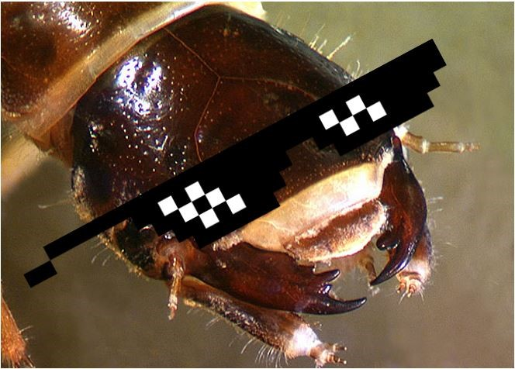

## Scientist stuff

All info can be found here [\\file\herman\E\WQ\03\05\SoE Biomonitoring](file://file/herman/E/WQ/03/05/SoE%20Biomonitoring)

Procurement

* The periphyton samples are covered by the contract that does all other monthly periphyton processing.
* Macroinvertebrate procurement needs to be organised ideally around the start of the new financial year for the following calendar year summer (I.e. start procurement in July/Aug for the upcoming Dec-Mar sampling season).
  + Current contract is with Boffa Miskell for 2023-24 and 2024-2025 sampling seasons with review for the following two seasons.
  + Procurement and contacts can be found here:
    - [\\file\herman\D\SR\01\01\Procurement\Rivers and streams\2022-2023](file://file/herman/D/SR/01/01/Procurement/Rivers%20and%20streams/2022-2023)
    - [\\file\herman\O\MS\06\07\2022-2023](file://file/herman/O/MS/06/07/2022-2023)
* The PO for the 2024-25 season is

There are two types of samples that HRC usually collects:

1) P2 samples (kick net) (all SoE samples)

2) P3 samples (surber) (only currently used for 5x samples at a single site, Turitea at Old West Rd which is a restoration site).

Purchase Orders

There will likely be the need to create purchase orders for various pieces of equipment and consumables (e.g. isopropyl).

## NEMS compliance

NEMS comparison will be done by taking an extra invertebrate sample using the sampling method set out in the NEMS. The NEMS sets out a different sampling procedure in which the kicknet samples are taken from mesohabitats proportional to the reach that we are sampling. This is different to how we have previously done it, as we usually sample only in riffle habitats. We will be doing this extra sampling at 12 sites to see how this new sampling method would potentially influence the trends of our previous sampling.

This means that there will be an extra field sheet to complete at these 12 sites (see below).

\\file\herman\D\SR\03\01\Rivers\SOE Biomonitoring\2020-2021 sampling\blank\_field\_sheet.pdf

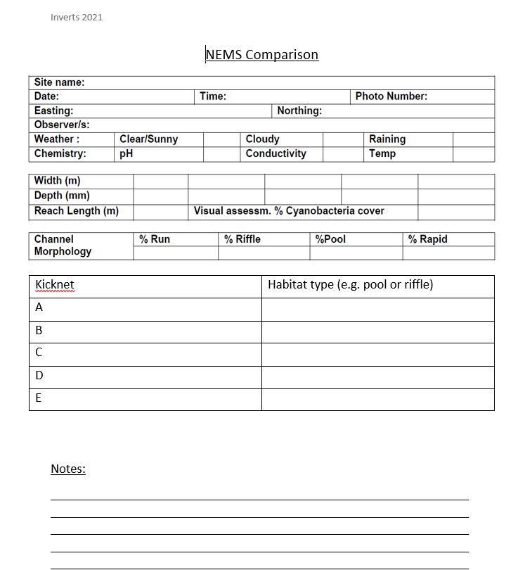

When filling in the NEMS field sheet, you will need to record the overall channel morphology but also what habitat type it is you sampled in for each 'kick', as you need to make this proportional to the channel morphology under the new guidelines. This may not always be viable, especially for sites that may have a large amount of pool habitat, as we are not able access deep pools.

## PLAN - Lab Contract, Vehicles, Staffing

**Lab Contract**

The lab contract is currently with Boffa-Miskel, and is contracted for the years 2022 – 2023 & 2023 – 2024. The contract can be found here:

\\file\herman\D\SR\01\01\Procurement\Rivers and streams\2022-2023

**Vehicles**

Vehicle availability within the science team will be the key to determining whether or not a pool vehicle has to be organised. Science vehicles should be preferred over the use of pool vehicles. Any vehicles used should be equipped with 4WD, first aid kits, and road side hazard beacons (if required).

Vehicles can be booked using the E Road booking system which can be found in the Horizons Desktop Apps (see below). It is worth checking the run guides when booking an extra vehicle from the pool because some sites might require a 4WD vehicle and not all pool cars are suitable for all sites. If the site does not exist in a run guide or you can’t find it then ask one of the team. 



**Staffing**

As there is a few sites and a limited amount of time and site suitability other team members can be called on to help sampling. Unusually it is best to have 2 teams of 2 people sampling at the same time.  Liase with other Research Associates and senior staff to organise time availability.  All staff should be trained appropriately and should attend the refresher training course

**Training**

Training for any new staff should be completed with a suitable member of staff. Ideally all new staff would be trained by the same person (Ian) to keep standards "high", but most importantly methods consistent among all samplers.  Refresher training should be done before the Christmas break at the latest. The training consist of going to a site and working through each sampling step until complete.  Ideally the site would be one of the SOE sampling sites so you have one less to do. Manawatu at Teacher college is a good site to use due to its proximity to the Victoria Ave office



## PLAN - Equipment List and Labels

The following equipment is required for invertebrate monitoring, and should be ordered and/or checked before monitoring begins (ideally any equipment that needs to be ordered should be done in July- August). If you need to order more equipment (e.g. pottles) our preferred suppliers can be found here

file:///\\file\herman\D\SR\03\01\Admin\Supplier%20List\Supply%20costs%2020120529%20costs.xls

**Equipment List:**

* Periphyton gear
  + Orange viewer
  + Rock scrubbing kit (large container, ice cream container, yellow lid, toothbrush, dishwashing brush, bottle)
  + Pottles and lids
  + Periphyton labels
  + iPad or field sheets for visual assessments
* Kick net
* Invertebrate containers (large white pottles with red lids)
* Propan-2-ol
* Invertebrate sampling sheets and pencils
* Gravelometer (for the Walman walk)
* Metal ruler (for measuring depths)
* White Plastic Tray
* PLB
* Life jackets (one per person)
* Camera
* GPS
* Chilly bin and ice packs

Propan-2-ol is ordered from thermofisher in 5L containers from .  It pays to check the level of propan-2-ol early on as ordering more can take some time.

**Accommodation**

For the northern run you will require 1 night accommodation in Ohakune and 1 in Taumaranui. The group secretary will organize this for you when you provide them the dates of sampling. This does not need to be done too far in advance. It is better to make sure the flow conditions and weather are suitable before making any decisions.

**Labels**

Invert samples need to be labeled twice. Once inside the pottle itself and once on the outside. The inside labels can be hand written on the waterproof paper with a pencil and put in the sample while the labels on the outside can be hand written on normal paper labeled and stuck on the outside.

Normal periphyton stickers can be used for the accompanying periphyton samples. These can either be hand written or printed off like normal periphyton stickers following instruction in the CADDIS part of the Notebook.

**Field sheets**

The paper we us for the field sheets is waterproof paper supplied by "rite in the rain". Books can be ordered by either going and talking to the print room, the information office (in the library) or by yourself with a PO.

Printing the field sheets:

There are 2 field sheet files that need to be printed on the above mentioned waterproof paper. There is one habitat sheet which can be found here [file:///\\file\herman\E\WQ\03\05\SoE Biomonitoring\Admin\Sampling Form\Seperate sampling form\National rapid habitat assessment protocol development for streams and rivers\_2015.pdf](file://file/herman/E/WQ/03/05/SoE%20Biomonitoring/Admin/Sampling%20Form/Seperate%20sampling%20form/National%20rapid%20habitat%20assessment%20protocol%20development%20for%20streams%20and%20rivers_2015.pdf)

And the periphyton sheet which can be found here [\\file\herman\E\WQ\03\05\SoE Biomonitoring\Admin\Sampling Form\Seperate sampling form\Invertebrate - periphyton sampling sheet.pdf](file://file/herman/E/WQ/03/05/SoE%20Biomonitoring/Admin/Sampling%20Form/Seperate%20sampling%20form/Invertebrate%20-%20periphyton%20sampling%20sheet.pdf)

The combined habitat and periphyton sheets are here

\\file\herman\D\SR\03\01\Rivers\SOE Biomonitoring\2020-2021 sampling\blank\_field\_sheet.pdf

 The following equipment is required for invertebrate monitoring, and should be ordered and/or checked before monitoring begins (ideally any equipment that needs to be ordered should be done in July- August). If you need to order more equipment (e.g. pottles) our preferred suppliers can be found here

file:///\\file\herman\D\SR\03\01\Admin\Supplier%20List\Supply%20costs%2020120529%20costs.xls

**Equipment List:**

* Periphyton gear
  + Orange viewer
  + Rock scrubbing kit (large container, ice cream container, yellow lid, toothbrush, dishwashing brush, bottle)
  + Pottles and lids
  + Periphyton labels
  + iPad or field sheets for visual assessments
* Kick net
* Invertebrate containers (large white pottles with red lids)
* Propan-2-ol
* Invertebrate sampling sheets and pencils
* Gravelometer (for the Walman walk)
* Metal ruler (for measuring depths)
* White Plastic Tray
* PLB
* Life jackets (one per person)
* Camera
* GPS
* Chilly bin and ice packs

Propan-2-ol is ordered from thermofisher in 5L containers from .  It pays to check the level of propan-2-ol early on as ordering more can take some time.

**Accommodation**

For the northern run you will require 1 night accommodation in Ohakune and 1 in Taumaranui. The group secretary will organize this for you when you provide them the dates of sampling. This does not need to be done too far in advance. It is better to make sure the flow conditions and weather are suitable before making any decisions.

**Labels**

Invert samples need to be labeled twice. Once inside the pottle itself and once on the outside. The inside labels can be hand written on the waterproof paper with a pencil and put in the sample while the labels on the outside can be hand written on normal paper labeled and stuck on the outside.

Normal periphyton stickers can be used for the accompanying periphyton samples. These can either be hand written or printed off like normal periphyton stickers following instruction in the CADDIS part of the Notebook.

**Field sheets**

The paper we us for the field sheets is waterproof paper supplied by "rite in the rain". Books can be ordered by either going and talking to the print room, the information office (in the library) or by yourself with a PO.

Printing the field sheets:

There are 2 field sheet files that need to be printed on the above mentioned waterproof paper. There is one habitat sheet which can be found here [file:///\\file\herman\E\WQ\03\05\SoE Biomonitoring\Admin\Sampling Form\Seperate sampling form\National rapid habitat assessment protocol development for streams and rivers\_2015.pdf](file://file/herman/E/WQ/03/05/SoE%20Biomonitoring/Admin/Sampling%20Form/Seperate%20sampling%20form/National%20rapid%20habitat%20assessment%20protocol%20development%20for%20streams%20and%20rivers_2015.pdf)

And the periphyton sheet which can be found here [\\file\herman\E\WQ\03\05\SoE Biomonitoring\Admin\Sampling Form\Seperate sampling form\Invertebrate - periphyton sampling sheet.pdf](file://file/herman/E/WQ/03/05/SoE%20Biomonitoring/Admin/Sampling%20Form/Seperate%20sampling%20form/Invertebrate%20-%20periphyton%20sampling%20sheet.pdf)

The combined habitat and periphyton sheets are here

\\file\herman\D\SR\03\01\Rivers\SOE Biomonitoring\2020-2021 sampling\blank\_field\_sheet.pdf

The following equipment is required for invertebrate monitoring, and should be ordered and/or checked before monitoring begins (ideally any equipment that needs to be ordered should be done in July- August). If you need to order more equipment (e.g. pottles) our preferred suppliers can be found here

file:///\\file\herman\D\SR\03\01\Admin\Supplier%20List\Supply%20costs%2020120529%20costs.xls

**Equipment List:**

* Periphyton gear
  + Orange viewer
  + Rock scrubbing kit (large container, ice cream container, yellow lid, toothbrush, dishwashing brush, bottle)
  + Pottles and lids
  + Periphyton labels
  + iPad or field sheets for visual assessments
* Kick net
* Invertebrate containers (large white pottles with red lids)
* Propan-2-ol
* Invertebrate sampling sheets and pencils
* Gravelometer (for the Walman walk)
* Metal ruler (for measuring depths)
* White Plastic Tray
* PLB
* Life jackets (one per person)
* Camera
* GPS
* Chilly bin and ice packs

Propan-2-ol is ordered from thermofisher in 5L containers from .  It pays to check the level of propan-2-ol early on as ordering more can take some time.

**Accommodation**

For the northern run you will require 1 night accommodation in Ohakune and 1 in Taumaranui. The group secretary will organize this for you when you provide them the dates of sampling. This does not need to be done too far in advance. It is better to make sure the flow conditions and weather are suitable before making any decisions.

**Labels**

Invert samples need to be labeled twice. Once inside the pottle itself and once on the outside. The inside labels can be hand written on the waterproof paper with a pencil and put in the sample while the labels on the outside can be hand written on normal paper labeled and stuck on the outside.

Normal periphyton stickers can be used for the accompanying periphyton samples. These can either be hand written or printed off like normal periphyton stickers following instruction in the CADDIS part of the Notebook.

**Field sheets**

The paper we us for the field sheets is waterproof paper supplied by "rite in the rain". Books can be ordered by either going and talking to the print room, the information office (in the library) or by yourself with a PO.

Printing the field sheets:

There are 2 field sheet files that need to be printed on the above mentioned waterproof paper. There is one habitat sheet which can be found here [file:///\\file\herman\E\WQ\03\05\SoE Biomonitoring\Admin\Sampling Form\Seperate sampling form\National rapid habitat assessment protocol development for streams and rivers\_2015.pdf](file://file/herman/E/WQ/03/05/SoE%20Biomonitoring/Admin/Sampling%20Form/Seperate%20sampling%20form/National%20rapid%20habitat%20assessment%20protocol%20development%20for%20streams%20and%20rivers_2015.pdf)

And the periphyton sheet which can be found here [\\file\herman\E\WQ\03\05\SoE Biomonitoring\Admin\Sampling Form\Seperate sampling form\Invertebrate - periphyton sampling sheet.pdf](file://file/herman/E/WQ/03/05/SoE%20Biomonitoring/Admin/Sampling%20Form/Seperate%20sampling%20form/Invertebrate%20-%20periphyton%20sampling%20sheet.pdf)

The combined habitat and periphyton sheets are here

\\file\herman\D\SR\03\01\Rivers\SOE Biomonitoring\2020-2021 sampling\blank\_field\_sheet.pdf

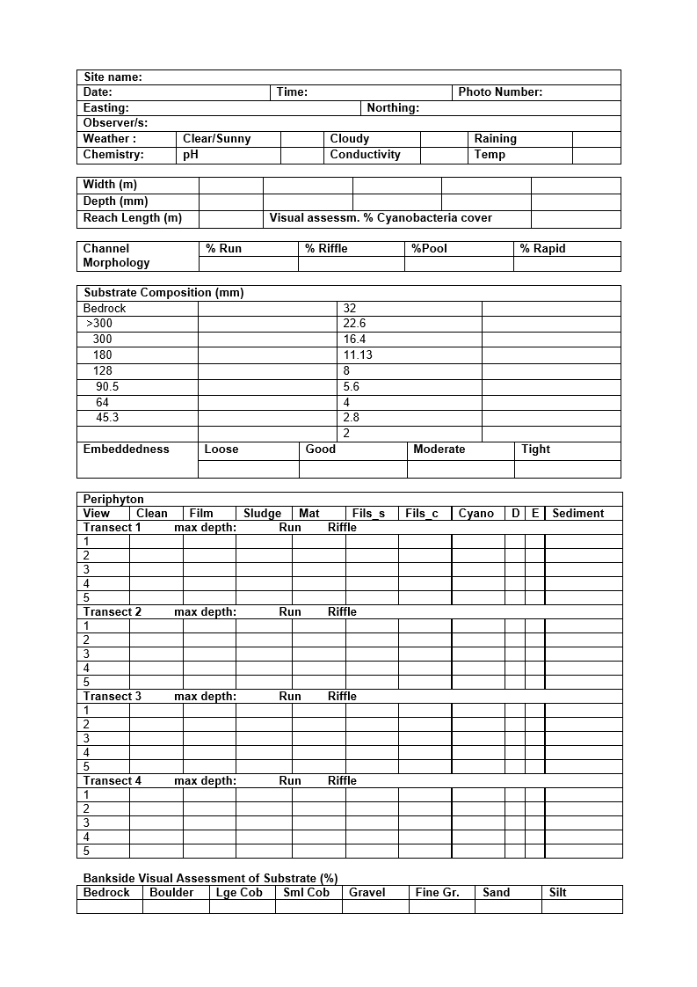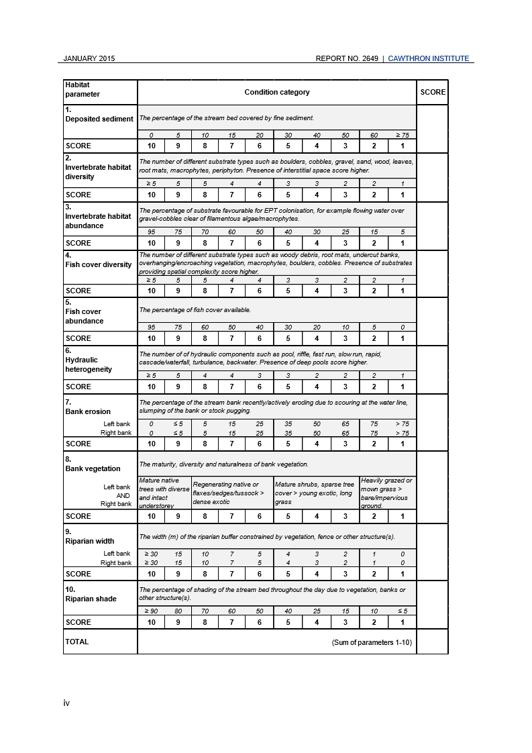

## PLAN - Run Guides, Site List, and Creating Samples in CADDIS

Before the season starts it is good to familiarize yourself with the site list and make sure then run guides are up to date and include all sites.

**Run Guides**

Run guides can be found here: \\file\herman\D\SR\03\01\Rivers\SOE Biomonitoring\Run guides\Updated Run Guides

**Site List**

Here is a site list for the 2020 Bio-Monitoring season. This list may change from year to year and will need to be updated. This site list may become useful when setting up the CADDIS survey.

|  |
| --- |
| Arawhata Stream at Hokio Beach Road |
| Hautapu at Alabasters |
| Hautapu u/s Rangitikei confluence |
| Hokio at Lake Outlet Weir |
| Kahuterawa at Johnstons Rata |
| Kahuterawa at Keebles Farm |
| Kiwitea Stream at SH54 |
| Koputaroa at Tavistock Road |
| KuKu at North Johnstone Road |
| Kumeti at Te Rehunga |
| Makahika Above Ohau Confluence |
| Makakahi at DoC Reserve |
| Makakahi at Hamua |
| Makaretu Above Ohau Confluence |
| Makorokio at Tirohanga Station |
| Makotuku at Raetihi |
| Makotuku at SH49 |
| Makotuku d/s Raetihi STP |
| Makotuku u/s Raetihi STP |
| Makuri at Tuscan Hills |
| Manakau at Cemetry |
| Manakau Stream at SH1 Bridge |
| Manawatu  at Weber Road |
| Manawatu at Hopelands |
| Manawatu at Opiki Bridge |
| Manawatu at Teachers College |
| Manawatu at Upper Gorge |
| Manawatu d/s PNCC STP |
| Manawatu u/s PNCC STP |
| Mangaatua d/s Woodville STP |
| Mangaatua u/s Woodville STP |
| Mangahao at Ballance |
| Manganaonao at Ohau West Road |
| Manganui o te Ao at Ashworth |
| Mangapapa at Troup Road |
| Mangatainoka at d/s Pahiatua STP |
| Mangatainoka at Hukanui road |
| Mangatainoka at Larsons road |
| Mangatainoka at Pahiatua Town Bridge |
| Mangatainoka at Putara |
| Mangatainoka at Scarborough Konini Road |
| Mangatainoka at SH2 |
| Mangatainoka at u/s Pahiatua STP |
| Mangatainoka u/s Tiraumea confluence |
| Mangatera at Timber Bay |
| Mangatera d/s Dannevirke STP |
| Mangatera u/s Dannevirke STP |
| Mangatewainui at Hardys |
| Mangatoro at Mangahei Road |
| Mangawhero at DoC |
| Mangawhero at Pakihi Rd Bridge |
| Mangawhero at Raupiu Rd |
| Mangawhero d/s Ohakune STP |
| Mangawhero u/s Ohakune STP |
| Ohau at Gladstone Reserve |
| Ohau at Haines Farm |
| Ohau at SH1 |
| Ohau at u/s Makahika Confluence |
| Ongarue at Taringamotu |
| Oroua at Almadale |
| Oroua at Apiti Gorge |
| Oroua at Awahuri Bridge |
| Oroua d/s Feilding STP |
| Oroua u/s Feilding STP |
| Oruakeretaki at SH2 |
| Owahanga at Branscombe Bridge |
| Patiki Stream at Kawiu Road |
| Pohangina at Mais Reach |
| Pohangina at Piripiri |
| Porewa at Onepuhi Road |
| Rangitikei at Mangaweka |
| Rangitikei at McKelvies |
| Rangitikei at Onepuhi |
| Rangitikei at Pukeokahu |
| Raparapawai at Jackson Road |
| Retaruke u/s Whanganui Confluence |
| Tamaki at Hatridges |
| Tamaki at Reserve |
| Tiraumea at Ngaturi |
| Tokiahuru at Karioi |
| Tokomaru at Horseshoe Bend |
| Turakina at O'Neils |
| Turitea at No1 Dairy |
| Waikawa at Huritini |
| Waikawa at North Manakau Road |
| Waikawa at u/s Manakau Confluence |
| Whanganui at Cherry Grove |
| Whanganui at Pipiriki |
| Whanganui at Te Maire |
| Whanganui d/s Retaruke confluence |

## PLAN – Flow Stats

Flow stats – Should We Sample Now?

http://172.29.100.109:8520/Site\_Monitoring\_Tools

Sampling at a site occurs after flows at the reference site have been below 3x median flows for 14 days. When planning which invertebrate sites to monitor on a given day you will need to check the flows at each site. For invertebrate monitoring flows are advised to be below three times median for 14 days. Flow stats can be found seen in Hilltop manager.

To start off with we need to create a spreadsheet from one used the previous year. There will be a spreadsheet titled "flow info" in the previous years folder, take this and put a copy into this year's folder. This spread sheet will contain monitoring sites and reference flow sites attributed to them; on the left hand side there will be a list of flow sites, the 3x median flow in l/s, and a space to enter the last date the site had flow over the 3x threshold. The accrual days column of the spreadsheet will calculate the days accrued since last 3x median flow based on entered data. The accrued days column need to reach 14 for the site to be suitable to sample.

To get the flow data

You will need to open Hilltop from Desktop apps. \\file\appdata\Desktop\TSFARM Horizons Desktop Apps

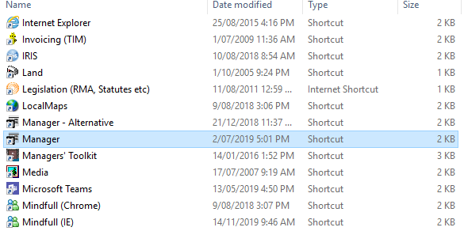

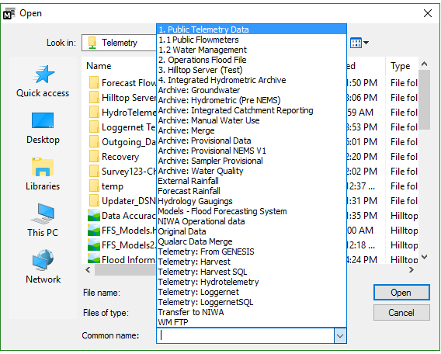

Choose file then open from the top menu, a window will pop open and from there in the common dropdown box choose 1. PublicTelemetry (fig above).

Once open, you will see a site tree on the left hand side. From the site tree find the site you require and open the flow measurement.

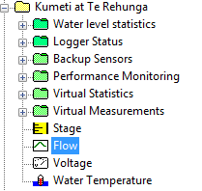

In the spreadsheet you need to update the date where the flows drop back below the 3FE2017 number. In some of the sites this number exists as a line in the Hilltop file making it easy to see. In other sites you will need to manually decipher when the flows dropped below the threshold. In the picture below you can see that this site has a 3FE line and the red circle shows where it has last gone below that line. The spreadsheet you would enter 23/07/2019. Then the formulas will let you know how many days since then and whether it is good to sample.

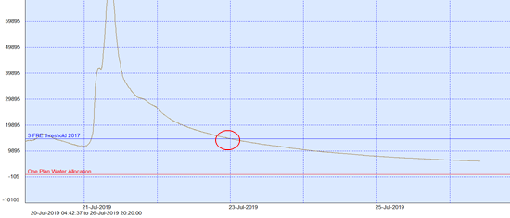

In the example you see below there is no 3FE line so the easiest way to see when the flow last went under 3FE is to click anywhere on the y axis and change the max number to the 3FE number from the spreadsheet. This will clip the graph so the highest point on the y axis is the specified value. Then you can see when the flow trace comes back into view. If the 3FE was 45000 then it is the 19/07/2019 that the flow returns to below 3FE.

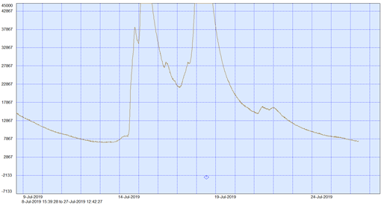

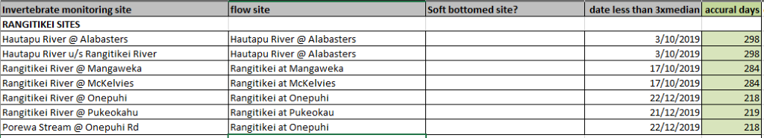

*Example of flow spreadsheet*

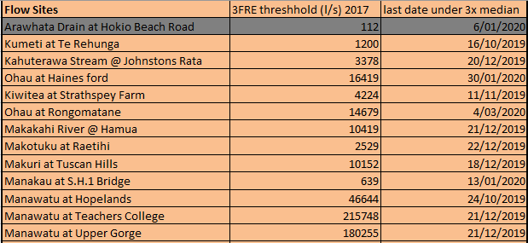

*Example of flow spreadsheet*

## DATA COLLECTION - Sample Collection and Storage

**Before Leaving the Office**

Double check you have all the right gear before you leave.

Make sure you have a check-in buddy that knows what run you are doing/sites visiting (and where to access the run guide) and what time you will be back. Please remember to txt them when you return safely.

Also start the GetHomeSafe App to track your location throughout the day. Log into [GetHomeSafe](https://www.gethomesafe.com/" \t "_blank) to see your activities. Along with setting up GetHomeSafe, take an InReach unit with you. Another app, Earthmate can be downloaded alongside the InReach units, which can be used to send messages to people to let them know you are ok or alternatively not.

**Sampling Procedure**

The current protocol for sampling is below. This uses the previously mentioned sampling field sheet and gear list.

The Macroinvertebrate NEMS can be found here: <http://www.nems.org.nz/documents/macroinvertebrates/>

The protocol for invertebrate sampling is as follows:

1. **Site information** – complete the site name, observers, date, time, GPS co-ordinates and note the weather
2. **Visual assessment** – this is just the same as a Periphyton assessment but instead of using iAuditor on the iPad enter the visual assessments on to the paper form.
3. **Walman walk** – using the gravelometer have one person work their way down the river in transects picking up rocks and measuring them using the gravelometer. The other person in the field will keep a tally of the size and number of rocks counted. You must count 100 rocks at each site. It is good to take it in turns measuring and writing.
4. **Invertebrate sample** – using the kick net and the metal ruler. The kick net should be set-up in a riffle and the depth measured using the metal ruler. The rocks that fall within the kick net area are disturbed so that the inverts are caught in the net. This should be done 5 times and the depths and widths are to be measured by the note taker.
5. **Periphyton sample -**Chla sample taken in riffle and run using 10 rock scrapings. Similar to normal periphyton samples.
6. **Habitat surveys**– complete survey.
7. **Channel morphology and bankside visual assessment of substrate** – complete these sections of the paperwork.

Current sampling protocols developed by john stark in 2001 can be found here   - [\\file\herman\E\WQ\03\05\SoE Biomonitoring\Admin\ProtocolsManual.pdf](file://file/herman/E/WQ/03/05/SoE%20Biomonitoring/Admin/ProtocolsManual.pdf)

A NEMS for macroinvertebrates came into effect from November 2020, which guides us is how to complete our Macroinvertebrate monitoring. They can be found here: <https://www.nems.org.nz/documents/macroinvertebrates/>

We are currently working on macroinvertebrate office and field manual, as well as a macoinvertebrate SOP

**Sample Storage**

**Invert samples**

All samples collected should be clearly labelled. We recommend a sticky label on the side of the sample container with information written using a permanent marker (i.e., waterproof and alcohol resistant felt pen or pencil). Reliance solely on labels on pottle lids is not recommended – lids can easily be interchanged. A label written in pencil on waterproof paper should also be placed inside the container. Labels should include site name and number, sampling date, sampler initials and container number if applicable.

Samples are preserved in isopropyl and can be sorted for 2 weeks to 6 months prior to analysis. Samples can be stored in a dark dry spot in the science shed (usually on a shelf or in a polystyrene box).

After you put the isopropanol in the sample and put the site sticker on the sample container, add the new flammable liquids label to it as well. It is saved here: \\file\herman\D\SR\03\01\Rivers\SOE Biomonitoring\Flammable Goods

Some more will need to be printed out at the start of each season in case some have been damaged when they have arrived at the lab.

**Periphyton samples**

Periphyton samples should be labeled and stored  as per the periphyton guide.

## DATA COLLECTION - Sending Samples

**Invertebrate samples**

As invertebrate samples are collected they are stored in polystyrene boxes (located in the science shed) until the boxes become full. Once a couple of boxes are full of samples email the lab and ask if they are ready to start receiving samples. If the reply is yes, then follow the following steps. You will also need to talk to Simon about sending the box, make sure he knows it holds flammable goods.

**Step 1:**

In the Habitat Data excel spreadsheet, create another tab and label it ‘Samples to be sent off’. If the Habitat Data spreadsheet has not yet been created then copy one from the previous year and delete all existing data.

**Step 2:**

Create a table for each box in the new tab with the following headings: Site, Sample Number, Date Sampled and Box. Enter the details of the samples that are ready to be sent. You should have 24 samples per table.

**Step 3:**

Print out the completed table so you can take it down to the shed and make sure you have all the correct site name and date combos.

**Step 4: Packing the box**

When checking off samples before repacking them into the box make sure the label is still legible, if not re-write the labels so that the lab can read them.

Each invertebrate pottle needs to be taped at the top to prevent spillage. Each pottle also needs a flammable goods sticker. These can be found here:

\\file\herman\D\SR\03\01\Rivers\SOE Biomonitoring\Flammable Goods

These can be printed on the same stickers as the periphyton sticker sheet

**Step 5:**

Fill out Dangerous goods declaration to go with the samples. Refer to the guide that goes with it if needed. This is needed for transportation of the ethanol preserve.

Form:

<https://phlextras.co.nz/forms/dangerous_goods/>

Guide:

<https://phlextras.co.nz/forms/dangerous_goods/dg_guide.html>

Fill in as follows as an example:

\\file\herman\D\SR\03\01\Admin\Haz Subs\Propan 2 ol resources\20180215\_Isopropanol DG declaration.pdf

DGLQ: Yes

**Shippers Details**

Company name: Horizons Regional Council

Address: 11-15 Victoria Ave, Palmerston North, 4410

Phone: your contact number

**Consignee Details**

Company Name: (lab name eg Stark)

Full Delivery Address: (lab address)

**Item details**

|  |  |  |  |  |  |  |
| --- | --- | --- | --- | --- | --- | --- |
| UN or ID | Proper Shipping Name | Class | Packing Group | Item Description | Units | Total |
| 1219 | Isopropanol | 3 | 2 | Bottles | 24 | 10L |

Flashpoint(°C): 12

Marine Pollutant: No

Quantity and Type of Packaging: 24 bottles of 440mL

Total Weight (Kg): 10 (usually around 10kg)

Check the tick box and enter your work details.

**Print 3 copies of the dangerous goods declaration for each box. One for the inside and two for the outside.**

The dangerous goods declarations on the outside of the box needs to go in a plastic sleeve that can be opened by the courier. Make sure you put 2 copies in the plastic sleeve.

They will need to be sent by road, so if going to Nelson labs will need to be sent with Post Haste which is not the usual courier and the stickers may need to be ordered in.

**Step 6:**

Print the hazardous stickers that go on the outside of each box. Theses can be found here:

\\file\herman\D\SR\03\01\Rivers\SOE Biomonitoring\Flammable Goods

**Step 7:**

Before sending the samples, a chain of custody form will also need to be filled out for each box.

The form can be found here:

\\file\herman\D\SR\03\01\Rivers\SOE Biomonitoring\Chain of custody forms

Print out one chain of custody form for each box. You can use the information you entered into the habitat data sheet to fill this out.

**Step 8:**

Print the address of the lab

**Attention: Boffa Miskell Lab (W61)**   
**Phone: 07 571 5631**   
**Toi Ohomai**   
**Windermere Campus (W61)**   
**Gate 270**   
**Windermere Drive**   
**Poike, Tauranga 3112**

**Step 9:**

Tape up the box and place an address label, 2 copies of the hazardous good declaration in a plastic sleeve and the hazardous symbols on the top of the box. Inform Simon from the mail room that you have a box at the back door needing to be sent.

Email a copy of the chain of custody forms to  [tanya.blakely@boffamiskell.co.nz](mailto:tanya.blakely@boffamiskell.co.nz)

[taxonomy@boffamiskell.co.nz](mailto:taxonomy@boffamiskell.co.nz).

Make sure they know when you are sending the samples and how many boxes they can expect

**CHECKLIST FOR SENDING MACROINVERTBREATE SAMPLES:**

1. A Chain of custody form has been made for each box you are sending. This form is printed and in each box. The forms have also been sent to the lab via email.
2. Each macroinvertebrate pottle has a readable label on it. Each one is taped at the top and has an isopropanol warning sticker.
3. There is a dangerous goods declaration inside each box
4. There are **TWO** copies of the dangerous goods declaration in a plastic sleeve taped to the top of EACH box.
5. Each box has the address taped to the top.
6. Each box has a copy of the hazardous warning logos taped to the top of each box.
7. Each box has been securely taped closed.
8. Simon knows how many boxes and what you are sending and has put courier stickers on the boxes.

**Periphyton samples**

Periphyton samples are sent per the periphyton guide to the relevant lab (Cawthron) at the end of the inverts monitoring system. The usual sample submission will be required for the samples.

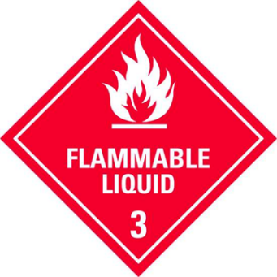



*Hazardous stickers required for each box sent*

## DATA PROCESSING - Field Data Entry

Data from the field sheets is entered in to a few different places. The habitat data is entered in to an excel spreadsheet while visual periphyton data is entered into CADDIS.

**Habitat Data**

Habitat data to be entered:

* Site, date, HRC sample number from CADDIS, time
* Wolman Size index
* Channel composition
* Habitat scores
* Bankside visual assessment of substrate (%)

The 2020 habitat data file, for example, can be found here:

[\\file\herman\E\WQ\03\05\SoE Biomonitoring\2019-2020 sampling\2020 Habitat Data.xls](file://file/herman/E/WQ/03/05/SoE%20Biomonitoring/2019-2020%20sampling/2020%20Habitat%20Data.xls)

You can duplicate this spreadsheet for the following years.

If there is any missing data in the field sheets when you come to enter them you will need to check with the field team and fill in the blanks, or enter ND

**Visual Data**

The date, time co-ordinates, weather, max. depth of the transects, embeddedness, substrate and visual assessment data are entered in to CADDIS. Follow the guide to CADDIS data entry

[file:///\\file\herman\E\WQ\03\10\CADDIS guides\Current CADDIS guides](file://file/herman/E/WQ/03/10/CADDIS%20guides/Current%20CADDIS%20guides)

The relevant section is **‘How to enter SoE Biomonitoring data in CADDIS**’ (pages 38 to 43). Once all the data from the field sheets has been entered you will need to scan and file the hard copies. The scanned copies are saved here: in the years sampling folder inside a folder called Field sheets. The data will then go through QA

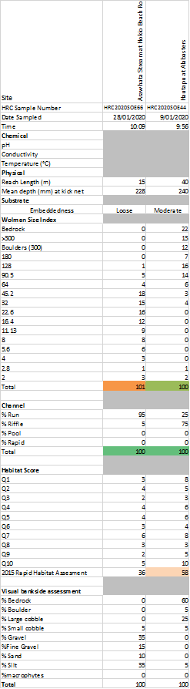

*Example of Habitat Data*

## DATA PROCESSING - Lab Data Entry

The data provided by the lab is entered into the CADDIS database. There will be two types of data coming from two different labs, Chla and pheophytin from NIWA and Macro data from Stark Environmental.

 Details on how to enter the data can be found in the  sections 4.2.8 (***Chl a and Pheophytin***) and 4.2.9 (***Macroinvertebrate Data***) in the CADDIS Instruction document [file:///\\file\herman\E\WQ\03\10\CADDIS guides\Current CADDIS guides](file://file/herman/E/WQ/03/10/CADDIS%20guides/Current%20CADDIS%20guides)

## DATA PROCESSING - Data QA

Once the field sheet data (both habitat and periphyton visual data) has been entered a 10% subset will be QAed. This should be done by someone else in the team.  If there are errors in the 10% then the entire data set needs to be checked as the 10% was to check that there were no errors. Follow the ***SOE QA section*** in CADDIS for instructions on data checks.

[file:///\\file\herman\E\WQ\03\10\CADDIS guides\Current CADDIS guides](file://file/herman/E/WQ/03/10/CADDIS%20guides/Current%20CADDIS%20guides)

[x](file://file/herman/E/WQ/03/10/CADDIS%20guides/Current%20CADDIS%20guides/20201126%20CADDIS%20instructions.docx)

This folder has a QA form to fill out for SoE to show that the QA has been done by this person on this day and these were the mistakes that have now been fixed etc...\\file\herman\E\WQ\03\10\Caddis Outputs\Data QA

## REPORTING- LAWA and SoE Reporting

**LAWA**

In approximately June LAWA (Land Air Water Aotearoa, a national database) will put in a request for all of our data. We need to add the previous years invertebrate data to this data set. As well as data for any new sites that may now meet the 5 year minimum requirements. Communicate with the water quality scientist or LAWA coordinator about the requirements for the current year. Someone from your team maybe nominated as the Macroinvertebrate contingent and will need to provide weekly checks on data to ensure that it is working.

In terms of providing the data this will need to be retrieved from CADDIS and then formatted in a spreadsheet to follow this format. Ensure that you use the correct names of sites or there will be issues later down the line.

[file:///\\ares\Environmental%20Data%20Requests\LAWA%20-%20EMaR\Water%20Quality\2019%20Request\Data\Inverts.csv](file://ares/Environmental%20Data%20Requests/LAWA%20-%20EMaR/Water%20Quality/2019%20Request/Data/Inverts.csv)

Then follow these instructions to unpack the data and get it ready for HILLTOP.

[file:///\\ares\Environmental%20Data%20Requests\LAWA%20-%20EMaR\Water%20Quality\Instructions\Import%20Macroinvertebrate%20Data.docx](file://ares/Environmental%20Data%20Requests/LAWA%20-%20EMaR/Water%20Quality/Instructions/Import%20Macroinvertebrate%20Data.docx)

Finally copy the file that is produced into HILLTOP. Once it is in HILLTOP check that the sites that you think should be there are there. Let the LAWA coordinator or the nominated data analyst from the science team of Environmental Data know that the Hilltop file is ready and they will updated it so that LAWA can access it.

**GIS**

GIS can be used to map some MCI and other macro data.

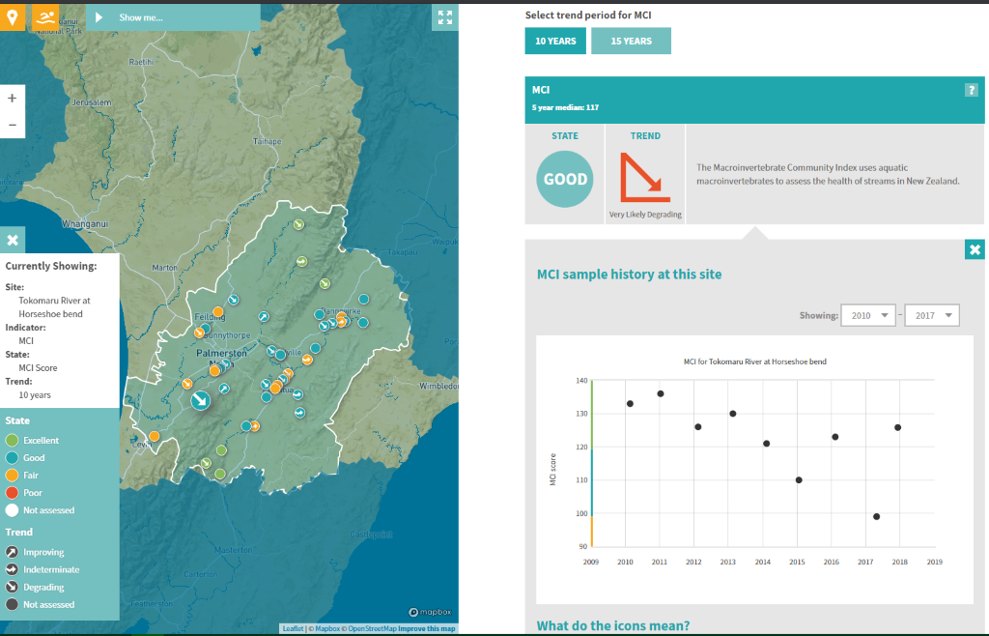

*Example of LAWA Macroinvertebrate data*

# Fishing

## Introduction to fishies

Part of Horizons Regional Council Requirements include the monitoring of freshwater fish species within our region’s borders, to determine the health of both the fish species themselves and as an indicator of water quality within the region. As a brief overview, fish surveys previously carried out in the Horizons Region have been carried out as either a part of the State of the Environment (SoE) monitoring programme which monitors and tracks the health of our regions waterways, or by targeting Site of Significance – Aquatic (SoS – A) sites to monitor those sites within our region recognized for their regionally significant fish species.

The fish monitoring programme is split into three different categories. All info can be found here:

[\\file\herman\E\WQ\03\05\Fish monitoring](file://file/herman/E/WQ/03/05/Fish%20monitoring)

* Mudfish
* SoE/SoS-A
* Inanga spawning

Below is the Gantt chart which gives an overview of when various activities are undertaken.

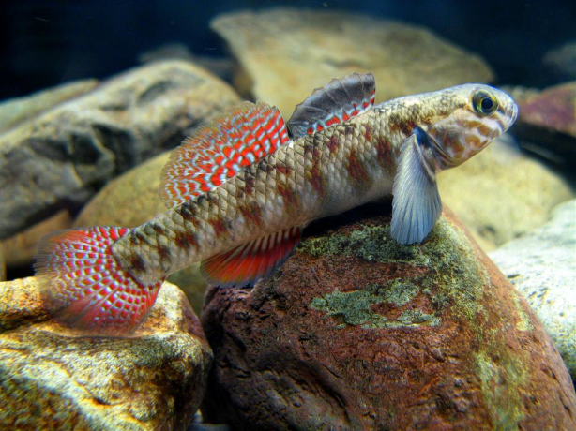

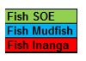

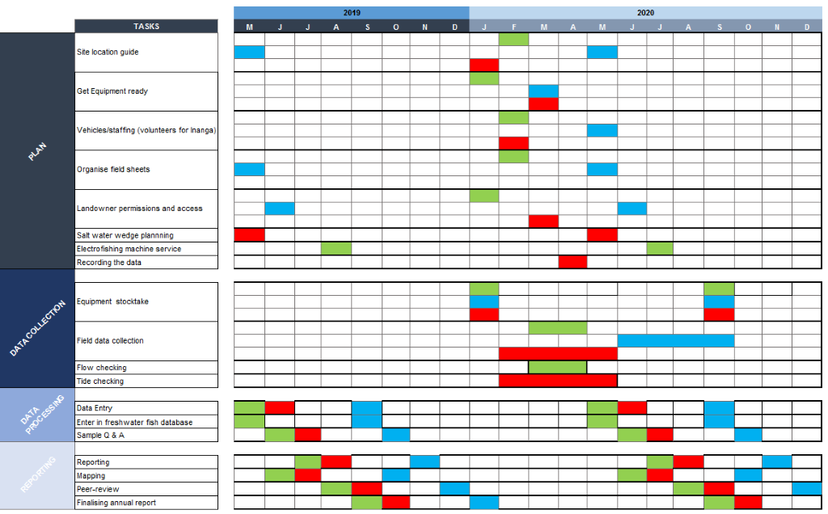

## Scientist stuff

All info can be found here:

[\\file\herman\E\WQ\03\05\Fish monitoring](file://file/herman/E/WQ/03/05/Fish%20monitoring)

**Electric-fishing**

Ensure that e-fishing machines are sent off in approx October for revalidation and certification (see Gear Checks page for more details). Note that Fish Passage use our second machine which is stored at Kairanga. Ensure everyone that needs to be certified has been on a fishing course (usually done with NIWA).

**Iwi liaison**

This is particularly relevant for mudfishing sites which are often on iwi owned or DOC land. Ensure that sites that the process for organising mudfishing sites begins in April each year for Aug/Sept sampling. This provides enough time to liaise with landowners, iwi and DOC to ensure that everyone is able to participate as appropriate.

**Mudfishing – working with fish passage team**

Mudfishing is also undertaken by the Fish Passage team. The science team monitor 'known sites' and then some 'exploratory sites' if there is time whereas the Fish Passage team tend to monitor 'exploratory sites' only. It is important to communicate who is doing what during the season so that there is no overlap.

There was an exercise completed in 2020 that identified new exploratory locations. Information for different regions can be found here: [\\file\herman\E\WQ\03\05\Fish monitoring\Mudfish\Mudfish sites that intersect with BioD sites\Potential\_mudfish\_sites](file://file/herman/E/WQ/03/05/Fish%20monitoring/Mudfish/Mudfish%20sites%20that%20intersect%20with%20BioD%20sites/Potential_mudfish_sites). This provides a list of potentially suitable habitats in Horowhenua and Tararua districts. Ideally, both teams would start working through these sites to explore first. Calling landowners etc is important to get an idea of whether or not these areas would be suitable prior to heading out there.

**Buying catbiscuits for mudfishing**

HRC has a New World card which can be used to buy items from New World. This can be picked up from Finance. You will still require a PO and a receipt from New World. Write the PO number on the receipt and drop both the card and the receipt back to finance once finished.

## NIWA Fish Passage App

Google account for NIWA citizen science fish passage app details:

[Science.horizonsRC@gmail.com](mailto:Science.horizonsRC@gmail.com)

Password: 4321LargeEels

SOP for using the app:

[\\file\herman\E\WQ\03\05\Fish monitoring\Jobs For Nature\Reference files, permits and forms\Standard Operation Procedures (SOPs)](file://file/herman/E/WQ/03/05/Fish%20monitoring/Jobs%20For%20Nature/Reference%20files,%20permits%20and%20forms/Standard%20Operation%20Procedures%20(SOPs))

## Mudfish Fishing

**Before Leaving the Office**

Read the mudfishing SOP found here:

[\\file\herman\E\WQ\03\05\Fish monitoring\Mudfish\Admin\20212907\_Mudfishing\_SOP\_Final.docx](file://file/herman/E/WQ/03/05/Fish%20monitoring/Mudfish/Admin/20212907_Mudfishing_SOP_Final.docx)

Double check you have all the right gear before you leave.

Make sure you have a check-in buddy that knows what run you are doing/sites visiting (and where to access the run guide) and what time you will be back. Please remember to txt them when you return safely.

Also start the GetHomeSafe App to track your location throughout the day. Log into [GetHomeSafe](https://www.gethomesafe.com/" \t "_blank) to see your activities. Along with setting up GetHomeSafe, take an InReach unit with you. Another app, Earthmate can be downloaded alongside the InReach units, which can be used to send messages to people to let them know you are ok or alternatively not.

**PLAN - Site Selection**

Mudfish are typically monitored between June and September when it is wet.  Below is the list of known mudfish sites. The sites are sampled on a rolling basis of about 4-5 sites a year plus a few exploratory sites. If a known site has been done in the previous year and no mudfish were found it is to be re-done in the following year. If a site has been done in the previous year and mudfish were found then choose another site that has been done less recently. A full list of known and exploratory sites can be found here (be sure to check the most recent years folder for a site list as there may be new exploratory sites added) [\\file\herman\E\WQ\03\05\Fish monitoring\Mudfish](file://file/herman/E/WQ/03/05/Fish%20monitoring/Mudfish). When looking for new exploratory sites, email the FW team and the Biodiversity team as they may have some suggestions. **Ensure that you are not crossing over with the Fish Passage team who also look at exploratory sites for us.**

There was an exercise completed in 2020 that identified new exploratory locations. Information for different regions can be found here: [\\file\herman\E\WQ\03\05\Fish monitoring\Mudfish\Mudfish sites that intersect with BioD sites\Potential\_mudfish\_sites](file://file/herman/E/WQ/03/05/Fish%20monitoring/Mudfish/Mudfish%20sites%20that%20intersect%20with%20BioD%20sites/Potential_mudfish_sites). This provides a list of potentially suitable habitats in Horowhenua and Tararua districts. Ideally, through both the Sci and FP teams we would start working through these sites. Calling landowners etc is important to get an idea of whether or not these areas would be suitable prior to heading out there.

* Ashhurst Domain
* Knottingly Swamp
* Koputaroa Wetland
* Lake Herbert
* Lake Papitonga/Waiwiri
* Makerua Wetland
* No. 1 Line Wetland **needs run guide**
* Omarupapako (Round Bush) Scenic Reserve
* Tutaenui Stream (trib) **needs run guide**
* Whitiki Swamp **needs run guide**
* Foxton Loop?

Site location guides for the known mudfish sites can be found here [\\file\herman\E\WQ\03\05\Fish monitoring\Mudfish\Mudfish Run Guides](file://file/herman/E/WQ/03/05/Fish%20monitoring/Mudfish/Mudfish%20Run%20Guides)

**PLAN - Equipment List**

If you need to order more equipment (e.g. minnow traps or ropes etc) our preferred suppliers can be found here [file:///\\file\herman\E\WQ\03\05\Supplies\Supply%20costs%2020120529%20costs.xls](file://file/herman/E/WQ/03/05/Supplies/Supply%20costs%2020120529%20costs.xls). Essentially just ring the company and order however many things you need to order – make sure to confirm the price including freight and GST so that Mike can adjust the PO. Mike will also provide you with a PO to give to the company. Some things (e.g. cat biscuits etc) can be purchased from the supermarket using Mike's work card.

* Gee-minnow traps, clips and ropes (x20)
* Stakes for securing the traps
* Fluorescent tape
* Cat biscuits (seafood sensation flavour)
* At least 2 buckets (one for measuring and one for recovery)
* Measuring board
* Camera/phone
* GPS
* Field sheets and clipboard
* Pencil/Pen
* Waders
* Rain jacket (useful even if it isn't not raining because often get muddy and wet!)

**PLAN - Field Sheets**

Field sheets can be found here [\\file\herman\E\WQ\03\05\Fish monitoring\Mudfish\Mudfish Sampling Sheet.pdf](file://file/herman/E/WQ/03/05/Fish%20monitoring/Mudfish/Mudfish%20Sampling%20Sheet.pdf)

Print them double sided onto water proof paper.

**PLAN – Landowner Permissions and Access**

Some sites will require landowner permission before they can be accessed. Contact details for known and exploratory sites can be found here file:///\\file\herman\D\SR\03\01\Rivers\Fish%20Monitoring\Mudfish\Landowner%20Contact%20Details%20-%20Mudfish%20Sites.xlsx

**DATA COLLECTION – Field Data**

Mudfish monitoring occurs over two days. In the afternoon of day one, the traps are set and left overnight. First thing the next morning these traps are taken out. Mudfish traps should not be left in the water for longer than 24 hours due to the risk of predatory fish entering the traps with the mudfish and the risk of mortality.

To set the mudfish traps place a small handful of cat biscuits in one half of the trap. Attach the two halves together using a clip (which keeps the trap closed) and rope that has florescent tape attached. The tape helps you to identify where the traps are located. Failing that you should have some extra rope to tie the two halves of the trap together. There should be 20 traps used for each monitoring site.

To install the gee-minnows, find a suitable location (refer to the mudfish monitoring guide here

\\file\herman\D\SR\03\01\Rivers\Fish Monitoring\Mudfish[\Methodology to survey and monitor New Zealand mudfish species.pdf](file://file/herman/E/WQ/03/05/Fish%20monitoring/Mudfish/Methodology%20to%20survey%20and%20monitor%20New%20Zealand%20mudfish%20species.pdf)) and submerge the trap into the water. It is important that the top half of the trap remains of the water so that air flow is maintained and the entrance holes to the traps are under the water level. If the water is deeper you can use the rope to tie the trap to a tree/stake so that it remains out of the water. Make sure to tie each trap to a branch or tree so that the florescent take is visible. This will help you to relocate the traps the next day. As you install the gee-minnows, record the GPS coordinates.

The next day, collect each trap individually. Put a small amount of water in the bucket in preparation for finding some fish. If there are fish in the trap (ideally mudfish!) carefully transfer them to the bucket then measure them individually and put them back into the habitat that you found them.

TAKE PHOTOS of the fish you catch and of the environment itself so that they can be  used in the end of year report.

Before the traps can be used again at another site they need to be given a thorough wash. This can be done at the Kairanga depot. After washing them, place them overnight into a small wheelie bin with detergent to denature any nasties (this can be done at Regional House). Don't forget to rinse them once you take them out of the detergent.

**DATA PROCESSING – Data Entry**

Mudfish data per site are entered into an Excel spreadsheet. The template is located here [\\file\herman\E\WQ\03\05\Fish monitoring\Mudfish\Mudfish Data Template.xlsx](file://file/herman/E/WQ/03/05/Fish%20monitoring/Mudfish/Mudfish%20Data%20Template.xlsx) and should be renamed to *Mudfish Data Year*, e.g. Mudfish Data 2020 and saved to the relevant years folder

The data should also be entered into NIWA's NZ Freshwater Fish Database (NZFFDB). Log into NZFFDB <https://nzffdms.niwa.co.nz/> using the Horizons login:

* Username: HorizonsRC
* Password: fishDB515

Enter all of the data from the field sheet; when you come to the final page the website will ask if you want to submit the information. Note down on the field sheet that you have entered the data into NZFFDB and record the NZFFDB number on the sheet that the website has generated. Then click *Submit*.

See this document for a checklist of all the necessary steps and procedures that need to be completed prior to disposing of fish survey field sheets [\\file\herman\E\WQ\03\05\Fish monitoring\Fish Fieldsheets Data Entry Protocols](file://file/herman/E/WQ/03/05/Fish%20monitoring/Fish%20Fieldsheets%20Data%20Entry%20Protocols)

**DATA PROCESSING – Data QA**

Once the field sheet data has been entered another member of the team will need to QA a 10% subset.

**REPORTING – Data Mining and Analysis**

We write a report of the sites that we sampled during that season and the results. There is a 'template' which is used. This can be found in the mudfish folder under the previous years data. E.g. for the 2021 report – go into the 2020 mudfish folder and copy the 2020 report into the 2021 mudfish folder and make your edits from there.

For each site you will do a brief summary of the time, samplers, site vegetation, any relevant comments, number and size class of fish caught and add some relevant photos.

**REPORTING – GIS Mapping**

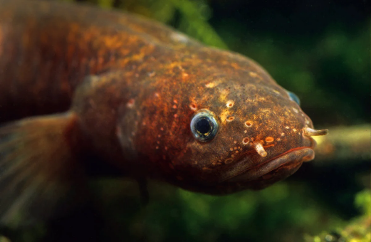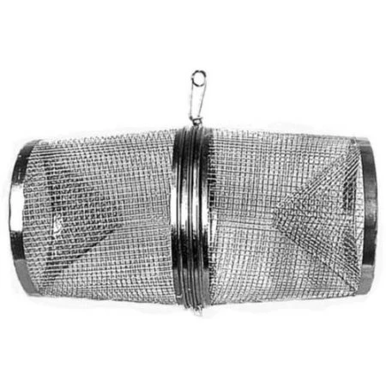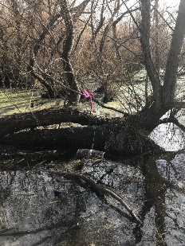

Data Entry – GPS coordinates

Using: <https://www.geodesy.linz.govt.nz/concord/>

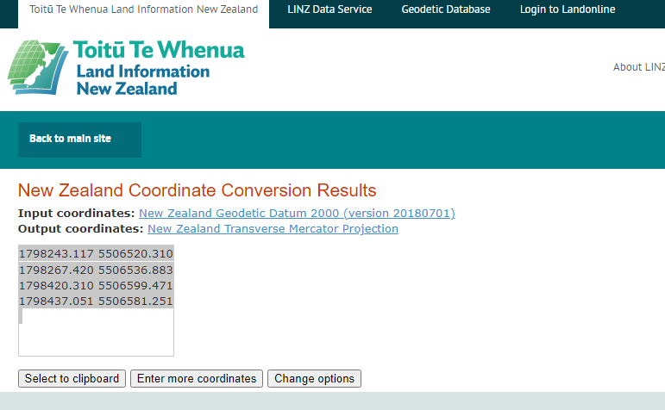

## SoE Fishing

**Start of Season**

At the start of each SoE Monitoring season, there are a few things that need to be completed to make sure the season runs smoothly. This includes: checking all gear (e.g. no holes in any nets etc.), making sure that there are trained/experienced people in the team that know what they are doing and have awareness of different situations, have sent the electric fishing machines for gear checks (see gear checks section) and there is a planned trainer/refresher day planned to be completed with the monitoring scientist.

There is a new form that can be used to assess each team members competency levels with field work, which can be found here: \\file\herman\E\WQ\03\05\Fish monitoring\2022

This form makes sure that everyone is following the correct protocols and making sure that sampling is completed to the correct standard while taking health and safety into account. The form is currently "valid for three years", but this could be changed to it being completed every year, especially for new people to make sure that they know that they are doing and are following the same procedures as everyone else, as well as gaining experience and confidence.

**Before Leaving the Office**

Double check you have all the right gear before you leave. Make sure you have a check-in buddy that knows what run you are doing/sites visiting (and where to access the run guide) and what time you will be back. Please remember to txt them when you return safely. Also start the GetHomeSafe App to track your location throughout the day. Log into [GetHomeSafe](https://www.gethomesafe.com/" \t "_blank) to see your activities. Along with setting up GetHomeSafe, take an InReach unit with you. Another app, Earthmate can be downloaded alongside the InReach units, which can be used to send messages to people to let them know you are ok or alternatively not.  Electrofishing requires a minimum of a three-person team (it can be done with two people but work is very slow). All staff are required to have a valid Comprehensive First Aid certification and only those with suitable training are able to operate the electrofishing machine. The HMP for electrofishing can be found on the HUIA and should be read by each staff member before electrofishing.

<https://horizonsregionalcouncil.sharepoint.com/ControlledDocuments/Forms/AllItems.aspx?id=%2FControlledDocuments%2FHMP%2023%20%2D%20Use%20of%20Electrical%20Appliances%2Epdf&parent=%2FControlledDocuments>

**PLAN - Site Selection**

Currently there are 12 sites that are monitored every year as part of the SoE monitoring programme. There are also 58(92) SoS-A sites (excluding Brown Mudfish or Dwarf Galaxias) that are on a rotation which can be found here [\\file\herman\E\WQ\03\05\Fish monitoring\SoE and SoS A fish monitoring sites.xls](file://file/herman/E/WQ/03/05/Fish%20monitoring/SoE%20and%20SoS%20A%20fish%20monitoring%20sites.xls)

* Arawhata at Hokio Beach Rd
* Hokio at lake outlet at weir
* Kahuterawa at Johnstons Rata
* Mangapapa at Troup Rd Bridge
* Mangatera confluence at Timber Bay
* Owahanga at Branscombe Bridge
* Patiki at Kawiu Road (75m downstream the culvert, 75, upstream the culvert; call the cattery and let them know we’ll be there/confirm that we can park in their driveway https://www.pussywillowcats.co.nz/)
* Porewa at Onepuhi Rd (start just above the bridge, measure 150m upstream)
* Tamaki at Reserve (measure 150m downstream of the SOE peri site)
* Tokomaru at Horseshoe bend (measure 150m upstream from the pool at the bottom of the SOE reach, by the cliff)
* Waikawa at Nth Manakau Road (measure 150m upstream of the pool below the cascade/riffle, walking downstream from the SOE peri site)
* Kumeti at Te Rehunga (measure 75m below the dam and 75m above the dam)

**PLAN - Equipment List**

If you need to order more equipment (e.g. gloves, nets etc) our preferred suppliers can be found here [file:///\\file\herman\E\WQ\03\05\Supplies\Supply%20costs%2020120529%20costs.xls](file://file/herman/E/WQ/03/05/Supplies/Supply%20costs%2020120529%20costs.xls). Essentially just ring the company and order however many things you need to order – make sure to confirm the price including freight and GST so that Mike can adjust the PO. Mike will also provide you with a PO to give to the company. Some things (e.g. buckets, containers etc) can be purchased from the supermarket using Mike's work card.

* Electric fishing machine
* Wand
* Large and small anodes (screws and screw driver to go with it)
* Batteries (charged) at least 2
* Waders (chest waders suggested in HMP)
* Nets
* Buckets
* Measurer
* Camera
* GPS
* Field sheets
* Pencil/pen/something to write on like a clipboard
* Flagging tape
* Tape measure (to measure each reach 15m min)

**PLAN - Field Sheets**

Field sheets can be found here [\\file\herman\E\WQ\03\05\Fish monitoring\Admin\Electric fishing survey sheet.pdf](file://file/herman/E/WQ/03/05/Fish%20monitoring/Admin/Electric%20fishing%20survey%20sheet.pdf)

Print them double-sided on water proof paper. Science Copier/RH printer prints on the face-up side of the page in the paper tray, e.g. whatever side is facing up in the tray is what will be printed on. Put the field sheets printed side down for side 2.

**PLAN – Landowner Permissions and Access**

Make sure you check if you require landowner permission to access the sites. The General Environmental Monitoring group in Teams has a [Site Contact List](https://teams.microsoft.com/_#/xlsx/viewer/teams/https:~2F~2Fhorizonsregionalcouncil.sharepoint.com~2Fsites~2FgTeam_EnvironmentalMonitoring~2FShared%20Documents~2FGeneral~2FSite%20Contact%20List.xlsx?threadId=19:6dc901ead6384c909351b43c24f29f59@thread.tacv2&baseUrl=https:~2F~2Fhorizonsregionalcouncil.sharepoint.com~2Fsites~2FgTeam_EnvironmentalMonitoring&fileId=75eeb176-d14f-439f-8301-b166f3ea931d&ctx=files&rootContext=items_view&viewerAction=view) for the majority of the sites we visit on a regular basis. This is likely to have contacts for some of the SoE sites and some of the SoS-A sites.

There is also a Landowner contact sheet here [\\file\herman\E\WQ\03\05\Fish monitoring\Landowner contacts.xlsx](file://file/herman/E/WQ/03/05/Fish%20monitoring/Landowner%20contacts.xlsx)

**DATA COLLECTION – Field checks (vault notify)**

There is a form on vault check that can be used to complete site assessments at a site before electrofishing commences called 'Electrofishing Job Safety Analysis'. This form takes you through the common hazards that may be in the stream that would have a negative impact on health and safety while completing monitoring. This can be done before fishing starts when you get to the site.

**DATA COLLECTION – Field Data**

Currently we follow the electro-fishing methodology described by NIWA which can be found here

<https://niwa.co.nz/static/web/New_Zealand_Freshwater_Fish_Sampling_Protocols.pdf>

In future, the NEMS protocols will provide a standardized method for fish monitoring which will be able to be found here <http://www.nems.org.nz/documents/>

**DATA PROCESSING – Data Entry**

The data should be entered into NIWA's NZ Freshwater Fish Database (NZFFDB). Log into NZFFDB <https://nzffdms.niwa.co.nz/> using the Horizons login:

* Username: HorizonsRC
* Password: fishDB515

Enter all of the data from the field sheet; when you come to the final page the website will ask if you want to submit the information. Note down on the field sheet that you have entered the data into NZFFDB and record the NZFFDB number on the sheet that the website has generated. Then click *Submit*.

See this document for a checklist of all the necessary steps and procedures that need to be completed prior to disposing of fish survey field sheets [\\file\herman\E\WQ\03\05\Fish monitoring\Fish Fieldsheets Data Entry Protocols](file://file/herman/E/WQ/03/05/Fish%20monitoring/Fish%20Fieldsheets%20Data%20Entry%20Protocols)

**DATA PROCESSING – Data QA**

**REPORTING – Data Mining and Analysis**

**REPORTING – GIS Mapping**

## Inanga Fishing

**PLAN - Site Selection**

**PLAN - Equipment List**

If you need to order more equipment (e.g. gloves, nets etc) our preferred suppliers can be found here [file:///\\file\herman\E\WQ\03\05\Supplies\Supply%20costs%2020120529%20costs.xls](file://file/herman/E/WQ/03/05/Supplies/Supply%20costs%2020120529%20costs.xls). Essentially just ring the company and order however many things you need to order – make sure to confirm the price including freight and GST so that Mike can adjust the PO. Mike will also provide you with a PO to give to the company. Some things (e.g. buckets, containers etc) can be purchased from the supermarket/hardware store etc using Mike's work card.

**PLAN - Field Sheets**

**PLAN – Landowner Permissions and Access**

**DATA COLLECTION – Field Data**

**DATA PROCESSING – Data Entry**

The data should be entered into NIWA's NZ Freshwater Fish Database (NZFFDB). Log into NZFFDB <https://nzffdms.niwa.co.nz/> using the Horizons login:

* Username: HorizonsRC
* Password: fishDB515

Enter all of the data from the field sheet; when you come to the final page the website will ask if you want to submit the information. Note down on the field sheet that you have entered the data into NZFFDB and record the NZFFDB number on the sheet that the website has generated. Then click *Submit*.

See this document for a checklist of all the necessary steps and procedures that need to be completed prior to disposing of fish survey field sheets [\\file\herman\E\WQ\03\05\Fish monitoring\Fish Fieldsheets Data Entry Protocols](file://file/herman/E/WQ/03/05/Fish%20monitoring/Fish%20Fieldsheets%20Data%20Entry%20Protocols)

**DATA PROCESSING – Data QA**

**REPORTING – Data Mining and Analysis**

**REPORTING – GIS Mapping**

## eDNA

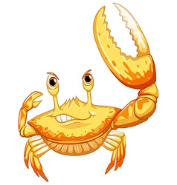

**General overview of environmental DNA**

Living organisms constantly release, slough or otherwise loose  organic material to their surrounding environment. This can be in the form of skin cells, scales, hair, faecal material, reproductive material, or other organic matter, all of which contains DNA. Advances in genetic technologies allow samples of this collected organic material to be analysed in such a way that it is possible, under appropriate circumstances, to ascertain the taxa of origin of the material, even when there is a vast array of material present.

In practise this allows samples of water to be collected and analysed against a database of known taxa DNA sequences.

Lotic environments such as rivers and streams are ideal environments for the collection of eDNA. High energy flowing water entrains organic material in the water column, transporting it potentially great distances downstream. This allows for water (and its associated organic material) at a given location to be sampled, with all species that may have shed DNA into the waterway upstream of this point having a chance of being detected. However, increased volumes of shed DNA and proximity to the sample site increase likelihood of detection.

**Collecting samples**

Equipment for standard sampling:

* 3 x eDNA sampling packs from Wilderlab - each pack should include: 1 x 60mL syringe, 1 x pair of gloves, 1 x ziplock bag with ID label containing 1 x syringe filter and 1 x preservative syringe
* GPS record sampling location (if available)
* Pencil
* Caulking gun(s) - to use if when your arms get weak
* Chilly-bin or box to store samples out of the light until they are posted.
* Spare nitrite gloves and eDNA kit

**Before Leaving the Office**

Double check you have all the right gear before you leave.

Make sure you have a check-in buddy that knows what run you are doing/sites visiting (and where to access the run guide) and what time you will be back. Please remember to txt them when you return safely.

Also start the GetHomeSafe App to track your location throughout the day. Log into [GetHomeSafe](https://www.gethomesafe.com/" \t "_blank) to see your activities. Along with setting up GetHomeSafe, take an InReach unit with you. Another app, Earthmate can be downloaded alongside the InReach units, which can be used to send messages to people to let them know you are ok or alternatively not.

**Sample collection:**

Aim to carry out sample when water level is low and ideally not within two weeks of bed movement/3 x median flow. No not carry out sampling if water is noticeably discolored or swollen following rain fall.

At each site three samples (replicates) should be collected

AVOID CONTAMINATION: make sure you handle the kit with gloves and sample upstream of where you and others are standing. Note any possible contamination sources if seen e.g. people swimming upstream.

1. Put gloves on
2. Draw 50mL of water into the syringe from just below the surface in a well-mixed area of the river upstream of where you are standing
3. Screw filter onto syringe and push water out
4. Unscrew filter and redraw water
5. Repeat until 1 L of water has been filtered or it is no longer possible to push water through the filter
6. With the filter detached, draw 50mL of air into the syringe, re-attach the filter and push all the air through.
7. Unscrew black tip of preservative syringe and screw onto the base of the filter. Remover filter from the  60mL syringe and attach to preservative syringe. Pump preservative through filter a few times, give it a tap. Place into the ziplock bag. Label with site name, collector and volume filtered.
8. Store out of light.
9. Repeat for the other two eDNA sampling packs.

AND If it all gets too hard use the caulking gun

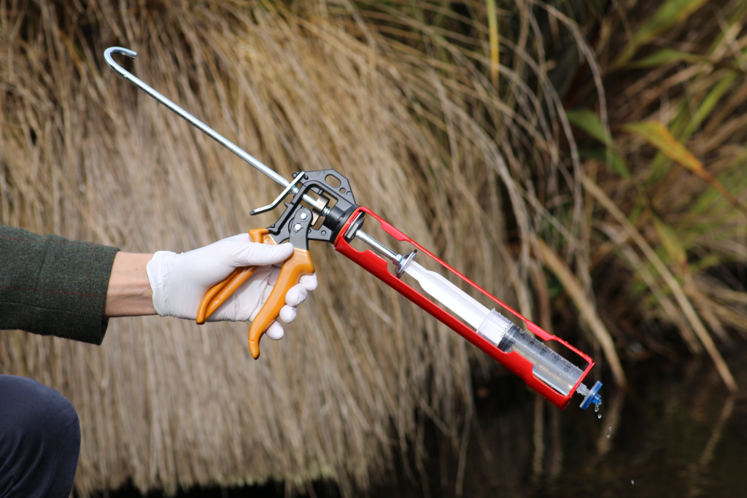

**General overview of environmental DNA**

Living organisms constantly release, slough or otherwise loose  organic material to their surrounding environment. This can be in the form of skin cells, scales, hair, faecal material, reproductive material, or other organic matter, all of which contains DNA. Advances in genetic technologies allow samples of this collected organic material to be analysed in such a way that it is possible, under appropriate circumstances, to ascertain the taxa of origin of the material, even when there is a vast array of material present.

In practise this allows samples of water to be collected and analysed against a database of known taxa DNA sequences.

Lotic environments such as rivers and streams are ideal environments for the collection of eDNA. High energy flowing water entrains organic material in the water column, transporting it potentially great distances downstream. This allows for water (and its associated organic material) at a given location to be sampled, with all species that may have shed DNA into the waterway upstream of this point having a chance of being detected. However, increased volumes of shed DNA and proximity to the sample site increase likelihood of detection.

**Collecting samples**

Equipment for standard sampling:

* 3 x eDNA sampling packs from Wilderlab - each pack should include: 1 x 60mL syringe, 1 x pair of gloves, 1 x ziplock bag with ID label containing 1 x syringe filter and 1 x preservative syringe
* GPS record sampling location (if available)
* Pencil
* Caulking gun(s) - to use if when your arms get weak
* Chilly-bin or box to store samples out of the light until they are posted.
* Spare nitrite gloves and eDNA kit

**Before Leaving the Office**

Double check you have all the right gear before you leave.

Make sure you have a check-in buddy that knows what run you are doing/sites visiting (and where to access the run guide) and what time you will be back. Please remember to txt them when you return safely.

Also start the GetHomeSafe App to track your location throughout the day. Log into [GetHomeSafe](https://www.gethomesafe.com/" \t "_blank) to see your activities. Along with setting up GetHomeSafe, take an InReach unit with you. Another app, Earthmate can be downloaded alongside the InReach units, which can be used to send messages to people to let them know you are ok or alternatively not.

**Sample collection:**

Aim to carry out sample when water level is low and ideally not within two weeks of bed movement/3 x median flow. No not carry out sampling if water is noticeably discolored or swollen following rain fall.

At each site three samples (replicates) should be collected

AVOID CONTAMINATION: make sure you handle the kit with gloves and sample upstream of where you and others are standing. Note any possible contamination sources if seen e.g. people swimming upstream.

1. Put gloves on
2. Draw 50mL of water into the syringe from just below the surface in a well-mixed area of the river upstream of where you are standing
3. Screw filter onto syringe and push water out
4. Unscrew filter and redraw water
5. Repeat until 1 L of water has been filtered or it is no longer possible to push water through the filter
6. With the filter detached, draw 50mL of air into the syringe, re-attach the filter and push all the air through.
7. Unscrew black tip of preservative syringe and screw onto the base of the filter. Remover filter from the  60mL syringe and attach to preservative syringe. Pump preservative through filter a few times, give it a tap. Place into the ziplock bag. Label with site name, collector and volume filtered.
8. Store out of light.
9. Repeat for the other two eDNA sampling packs.

AND If it all gets too hard use the caulking gun

NOTE: samples do not need to be stored in the fridge or freezer, just keep in a dark place

Instructions from Wilderlab can be found here:

[\\file\herman\E\WQ\03\05\Fish monitoring\eDNA\eDNA sample collection and submission instructions.pdf](file://file/herman/E/WQ/03/05/Fish%20monitoring/eDNA/eDNA%20sample%20collection%20and%20submission%20instructions.pdf)

**Sending Samples**

NOTE: Samples do not need to be send immediately. Store in a dark dry place until sent.

1. Fill out the eDNA analysis request form at <https://www.wilderlab.co.nz/submit-samples>

NOTE: if sending multiple sites at once from different rivers etc., it is easier for the lab and to view the results if a submission form is done for each site.

AccountName: Horizons Regional Council

AccountNumber: leave blank

ContactName: Your name or Mike's

Contact Email: Yours or Mike's

Contact Phone: yours or Mike's

PurchaseOrder: 129929

Job Reference: name of stream and purpose e.g. Species confirmation Ohau River at Gladstone Reserve

JobNotes: general notes from site that are worth mentioning

Are the samples funded through the Wai tuwhera o te Taiao programme? No

Default sample selection is "Fish and insects" leave it as this unless specified elsewhere

Do you want them made public? Yes

When you select submit a pop up box will appear saying "your job number is..." Copy and paste the job number into the excel spreadsheet and safe under job notes in case you need it in future (you shouldn't need it but just in case

1. Save a copy of the sample submission excel spreadsheet here:

[\\file\herman\E\WQ\03\05\Fish monitoring\eDNA\Samples sent](file://file/herman/E/WQ/03/05/Fish%20monitoring/eDNA/Samples%20sent)

Re-name spreadsheet with date collected (YYYYMMDD) followed by site name

1. Print a copy of the sample submission spreadsheet – send this with the samples to Wilderlab
2. Courier samples to:

Wilderlab NZ Ltd

Level 2, 129 Park Road

Miramar

Wellington, 6022

Here is a link so you don’t have to type the address:

[file:///\\file\herman\E\WQ\03\05\Fish%20monitoring\eDNA\Samples%20sent\Courier%20Address%20WilderLab%20NZ%20Ltd.docx](file://file/herman/E/WQ/03/05/Fish%20monitoring/eDNA/Samples%20sent/Courier%20Address%20WilderLab%20NZ%20Ltd.docx)

**Saving results**

1. When results come through rename date collected (YYYYMMDD) followed by site name and save them into this folder:

[\\file\herman\E\WQ\03\05\Fish monitoring\eDNA\All eDNA results](file://file/herman/E/WQ/03/05/Fish%20monitoring/eDNA/All%20eDNA%20results)

1. Record in the result register:

[file:///\\file\herman\E\WQ\03\05\Fish%20monitoring\eDNA\All%20eDNA%20results\Result%20register.xlsx](file://file/herman/E/WQ/03/05/Fish%20monitoring/eDNA/All%20eDNA%20results/Result%20register.xlsx)

**Extra admin for certain eDNA Projects**

***2021 Summer eDNA project***

1. Record collection date and whether samples have been sent/results received and fish species detected from eDNA sampling results here:

[file:///\\file\herman\E\WQ\03\05\Fish%20monitoring\eDNA\2021%20summer%20project\20210311%20%20eDNA%20site%20list%20and%20species%20list.xlsx](file://file/herman/E/WQ/03/05/Fish%20monitoring/eDNA/2021%20summer%20project/20210311%20%20eDNA%20site%20list%20and%20species%20list.xlsx)

Other useful information for the summer project:

Maps of sites and  fish species distributions can be found here:

[\\file\herman\E\WQ\03\05\Fish monitoring\eDNA\2021 summer project\eDNA species distribution maps](file://file/herman/E/WQ/03/05/Fish%20monitoring/eDNA/2021%20summer%20project/eDNA%20species%20distribution%20maps)

There is also a set of shp. files by species based of the NZFFD in arcGIS in this file:

[\\gisdata\gis\Department\Research\Biodiversity\Aquatic Biodiversity\Fish files\Fresh Water Fish Database 2020\Fish distribution files NZFFD Mar2021](file://gisdata/gis/Department/Research/Biodiversity/Aquatic%20Biodiversity/Fish%20files/Fresh%20Water%20Fish%20Database%202020/Fish%20distribution%20files%20NZFFD%20Mar%202021)

**At some point very very soon all of Horizons eDNA data and all other eDNA data that is  public will be available here**<https://www.wilderlab.co.nz/explore>

NOTE: samples do not need to be stored in the fridge or freezer, just keep in a dark place

Instructions from Wilderlab can be found here:

[\\file\herman\E\WQ\03\05\Fish monitoring\eDNA\eDNA sample collection and submission instructions.pdf](file://file/herman/E/WQ/03/05/Fish%20monitoring/eDNA/eDNA%20sample%20collection%20and%20submission%20instructions.pdf)

**Sending Samples**

NOTE: Samples do not need to be send immediately. Store in a dark dry place until sent.

1. Fill out the eDNA analysis request form at <https://www.wilderlab.co.nz/submit-samples>

NOTE: if sending multiple sites at once from different rivers etc., it is easier for the lab and to view the results if a submission form is done for each site.

AccountName: Horizons Regional Council

AccountNumber: leave blank

ContactName: Your name or Mike's

Contact Email: Yours or Mike's

Contact Phone: yours or Mike's

PurchaseOrder: 129929

Job Reference: name of stream and purpose e.g. Species confirmation Ohau River at Gladstone Reserve

JobNotes: general notes from site that are worth mentioning

Are the samples funded through the Wai tuwhera o te Taiao programme? No

Default sample selection is "Fish and insects" leave it as this unless specified elsewhere

Do you want them made public? Yes

When you select submit a pop up box will appear saying "your job number is..." Copy and paste the job number into the excel spreadsheet and safe under job notes in case you need it in future (you shouldn't need it but just in case

1. Save a copy of the sample submission excel spreadsheet here:

[\\file\herman\E\WQ\03\05\Fish monitoring\eDNA\Samples sent](file://file/herman/E/WQ/03/05/Fish%20monitoring/eDNA/Samples%20sent)

Re-name spreadsheet with date collected (YYYYMMDD) followed by site name

1. Print a copy of the sample submission spreadsheet – send this with the samples to Wilderlab
2. Courier samples to:

Wilderlab NZ Ltd

Level 2, 129 Park Road

Miramar

Wellington, 6022

Here is a link so you don’t have to type the address:

[file:///\\file\herman\E\WQ\03\05\Fish%20monitoring\eDNA\Samples%20sent\Courier%20Address%20WilderLab%20NZ%20Ltd.docx](file://file/herman/E/WQ/03/05/Fish%20monitoring/eDNA/Samples%20sent/Courier%20Address%20WilderLab%20NZ%20Ltd.docx)

**Saving results**

1. When results come through rename date collected (YYYYMMDD) followed by site name and save them into this folder:

[\\file\herman\E\WQ\03\05\Fish monitoring\eDNA\All eDNA results](file://file/herman/E/WQ/03/05/Fish%20monitoring/eDNA/All%20eDNA%20results)

1. Record in the result register:

[file:///\\file\herman\E\WQ\03\05\Fish%20monitoring\eDNA\All%20eDNA%20results\Result%20register.xlsx](file://file/herman/E/WQ/03/05/Fish%20monitoring/eDNA/All%20eDNA%20results/Result%20register.xlsx)

**Extra admin for certain eDNA Projects**

***2021 Summer eDNA project***

1. Record collection date and whether samples have been sent/results received and fish species detected from eDNA sampling results here:

[file:///\\file\herman\E\WQ\03\05\Fish%20monitoring\eDNA\2021%20summer%20project\20210311%20%20eDNA%20site%20list%20and%20species%20list.xlsx](file://file/herman/E/WQ/03/05/Fish%20monitoring/eDNA/2021%20summer%20project/20210311%20%20eDNA%20site%20list%20and%20species%20list.xlsx)

Other useful information for the summer project:

Maps of sites and  fish species distributions can be found here:

[\\file\herman\E\WQ\03\05\Fish monitoring\eDNA\2021 summer project\eDNA species distribution maps](file://file/herman/E/WQ/03/05/Fish%20monitoring/eDNA/2021%20summer%20project/eDNA%20species%20distribution%20maps)

There is also a set of shp. files by species based of the NZFFD in arcGIS in this file:

[\\gisdata\gis\Department\Research\Biodiversity\Aquatic Biodiversity\Fish files\Fresh Water Fish Database 2020\Fish distribution files NZFFD Mar2021](file://gisdata/gis/Department/Research/Biodiversity/Aquatic%20Biodiversity/Fish%20files/Fresh%20Water%20Fish%20Database%202020/Fish%20distribution%20files%20NZFFD%20Mar%202021)

**At some point very very soon all of Horizons eDNA data and all other eDNA data that is  public will be available here**<https://www.wilderlab.co.nz/explore>



 Environmental DNA Survey123 form

Docs live here: \\file\herman\D\SR\03\01\Rivers\Fish Monitoring\eDNA\Admin\_eDNA

Created for....

Site list is everything that was loaded in as an optional site; all of HRC SOE sites across all programmes

The paper form is just a paper version of the Survey123 form in case people want paper or something goes wrong in the field

## Gear Checks

**Electrofishing machine checks**

Usually around mid-October each year the electric fishing gear is sent off to NIWA for revalidation. This is to make sure that the machine is working properly before the next fishing season is due to start. The fishing season is usually between January to April each year, which is when there is the best weather and when fish are most active in streams.

Email this address instruments@niwa.co.nz  to get a quote and book in the gear for a check. It usually pays to check with the environmental scientist to make sure that we have enough budget to do this, as the price usually increases each year.

There is usually one electric fishing machine at Regional House and one out at Kairanga. Make sure that you contact someone from the Fish Passage Team to make sure that our other machine is also checked.

To send an EFM to NIWA for annual recertification, get a PO from the environmental scientist and speak to Simon in the print room for costs for courier. He will be able to attach a courier ticket which has the address printed on it. (Alternately, the address for NIWA can be found here: [file:///\\file\herman\E\WQ\03\05\Fish monitoring\Admin\NIWA E.Fishing Machine Certification Address.docx](file://file/herman/E/WQ/03/05/Fish%20monitoring/Admin/NIWA%20E.Fishing%20Machine%20Certification%20Address.docx), which needs to be attached to the EFM and the wand)

Once the EFM machine is sent, email the representative of NIWA that you have been talking to, or email [instruments@niwa.co.nz](mailto:instruments@niwa.co.nz)

**Battery charging and testing**

You have to charge the batteries before going fishing, and the charger is kept in the box with the batteries:

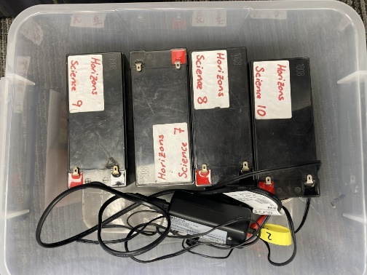

Just plug it in and connect it to the battery like this:

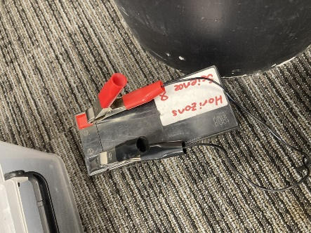

Check that the light is on/the charger is working. The light will go green when the battery is fully charged:

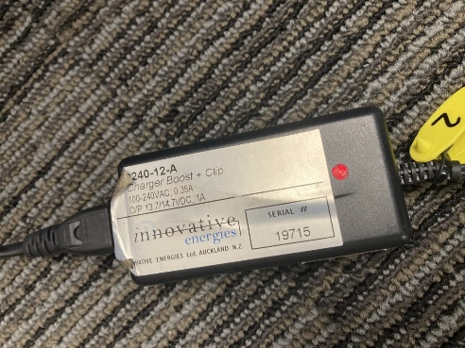

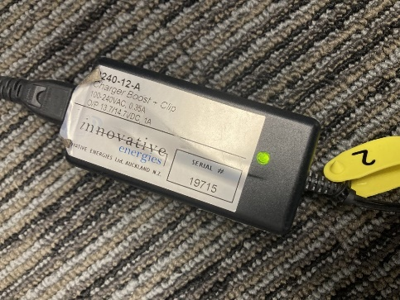

You can test the batteries using a volt meter (Hydro usually have one lying around); turn it onto the voltage setting:

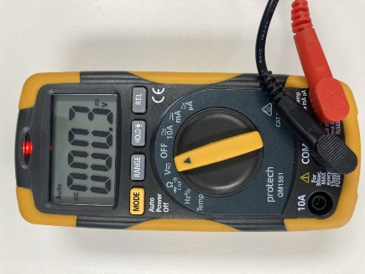

Also turns out you can't rotate pictures in Teams.

Test each battery using the prongs like this:

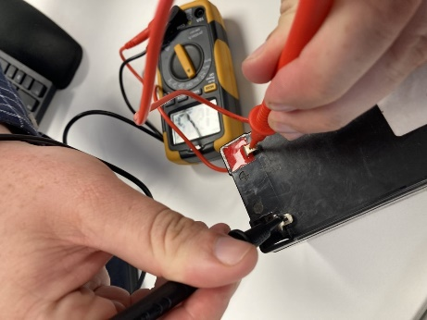

The voltage from the battery will appear on the screen. This battery has 12.95v, so we can keep using it:

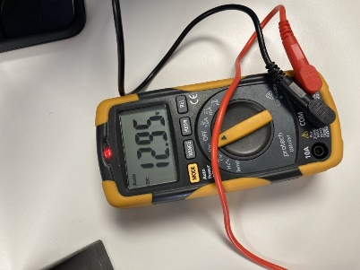

Readings less than 12.2v suggests the battery may need to be replaced. Replacements batteries are available at lots of places, with Jaycar being among the most common suppliers.

# Contact Rec

## Scientist stuff

**Programme overview**(Image and pdf copies can be found here [\\file\herman\E\WQ\03\02\Contact Rec 2022-23\Programme overview](file://file/herman/E/WQ/03/02/Contact%20Rec%202022-23/Programme%20overview)

In a nutshell – the scientist needs to know the ins and outs of all components of CR. Day to day, most of these things are handled by the CR staff but as the scientist you do some of the 'RA' tasks like archiving data just because you are in the office and able to do so faster. You will also receive lots of calls from the public and need to be able to explain how and why we do things for this programme.

**All info can be found here**[**\\file\herman\E\WQ\03\02**](file://file/herman/E/WQ/03/02)

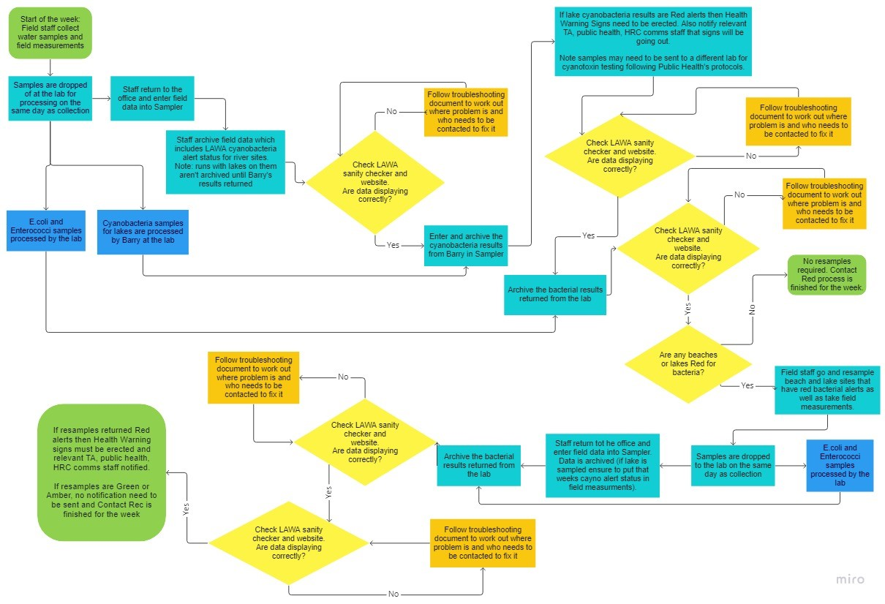

**Preseason**

* Lock in a list of sites for the season
  + Set up sampling days (Mon/Tues, resamples Wed/Thurs, signs Thurs/Fri). A Teams spreadsheet with a calendar is useful as it means all of the staff can access it and see updates as they occur.
  + Need to update Michaela Rose (so she can set up the back end of Hilltop) and Darren Bentley-Hewitt if any extra sites need to be added. Darren needs list regardless so that he can organise the runs in Sampler. Ensure that this list is separated into runs and the sites are in the order they occur in the run (it means they will be written into the books in order).
* Organise vehicles for the season with assets (often require 1 or 2 vehicles that are being sold this financial from 1 Nov to 30 April) - always check if the staff can drive manuals!
* Check LAWA stuff is ready to go (Luke Fullard will be able to help) - require site list for the season to do this step.
* Temperature probes to Darren for revalidation (ideally do this towards end of Sept so there is time to order new pieces if required)
* Organise public holidays (note, Taumarunui falls into Auckland Anniversary Day, with the rest of the region on Wellington Anniversary Day)
  + Whose working/which days are being switched for sampling (sometimes we need to adjust the Taumarunui run to ensure this falls on a day where couriers are working – usually non stat days). This is particularly important of Xmas/NY as well.
* Organise contract with Barry for lake algae identification (Barry usually works out of the CEL lab but is a contracted HRC employee).
* Get access to the [SwimSpots@horizons.govt.nz](mailto:SwimSpots@horizons.govt.nz) and [ContactRec@horizons.govt.nz](mailto:ContactRec@horizons.govt.nz) inboxes. The contact rec one has lab results and LAWA function emails come through here. The SwimSpots email is used by Barry to send out weekly updates regarding the lake cyano and e.coli status to relevant contacts.
* **This is one of the best documents you could use throughout the season!** At the start of season email relevant contacts (community groups, TAs, some internal staff members, Public Health etc.) to let them know the season has started. Attach this info sheet as well. The info sheet is super useful during the season when there are public enquiries or enquiries from other organisations. Note; we always advise people to check LAWA as we have too many sites to do individual notifications and it is faster to be updated via LAWA.
  + Info sheet [file:///\\file\herman\E\WQ\03\02\Contact%20Rec%202022-23\Kelly\Preseason\_swim\_spot\_info\_final.docx](file://file/herman/E/WQ/03/02/Contact%20Rec%202022-23/Kelly/Preseason_swim_spot_info_final.docx)
  + Preseason email [\\file\herman\E\WQ\03\02\Contact Rec 2022-23\Preseason info](file://file/herman/E/WQ/03/02/Contact%20Rec%202022-23/Preseason%20info)
* Organise a preseason meeting with everyone to ensure everyone is on the same page.
  + Comms (signage), ED team (Darren and Michaela), Barry, CR staff, Public Health.
  + Usually this includes identifying how many sites are being sampled this season, the days they will be sampled on etc.
  + 2022-2023 preseason powerpoint can be found here [file:///\\file\herman\E\WQ\03\02\Contact%20Rec%202022-23\Preseason%20info\2022-2023%20Preseason%20Draft%20pp%20swim%20spots.pptx](file://file/herman/E/WQ/03/02/Contact%20Rec%202022-23/Preseason%20info/2022-2023%20Preseason%20Draft%20pp%20swim%20spots.pptx)

**Lab**

* Organise procurement for sample processing. In the past this has always been with CEL (Central Environmental Laboratories). Procurement and contract for the 2022-2023 season can be found here:
  + [\\file\herman\D\SR\01\01\Procurement\Contact Rec\2022-23](file://file/herman/D/SR/01/01/Procurement/Contact%20Rec/2022-23)
  + [\\file\herman\O\MS\06\07\2022-2023](file://file/herman/O/MS/06/07/2022-2023)
* Get updated lab test csv from the lab for Darren to put into Sampler
* Ensure that you have the recipient list for the results set up. This should include the contact rec inbox ([ContactRec@horizons.govt.nz](mailto:ContactRec@horizons.govt.nz)), [wqlabresults@horizons.govt.nz](mailto:wqlabresults@horizons.govt.nz) (this then allows the results to go directly into Sampler), Science Manager, public health (both the generic and main contact emails), the primary contact rec field staff and the environmental monitoring scientist.
* Organise procurement for cyanotoxin sample process if required for swim spot lakes. In the past this has always been with Watercare. This is usually case by case and shouldn't be more than ~$3000. Procurement and contract for 2022-2023 season can be found here:
  + [\\file\herman\D\SR\01\01\Procurement\Contact Rec\2022-23](file://file/herman/D/SR/01/01/Procurement/Contact%20Rec/2022-23)
  + [\\file\herman\O\MS\06\07\2022-2023](file://file/herman/O/MS/06/07/2022-2023)

**Recruitment**

* Organise keys to sheds and CEL (usually a stash of them with the rest of the sci keys already together for the team)
* Organise phones/computers with IT (note only need to do this with staff that are in the science team. The interns in FW will have their items organised by their manager)
* Apps required on phone include GetHomeSafe, Qfile (for uploading photos onto TSFarm), Vault safety apps
* Organise H+S training (e.g. first aid, swift water training), again only need to do for the science staff (FW interns will be organised by their manager)
* Hold a sample training day with all of the new staff and any that will be covering runs. This is aimed to be a refresher for those that have done it before and to enable the newbies to understand the process prior to a sampling run. Note the first few runs will be done with one of the RA's who have an idea of how the process runs.
  + It is a good idea to do a mock data entry run in Sampler as well to show the staff how to use this – organise this with Darren.
* Organise PPE (good idea to do so once they have signed their contract so their waders turn up soon after they start)

In the past we have contracted iwi from Ohakune to do the monitoring of the northern sites around Taumarunui. For the past two seasons (2021/22 and 2022/23) there has been no capacity for them to do the monitoring and HRC have done it from RH office. Both situations are described below depending on the outcome:

* **Iwi contract**(information regarding contracts, address etc for former Ngati Rangi monitoring can be found here [\\file\herman\E\WQ\03\02\Ngati Rangi monitoring](file://file/herman/E/WQ/03/02/Ngati%20Rangi%20monitoring). Liasion with Ngati Uenuku and Ngati Haua for the 2023-2024 season can be found here [\\file\herman\E\WQ\03\02\Admin](file://file/herman/E/WQ/03/02/Admin)
  + Set up contract with relevant iwi from the northern run.
  + Organise gear to be dropped off (including books, stickers, chilly bin, courier tickets sourced from the lab) and to do a training day up there as well. This training day will detail how to do the monitoring, how to fill out the books, how to send samples, how to do data entry
  + Organise with the lab for sample bottles and chilly bin to be returned to iwi each week upon receipt of the sample
  + Ensure a contact person is established from both HRC and iwi to ensure that data entry and QA occurs on time
* **HRC monitoring northern sites**

When HRC monitors the northern sites this is conducted over two days with the staff member staying overnight in Taumarunui. The run 7 & 8 run guides can be found here: [\\file\herman\E\WQ\03\02\Contact recreation run guide\Updated Programme 2022\_2023](file://file/herman/E/WQ/03/02/Contact%20recreation%20run%20guide/Updated%20Programme%202022_2023). Samples from run 7 are couriered on the day to the lab.

* Organise and book (via group PA) accommodation for the whole season at the Central Park Motel, Taumarunui. 2022-23 accommodation document can be found here:  [file:///\\file\herman\E\WQ\03\02\Contact%20Rec%202022-23\20220915\_Taumarunui\_Accommodation.docx](file://file/herman/E/WQ/03/02/Contact%20Rec%202022-23/20220915_Taumarunui_Accommodation.docx)
* Organise courier tickets with the lab as well as reusable postal address labels.
* Ensure that staff pick up the chilly bin when they return to the lab on the second day of sampling.

**During the Season**

* **LAWA (more info in LAWA page)**

LAWA displays all of the swim spot information and need to be kept updated (usually one of the science CR staff ensures that this is correct throughout the season but when they are in the field it is the Scientists responsibility to ensure data is displaying correctly).

* This is the link to the LAWA sanity checker. The link updates approximately 45mins after the LAWA pull (which is every ~2hrs from 6am-6pm each day) and identifies if there are any discrepancies between data (data/time, e.coli/enterococci and cyano) in the Hilltop file (hts), the WFS file (HRC file that LAWA has access to pull data from), and what is actually being displayed on LAWA. This is used to help identify that information is displaying correctly on LAWA. <http://tqm.horizons.govt.nz/Hydrology/Science/lawa_contactrec_dashboard/LAWA_Contact_Rec.html>
* Luke or Rhianne should be able to help with LAWA however there is some information on where to log in and what we are looking at here:
  + LAWA Live and Staging websites info: we are interested in the Home Page tab --> Explore Data tab -->Manwatu-Whanganui Region--> the River Quality, Lakes and Coastal tabs (swimability tab is just metadata stuff). Warnings and alerts can be edited via the live log-in (link below). To do so navigate to the Warnings and Alerts tab following the same path above.

Lawa live site: <https://www.lawa.org.nz/>

Lawa live log-in: <http://lawa.org.nz/umbraco#/umbraco>

* + Lawa Staging site: [http://lawa.staging.effect.nz](http://lawa.staging.effect.nz/)

Lawa Staging Site log-in: <http://lawa.staging.effect.nz/umbraco#/umbraco>

* + Log in details: Username: Maree Clark; Password: Q1MSSI5W
* Ensure check-ins are organised a week prior to the field sampling. For the Xmas/NY period its important to organise the check-ins towards the end of November.

* **Sampler**
  + Field staff go into the field and field data is entered on the same day into Sampler.
  + Essential that time and date are entered correctly as these will prevent the run for archiving properly. (see Data Entry & QA process). CR staff do this amongst themselves but sometimes you need to if they get back at different time. Easiest to have one of the field staff of in charge of making sure all runs are QA'd and archived.
  + Important note – don't do the first archive (I.e. archive field data) for runs with lakes on them. This is because we need to add the cyano LAWA alert status but can't do so until Barry has provided his results back. Once Barry has provided, edit the field data and archive the data (this should be done before the lab results come back).

* **Public enquiries**
  + **This is one of the best documents you could use throughout the season!** The info sheet is super useful during the season when there are public enquiries or enquiries from other organisations. Note; we always advise people to check LAWA as we have too many sites to do individual notifications and it is faster to be updated via LAWA.
    - Info sheet [file:///\\file\herman\E\WQ\03\02\Contact%20Rec%202022-23\Kelly\Preseason\_swim\_spot\_info\_final.docx](file://file/herman/E/WQ/03/02/Contact%20Rec%202022-23/Kelly/Preseason_swim_spot_info_final.docx)
  + Always advise of self-safety (don't swim following 72hrs of heavy or prolonged rainfall even if that hasn't been in your area as upper catchment can affect downstream, check the water is clean and clear, if in doubt stay out)

* **Health warning signs**
  + These are only erected following two consecutive red bacterial samples at beaches or lakes (they may also be erected for cyanobacteria at lakes but this doesn't require a resample). See Erecting Health Warning Signs page for more details.

**End of Season**

* Do end of season meeting (internally) and with Public Health to see if there is anything that can be improved for next season or if there is anything that needs adjusting.
* Ensure all cyano transects have been entered [file:///\\file\herman\E\WQ\03\02\Contact%20Rec%202022-23\Cyanobacteria\Cyano%20transects%20from%20notebooks.xlsx](file://file/herman/E/WQ/03/02/Contact%20Rec%202022-23/Cyanobacteria/Cyano%20transects%20from%20notebooks.xlsx)
* Ensure that Barry's cyano results have also been entered (Barry to do this) [file:///\\file\herman\E\WQ\03\02\Contact%20Rec%202022-23\Cyanobacteria\Lakes%20cyano%20biovolumes.xlsx](file://file/herman/E/WQ/03/02/Contact%20Rec%202022-23/Cyanobacteria/Lakes%20cyano%20biovolumes.xlsx)
* Result emails saved into here: [\\ares\Environmental Monitoring Programmes\Discrete WQ - Contact Recreation\CR 2021-22](file://ares/Environmental%20Monitoring%20Programmes/Discrete%20WQ%20-%20Contact%20Recreation/CR%202021-22)

**Documenting site alterations/removals/additions**

Decisions regarding site changes/alterations/removals/additions can be found here [\\file\herman\E\WQ\03\02\Addition and removal of sites justification](file://file/herman/E/WQ/03/02/Addition%20and%20removal%20of%20sites%20justification)

Note this folder only contains shortcuts to the folder relevant CR 'year' folder which then contains all of the information regarding those decisions. It is important to document these so that future staff know what decisions were made when and why.

## Public Health contacts

Public health main contact [kathryn.knightbridge@midcentraldhb.govt.nz](mailto:kathryn.knightbridge@midcentraldhb.govt.nz); 0272015699

Public health general contact [PublicHealthOps@midcentraldhb.govt.nz](mailto:PublicHealthOps@midcentraldhb.govt.nz); 06 350 9110

Usually both are emailed but if during normal hours get hold of Kathryn first.

TA contact details can be found here (although need to be updated each year and should be saved in each years new folder): [file:///\\file\herman\E\WQ\03\02\Contact%20Rec%202022-23\TA%20contact%20details.xlsx](file://file/herman/E/WQ/03/02/Contact%20Rec%202022-23/TA%20contact%20details.xlsx)

## 

## LAWA

**LAWA**

Abi Loughman coordinates LAWA. Her contact details are [Abi.Loughnan@teurukahika.govt.nz](mailto:Abi.Loughnan@teurukahika.govt.nz)

[www.lawa.org.nz](http://www.lawa.org.nz/)

LAWA displays all of the swim spot information and need to be kept updated (usually one of the science CR staff ensures that this is correct throughout the season but when they are in the field it is the Scientists responsibility to ensure data is displaying correctly).

This is the link to the LAWA sanity checker. The link updates approximately 45mins after the LAWA pull (which is every ~2hrs from 6am-6pm each day) and identifies if there are any discrepancies between data (data/time, e.coli/enterococci and cyano) in the Hilltop file (hts), the WFS file (HRC file that LAWA has access to pull data from), and what is actually being displayed on LAWA. This is used to help identify that information is displaying correctly on LAWA. <http://tqm.horizons.govt.nz/Hydrology/Science/lawa_contactrec_dashboard/LAWA_Contact_Rec.html>

* Luke or Rhianne should be able to help with LAWA however there is some information on where to log in and what we are looking at here:
  + LAWA Live and Staging websites info: we are interested in the Home Page tab --> Explore Data tab -->Manwatu-Whanganui Region--> the River Quality, Lakes and Coastal tabs (swimability tab is just metadata stuff). Warnings and alerts can be edited via the live log-in (link below). To do so navigate to the Warnings and Alerts tab following the same path above.

Lawa live site: <https://www.lawa.org.nz/>

Lawa live log-in: <http://lawa.org.nz/umbraco#/umbraco>

* + Lawa Staging site: [http://lawa.staging.effect.nz](http://lawa.staging.effect.nz/)

Lawa Staging Site log-in: <http://lawa.staging.effect.nz/umbraco#/umbraco>

* + Log in details: Username: Maree Clark; Password: Q1MSSI5W

Warnings and alerts can be put on any sites at any time. Most warnings have already been made and just need to have a site added or removed to reflect the right sites. Further the whole warning can be turned off so that no sites (even those listed show the alert anymore).

Special statuses can also be put onto sites. For example, during Cyclone Gabrielle, we wanted swim spots to show a temporary red alert regardless of what the sample that week showed to notify the public it was unsuitable for swimming in rivers at this time and in flood waters. Special statuses are edited under each site specifically. Some sites like Kai Iwi Stream and Mowhanau Stream have permanent special 'red' statuses due to poor water quality.

Note an error message will come up preventing you from updating anything if the site has a Condition Trigger set up but not Condition Trigger Station (I.e. a flow site or rainfall gauge). Either add a Trigger Station or select 'No Trigger' and it should work from there.

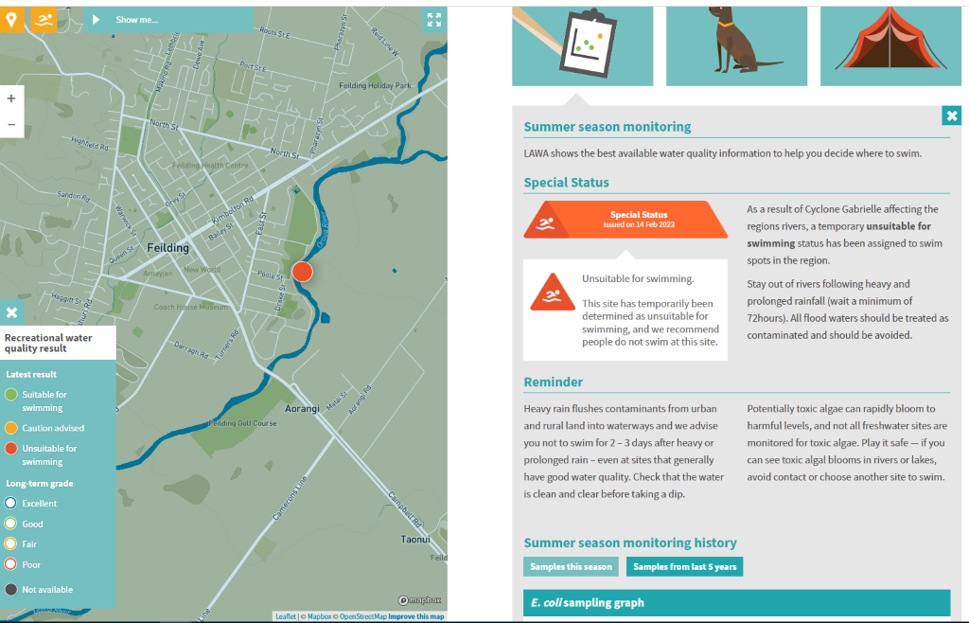

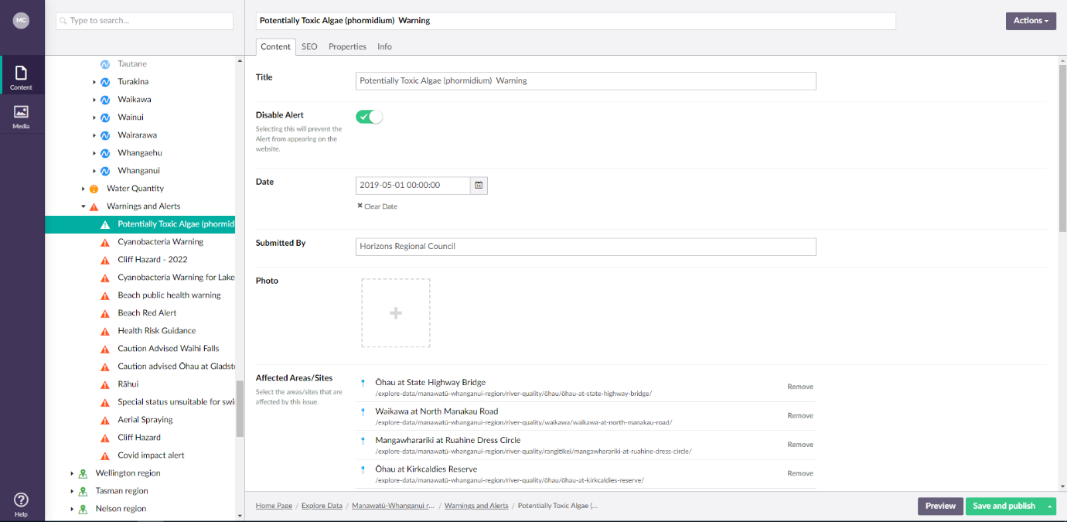

## Christmas Shutdown

HRC has a mandatory shut down for two weeks over Christmas and New Year. There are a few things that need to be organized ahead of that to make the process run as smoothly as possible.

**Sampling dates**

Ensure that you find out what days couriers are operating for the northern run particularly regarding public holidays. It is best if you can avoid sampling on public holidays however, do keep in mind any resamples or signs that might need to go out and what days they fall on.

Ensure you let the lab know which dates you intend to sample. Sometimes they like you to text them when samples arrive (or when you are about 0.5hrs away) so that they aren't waiting at the lab all day.

**Gear and vehicles**

Staff can usually take the gear and vehicles home over the Xmas break. This needs to be approved by the group manager. Once approved, ensure that assets also know which vehicles will be taken home and by whom. Ensure that everyone has enough gear to cover the 3 week period (first week back included) and that the designated sign person has everything they need to put up signs if required. Ensure that everyone has remote access to TSFarm (you may need to book laptops for this period if staff need them).

WQ books and lab test request forms will need to be prepped for three weeks (2 weeks of shutdown and first week back) with all of the stickers required.

**Data entry, QA, archiving and checking LAWA**

By the time shut down rolls around, all CR staff should know how to enter, QA and archive data in Sampler.

Designate one person to ensure the day to day running goes smoothly. This person will ensure:

* Field data is entered, QA'd and archived as required
* Lab data is received and archived as required
* LAWA is checked to ensure it is displaying correctly
* Any issues regarding results in Sampler or LAWA will be directed to the designated Hydro data contact
* Any resamples are conducted by them as required
* Any beaches or lakes which require Health Warning signs are erected or removed as required

Prior to going away, organise a catch up with Hydro data analysts (Michalea and whoever else is going to be on call. This is to discuss, how people should be contacted if there are issues with the Server or Sampler and ensure that everyone has the right contact details.

**Comms**

Prior to going away, organise a catch up with Comms (generally Cara and whoever oversees CR related stuff). This is to discuss what scenarios require media releases or social media posts (or both) and who the contact person/people are, ensuring everyone has their contact details.

See email for example of what was discussed in 2022-2023 season

**Check-ins**

Every time someone goes into the field they are required to have a check-in person. This is no different over the Xmas shutdown period. We try to spread this across the team so that everyone still gets a holiday. Send around the list of days check-ins are required to the science team and fill days from there. Once confirmed send a calendar invite with the details below (note you will need to update links and peoples details etc). An example can be found here: [\\file\herman\E\WQ\03\02\Contact Rec 2022-23\Christmas shutdown info\Contact Rec Check-in calendar invite example.ics](file://file/herman/E/WQ/03/02/Contact%20Rec%202022-23/Christmas%20shutdown%20info/Contact%20Rec%20Check-in%20calendar%20invite%20example.ics)

Check-ins need to be set up as supervisors in GetHomeSafe to ensure they get alerts if the GHS goes off. The group PA will be able to do this. They also need to be set up in ERoad to see the vehicles that will be going out in the field. Assests will be able to set this up.

Ensure that if check-in staff are called out they will have the required PPE and H&S equipment needed in a single place to make it easy.

Checkin-ins will be Duty Officers over the shut down period. 8hrs will go to Duty Officer leave under "Leave type" in TRS for the day(s) they are check-in. They will also tick a duty officer "allowance type" in TRS ($50 for non-public holidays; $100 for public holidays). For days where no one is scheduled to work but the designated CR staff member might be required resample or put up signs, still ensure that a check-in is lined up for that day but assume that noone will have to work so their timesheet will be annual leave as standard. If they do end up being check-in, their timesheets can be changed on the first day back by talking to People and Capability Team.

## CR staff – general info

**All info can be found here**[**\\file\herman\E\WQ\03\02**](file://file/herman/E/WQ/03/02)

**Site Safety**

Check that you can safely exit the car (e.g. no dangerous people or aggressive dogs), and that you can safely enter the river (e.g. very slippery banks, rough swells, unstable banks) before embarking on a sample mission. It's very dangerous to enter flooded rivers, and if you're unsure of your footing or the stability of the river bank, then use the sample pole (described below). If it's dodgy to even use the sample pole, you can abandon the sample. If you cannot complete a sample, then mark the site with the time of visit (we need the time to enter it into Sampler) and note that there was no site access. Your health and life are more important than a water sample.

**Microbial sample**

Every site will have a microbial sample taken in a specific pottle, usually with red or yellow lids:

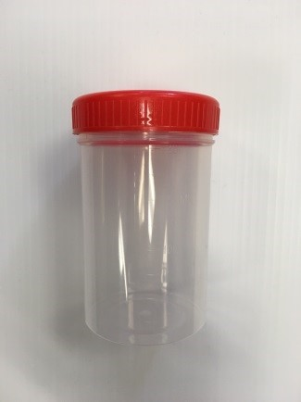

These pottles are sterile, and must not be opened before taking the sample. These pottles can be collected from CEL in large boxes, and are not re-usable. If you have any doubts about a pottle's sterility (e.g. the lid was open, or it looks like there's some detritus in it), then do not use it – even slight amounts of contamination can skew a microbial result. Try to sample away from disturbance such as people swimming or boats, as these can both cause the microbial results to spike in a way that doesn't represent the water body itself.

Most of your samples will be grab methods:

1) Face upstream (avoids contamination from you and your waders) and submerge the whole bottle beneath the surface of the water.

2) Open the lid, and wait for the bottle to fill with water.

3) Close the lid, and bring the bottle back above the surface.

4) Pour out some of the excess to leave a small air gap at the top of the sample. This is so that the bacteria still have an oxygen supply while you transport them throughout the day.

If you have to open the lid above the water surface, record it as a pole sample on the sheet (described below). After collecting the sample and securing the lid, you can attach the sample ID stickers. Put one on lid and one on pottle side just to make sure. It always pays to check the lid is securely and evenly on - the pottle lids can sometimes get awkwardly stuck, and the sample can then spill in the chilly bin during transport.

**Temperature**

Temperature is a really important measurement for a sample, and you take one at every site using a temperature probe. The probes can be delicate, so keep them in the silver or black cases as much as possible. To turn it on, press the green button on the handheld unit. You submerge the sensor/metal rod in the water, and wait until the numbers on the screen start to settle (usually around 30 seconds). When you record the temperature on the field sheet, you should also write the temp probe ID (sticker on the unit) in the "Meter ID" space. You also use the temp probe for the temp bottle reading at the lab. Just insert the sensor into the temp bottle and record the reading on the lab sheet.

While the cable and sensor are waterproof, DO NOT SUBMERGE THE HANDHELD UNIT. The unit is splashproof, but can be still be sensitive to water. Try to take the temperature where the water is around your knees to thighs in depth, but only if it is safe to do so. It can be helpful to streamline your site process by setting up your temp probe if there is somewhere dry to rest the unit, and checking the temperature after you've done your grab sample and substrate estimates.

Take special care of the cords going into the temperature probes, as bending these sharply or pulling them can cause the wires to break or disconnect from the connection plug. If you are unsure of the readings the unit is giving you (e.g. really high temperature readings, negative temperature readings, wild swings in numbers) or it is stuck on "open", report the issue to Ian and Darren Bentley-Hewitt.

*Temperature probe*

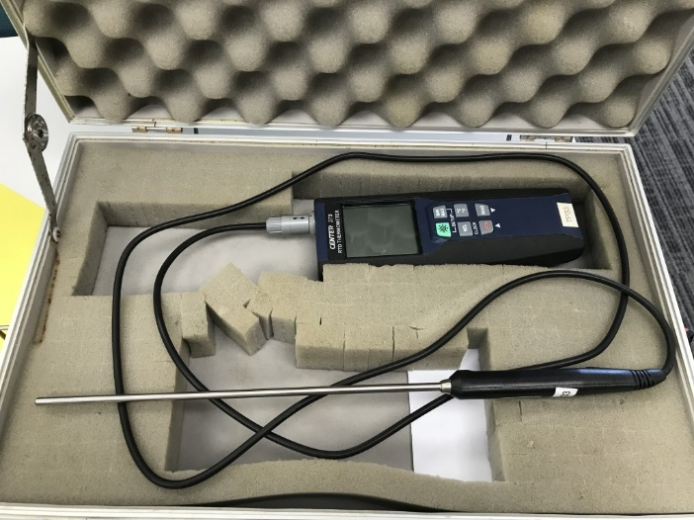

*Temp probe in operation. You can ignore the time on the screen. Note the ID at the bottom of the unit:*

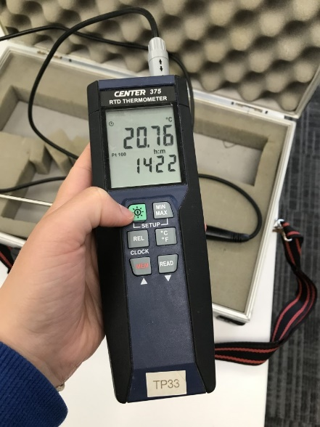

Once you're finished taking your sample, hold the green button down for three seconds until the unit turns off. It's important to turn the unit off between samples, as they can run the batteries dry pretty quickly. A quick dry down of the unit and sensor before returning it to the case is also a good idea.

**Sample pole**

If you cannot enter a waterway (floods, unstable banks) or you're at a lake (fine line between solid ground and littoral zone), you'll be using a sample pole. These are stored in the shed, and can extend out to considerable length. These poles can also be useful if you're accessing a steep site, kind of like tramping poles. To use the sample pole, simply press the wide metal parts, and insert the bottle in these metal parts so it is secure.

Remove the caps, and scoop some water with the pole. While you're likely to get some surface water using the pole, try and submerge the bottle as much as possible to minimise it. As this sampling method differs considerably from grab samples, you must always note pole samples on the field sheet.

**Cyanobacteria**

Cyanobacteria is known as blue-green algae, and is monitored due to its potential to produce powerful toxins. These toxins are typically resistant to things like hand sanitiser, and usually only break down in the sunlight. River cyanobacteria grows like black or dark brown mats on the riverbed, while lake cyanobacteria tends to be green scums (or what looks like tiny tiny green leaves suspended in the water). Both types can be highly toxic.

Lake cyanobacteria is monitored via a 1L sample that is taken to CEL for visual identification by Barry. Using the sample pole, fill the 1L bottle with lake water. Write the lake name, date of sample and time of sample on the bottle using a vivid. The bottle is then stored in the chilly bin with the rest of the bacterial samples. You don't need to visually assess the cover or density of cyanobacteria at the lake; however, it is helpful if you note the presence of scums or accumulations (see the picture below). While rare, benthic cyanobacteria can also occur in lakes – if you see benthic cyanobacteria either washed up on the lake shore or on the lake bottom, record it in the field comments.

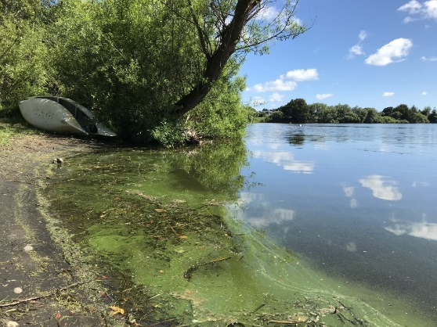

River (benthic) cyanobacteria is monitored via visual assessment of the riverbed. You will visually assess the percentage of the riverbed that you see covered with mats. If you notice any cyanobacteria you will perform a cyano transect and record the results in the paper notebook. River cyanobacteria is also judged by how much of it is exposed at or above the water line (write "exposed" in your field notes) or detaching from the rocks (write "detaching" in your field notes). Also note if there are mats that are washed up on the river banks – their ease of access to kids and dogs can make them more dangerous.

*River cyano:*

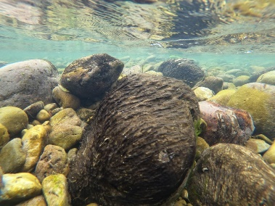

*Detaching:*

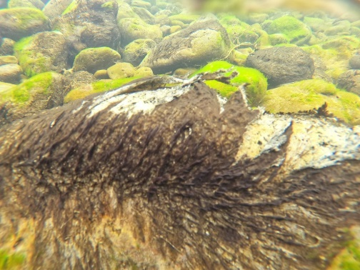

*Exposed or near-exposed:*

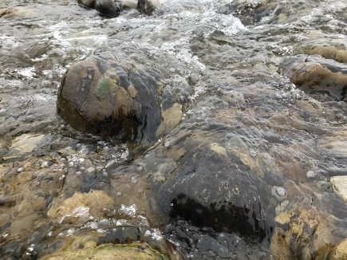

*Cyano mixed with non-toxic algae:*

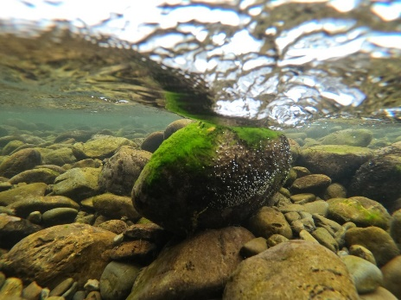

**Cyano transect**

To perform a cyano transect, select a point at the bottom of a reach that is safe to traverse. Starting at one side of the transect, look through the bathyscope and estimate the percentage of cyano cover (a "view"). Repeat this five times total along the transect, and when you're done, move upstream to the next transect line and repeat the same process. Overall, you should do four transects with five views (20 views in total), and record the results in the notebook. Try to space your views as evenly as possible along a transect, and only go as far across the river as you can go safely. Also try your best to be representative of the river (don't select transect lines that are only sandy when the riverbed is a mix of cobbles and sand). Aim your transect reach to an area of the river where benthic cyano is likely to grow (I.e. cobbles or gravel, riffles, etc). Always move upstream as you do your transects – moving downstream may mean that mats you loosen are counted again when they move downstream.

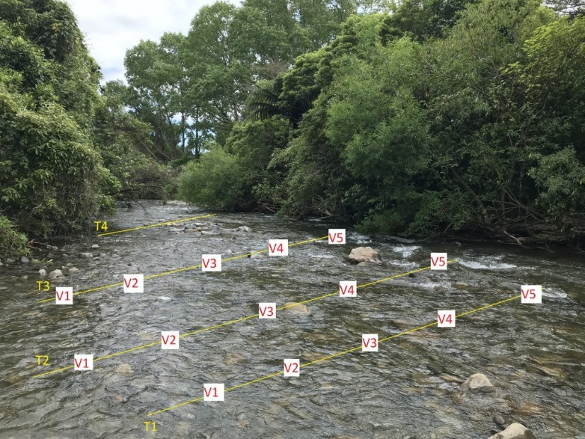

*Transect visual. T = transect, V = view*

**Paperwork**

You need both a field book and a lab book when you leave for a run:

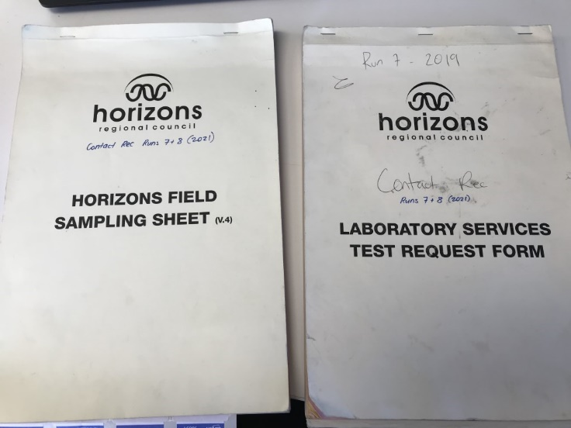

Your books for a run should be prepared the week before. You can pre-fill the dates, staff, sample IDs and site names. At each site, you will record the weather (fine, rainy, drizzle, overcast) and the time in NZST (your Contact Rec sampling is most likely occurring during daylight savings time, so take one hour off your phone's time). There is also space to record the sampling method (if "other" write the method in the space, e.g. 'sample pole'), and the sampling point. Note that the method and point refer to the bacterial sample: don't record "run" for the microbial sample and then "riffle" for the cyano transect. You also have space to record the water colour (if you can, try to differentiate between the water colour and the substrate colour) and the water clarity. The comments section is where you can include any observations, e.g. percentage of cyano cover. You can also include extra context to a sample. For example, if you see a dead pig upstream of a sample (true story), it may help explain if the bacterial result is high. It's also useful to note the flooding status of a waterway, or if a beach is at high or low tide.

**Cliff hazards**

Cliff hazards are common in some areas, such as the Pohangina River. We visually monitor these cliffs due to the dangers that they can pose to the public. Cliff hazards include signs of increased erosion, slumping trees or cracked rockfaces. The run guides will say what sites you must take cliff hazard photos for, but it's good practice to take photos of all sites as you visit them. If you see something such as a recent landslide or a cliff/tree that looks close to falling, record it in your field comments and tell the Science team.

*Falling cliff and trees:*

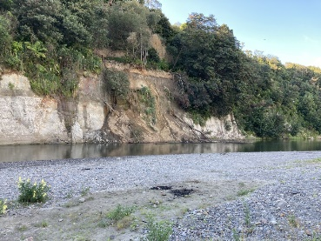

*After a cliff fall:*

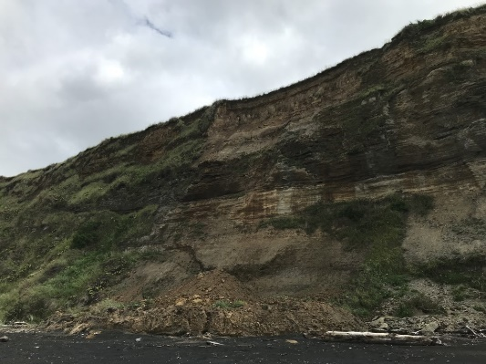

**Typical workflow**

Usually, sampling will be done on Monday and Tuesday. Runs with beaches and lakes tend to be stacked towards the earlier days to allow resampling if necessary. Wednesday, Thursday and Friday are typically resamples, office work and preparing for the next week.

In addition to field work and data entry, you also need to monitor the bottle supply and general equipment state. If you're running low on microbial bottles or 1L bottles, it's your responsibility to restock these. If equipment is broken, report it to Kelly as soon as possible.

You may also have to book vehicles. This is done via the eRoad booking app, and someone in the office can show you how to do it. To keep track of when vehicles need to be booked, you can have a look on the sampling calendar on the freshwater+science teams page.

|  |  |  |  |  |
| --- | --- | --- | --- | --- |
| **Monday** | **Tuesday** | **Wednesday** | **Thursday** | **Friday** |
| * Runs * Data entry into Sampler * Entering cyano status into spreadsheet * Double-checking what the cyano status should be in Sampler | * Runs * Data entry into Sampler * Entering cyano status into spreadsheet * Double-checking what the cyano status should be in Sampler * Archiving any results received from the lab in Sampler | * Resamples (if needed) * Archiving runs with lab results back * Uploading and renaming photos * Extra office work * Assisting other teams if necessary | * Resamples or erecting signage (if needed) * Prepping stickers and books for next week * Archiving runs with lab results back * Stocking CR boxes, making sure all the gear is ready * Extra office work * Assisting other teams if necessary | * Erecting signage (if needed) * Prepping stickers and books for next week * Weekly field work team meeting * Archiving runs with lab results back * Stocking CR boxes, making sure all the gear is ready * Anything left over from Thursday * Extra office work * Assisting other teams if necessary |

## Sampler - Building Runs

Start by going in Sampler. \\file\appdata\Desktop\TSFARM Horizons Desktop Apps

To start building a run click "Add New Run", shown in the red circle below. Now follow the steps below.

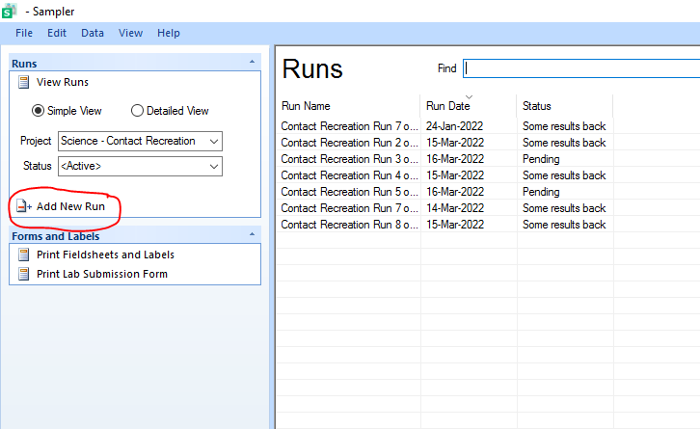

1. Use the drop down menu and select the appropriate run you want to build (named Contact Recreation Run ...)
2. Enter the date dd/mm/yyyy that the run is being completed on.
3. Click build a name. This will show as Contact Rec run … on dd/Mon/yyyy
4. Click build the run
5. Once the run is built check all of the sites are showing, save and close it.

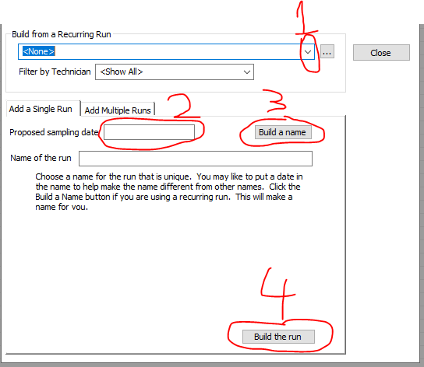

In the event of a resample do the steps 1-4 above. When completing step 5, you can remove any untested sites by right clicking and then clicking remove. Once you only have the site/s that are being resampled, save and close. Once closed any new sites will appear below on the main page of sampler.

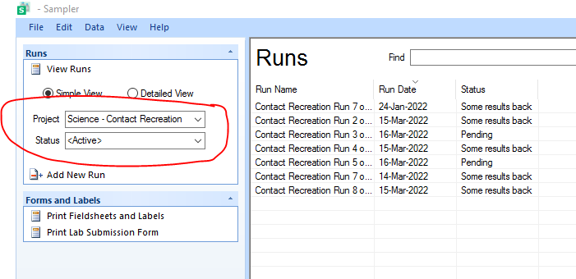

## Writing the books

There are 2 types of books to fill in for each run.

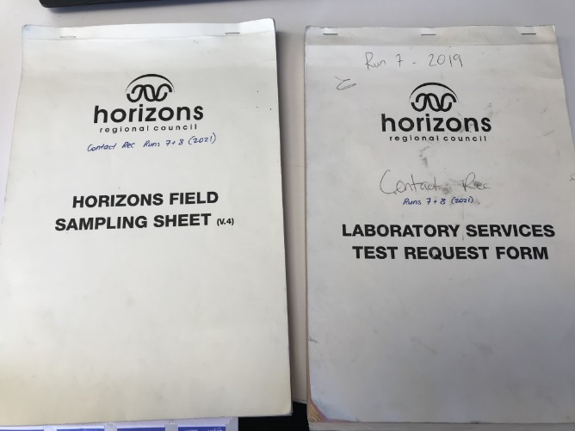

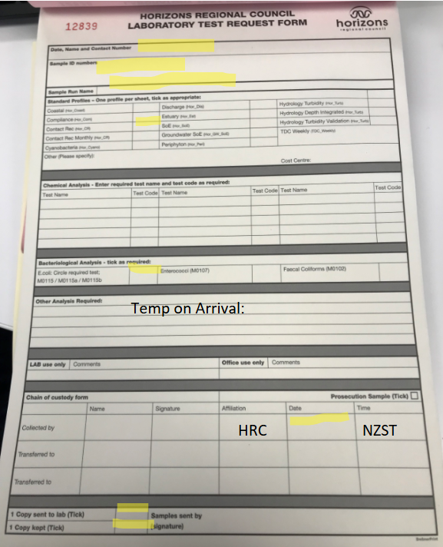

 All of the information you need to fill in is what is happening on the day of sampling, who is sampling, sample numbers and the date. The Sample ID are the numbers specific for the test being done. E.coli is for freshwater sites and enterococci is done for beach sites. This example form would be done for E.coli so you would only write the sample IDs of the freshwater sites for that run. If there are both freshwater and beach sites in a run, two lab forms need to be filled out; one for E.coli and one for enterococci.

 This is a field sampling form. This is what you will be filling in when you are in the field. The week before the runs the books have to be written up, the sections that are highlighted are the sections that need to be filled in. This includes Field Staff, Date Sampled, Run Name, circling sent to lab on same day and circling Contact Recreation.

You will then need to fill in the information about the sites that are being sampled. This is completed when you are setting up sampler, as the information is carried over into the books. When filling in the field sampling books you need to fill in the Sample ID, Source type and site name rows. All of this information can be found on the Sampler run that you would have set up prior to writing up the books.

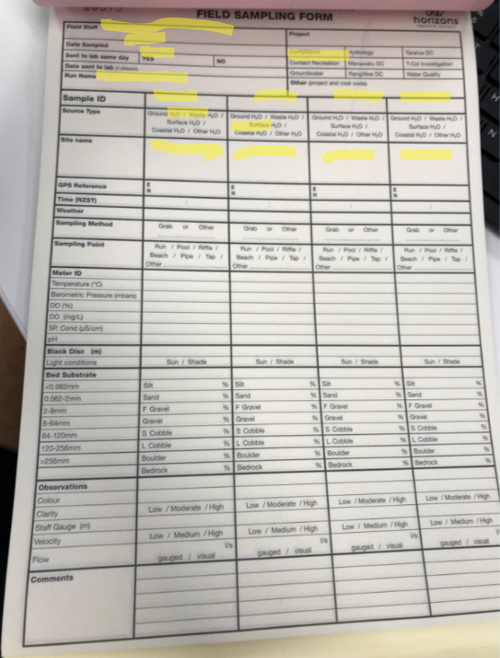

**Collecting Sample ID numbers**

Once you have finished writing up your books you need to get the sample ID numbers from hydro so that you are able to label the water samples. You just need to go to the little room that you walk into before you get to the hydro room. There will be a tray with sample numbers in it. Grab the sample numbers that you need to and leave the other ones in the tray, there is usually a pair of scissors there to cut off the stickers you don’t need.

Once you have collected these you can put them in the relevant book and then you will be all set for sampling!

## Run Guides

The run guides are a great guide, but locations can change. Take note of any useful information and keep the run guides updated.

The run guides provide a list of hazards these need to be kept updated.

Whenever run guides are updated save a new version as well as keeping the old version. Then throw out the old paper copy and print the new one

[\\file\herman\E\WQ\03\02\Contact recreation run guide\Updated Programme 2022\_2023](file://file/herman/E/WQ/03/02/Contact%20recreation%20run%20guide/Updated%20Programme%202022_2023)

## Leaving for the run

Gear List:

* Contact rec box
* Chilly bin with slicker pads in it
* Bacto bottles and lake cyanobacteria bottles (+ one spare & a temp bacto bottle)
* Bathoscope
* PLB (& an in-reach GPS unit on runs 1 & 5)
* Temperature Probe
* Run Guide
* Sample and lab sheets (& lab stickers)
* Waders
* Sampling pole
* Cyano signs
* PFD
* Rain Jacket

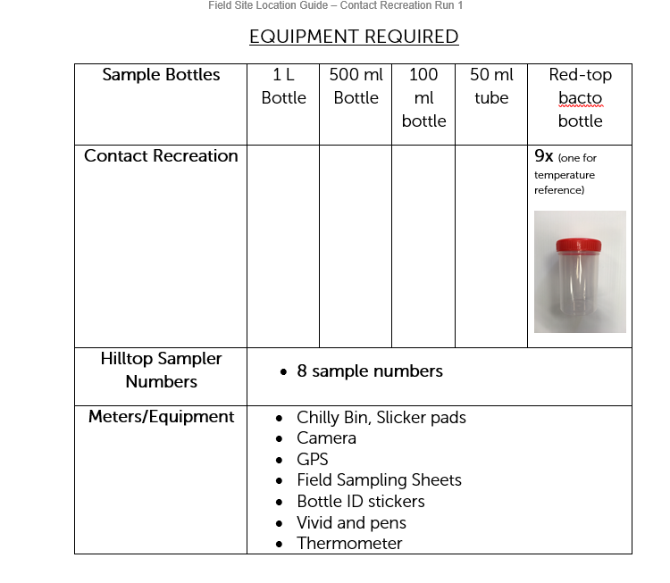

Example of the gear list above.

Once all of the gear is in the car and ready to go:

1. Text your check-in with where you are going and when you intend to be back by
2. Start get home safe, again where you are going and how long you will be.

## Data Entry & QA

Field data is entered at the end of the field sampling day and archived in Sampler as 'some results back' (as we are still waiting for lab results).

Note runs with lakes on them aren't archive on the same day because the Cyano LAWA alert status in Sampler can't be selected until Barry has undertaken his algae counts at the lab. These runs will

[\\file\herman\E\WQ\03\02\Contact Rec 2022-23\Procedures and run guides](file://file/herman/E/WQ/03/02/Contact%20Rec%202022-23/Procedures%20and%20run%20guides)

The above link outlines the general procedures after return to the office. Note that the cyanobacteria status that is sent through to LAWA is decided by a combination of both your day's observation and previous weeks' status, stored in a spreadsheet like this:

\\file\herman\E\WQ\03\02\Contact Rec 2023-24\Cyanobacteria\Cyano alerts 2023-2024.xlsx

2021 has worked differently to previous years due to an increase Covid Response from Public Health however it was agreed that this method is likely the most effective and will continue. Flowcharts of decision making here:

[\\file\herman\E\WQ\03\02\Contact rec 2022\_23\Response Protocols](file://file/herman/E/WQ/03/02/Contact%20rec%202022_23/Response%20Protocols)

## Faecal Source Tracking (FST)

Horizons has a legislative requirement to manage freshwater environments for values including contact recreation (swimming, boating, fishing, anything that involves coming into contact with water).

A risk to human contact value comes from the likelihood of infection by pathogens such as Campylobacter. Many of the pathogens that pose a high risk to human health have significant parts of their life cycle in the gut of warm blooded animals, thus faecal contamination of the water ways by mammals and birds is a significant risk to the value of human contact.

Faecal source tracking (FST) is a process of identifying host organisms at a general level (such as humans, cattle, sheep, birds etc.) through use of molecular tools such as DNA processing. When combined with synoptic surveys, high-risk broad areas of the region (previously identified via SoE monitoring) can be refined down to specific areas and land type so that targeted and appropriate interventions can be applied.

FST information can be found here [\\file\herman\E\WQ\03\02\Faecal Source Tracking](file://file/herman/E/WQ/03/02/Faecal%20Source%20Tracking)

Including the approach document (still in draft form currently) which is used to determine which sites will be FST that sampling year. In 2022-23 sampling season, Mowhanau and Kaikokopu streams will be investigated.

**Lab**

ESR is being used to undertake the e.coli measurements as well as the FST analyses. Quote details can be found in the email here [\\file\herman\E\WQ\03\02\Faecal Source Tracking\2023 FST](file://file/herman/E/WQ/03/02/Faecal%20Source%20Tracking/2023%20FST)

Contact person for this is Paula Scholes, [faecalsource@esr.cri.nz](mailto:faecalsource@esr.cri.nz)

There are 5 markers (2x human, 1x avian, 1x ruminant, 1x general) that will be tested for.

**Sending samples**

Fill in the sample submission form here [\\file\herman\E\WQ\03\02\Faecal Source Tracking\2023 FST](file://file/herman/E/WQ/03/02/Faecal%20Source%20Tracking/2023%20FST)

Print a copy and send with the samples.

Email a copy to [faecalsource@esr.cri.nz](mailto:faecalsource@esr.cri.nz) also letting them know samples are coming their way (a good idea to give them a heads up the day before if possible).

**Sampling timing**

Note the exact timing of this sampling will be variable depending on what you are trying to achieve. Broadly speaking FST is informed by surveillance monitoring such as State of the Environment monitoring, and contact recreation monitoring. These should be used to determine when targeted FST monitoring is undertaken.

Comparing surveillance monitoring to environmental conditions, and the catchment context may be able to inform target FST conditions. For example, if surveillance monitoring shows that high concentrations occur during high flows, low flows, or during holiday periods downstream of a holiday park for example, you may need to target monitoring to best replicate those conditions. If however, flows/rainfall/etc. Don’t appear to influence results (or they are high irrespective of environmental conditions) then you may need to simply try and get a range of conditions.

For these reasons, monitoring doesn't necessarily need to occur during low flows, or summer periods, and may continue into and across winter in some instances. Planning for FST early in the financial year is important to ensure you are best able to target appropriate monitoring conditions.

## Site Photos

Site photos are taken on every run. These are compulsory at certain sites with cliffs that may pose as hazardous in the event of a slip or falling debris. It is often beneficial to take site photos at other non-required sites to record the state of the site on that day. Finding strange occurrences that may affect lab results such as a dead animal should be photographed and recorded. Other newly formed hazards should also be photographed and recorded.

While in the office, photos can be uploaded past the horizons firewall with an app called Q-File.

* (1) Open Q-Fie on your work phone
* (2) Select the NAS folder called pictures
* (3) Select the folder which you will upload photos into. This will often be named (First initial + Last name)
* (4) In this folder select "Upload" in the options menu. Select the photos from your camera that you intend to upload.
* (5) Once uploaded, these photos will be accessible on TS Farm. They can be found under the Network tab in files after inputting the link below.

The link to find your photo folder. Search this link in 'This PC'

[\\upload\pictures](file://upload/pictures)

Photos uploaded into Q-File folders are deleted after 30 days, so these need to be moved to their respective locations before this date. Once site photos are uploaded, they should be named with their sample ID number and sorted into their respective site photo folders found in the contact Recreation File. New signage or newly vandalized/cleaned signage should be placed into a separate signage folder to record the state of the signage across the region.

Setting Up Q-File

[\\file\herman\E\WQ\03\05\Periphyton monitoring\QFile Setup.docx](file://file/herman/E/WQ/03/05/Periphyton%20monitoring/QFile%20Setup.docx)

## Re sample notification email

**When health warning signs are required**

This email is sent to various parties following red resample results or red cyanobacteria results at lakes (not if lakes have high cyano and bacteria levels at the same time, you are still required to resample for ecoli but signs would be erected prior to the ecoli result coming back due to the red cyanobacteria levels). This is to notify all parties that signs will be erected at the affected site, particularly as there are often lots of enquiries when signs do go up.

Send to: public health (both the main contact – [kathryn.knightbridge@midcentraldhb.govt.nz](mailto:kathryn.knightbridge@midcentraldhb.govt.nz) and the general ops email [PublicHealthOps@midcentraldhb.govt.nz](mailto:PublicHealthOps@midcentraldhb.govt.nz)), the relevant TA, cc Environmental Scientist, comms contact and Science Manager

TA contact details can be found here (although need to be updated each year and should be saved in each years new folder): [file:///\\file\herman\E\WQ\03\02\Contact%20Rec%202022-23\TA%20contact%20details.xlsx](file://file/herman/E/WQ/03/02/Contact%20Rec%202022-23/TA%20contact%20details.xlsx)

e.g. (highlighted bits are bits that need changing when email is sent)

"Kia ora tātou,

 This is to notify you that the swim spot Tasman Sea at South Beach was sampled on Tuesday 1 Nov 2022 and returned a red *Enterococci* result (insert result *Enterococci*per 100ml) which triggered the need to resample. The resample occurred on Thursday 3 Nov 2022 and has returned another red *Enterococci* result (insert result *Enterococci*per 100ml).

Horizons will be putting out health warning signs as quickly as practicable to notify the public that it is unsuitable for swimming and the red result is also displayed on LAWA. These signs will remain in place until bacterial levels return to a level deemed suitable for swimming. The next weekly sample is due on Monday 7 Nov 2022.

<https://www.lawa.org.nz/explore-data/manawat%C5%AB-whanganui-region/swimming/tasman-sea-at-south-beach/swimsite>

 Any questions please let me know.

 Ngā mihi nui,

Kelly"

***OR***

"Kia ora tātou,

This is to notify you that the swim spot Lake Dudding was sampled on Tuesday 1 Nov 2022 and returned a red cyanobacteriaresult (insert result mm3/L).

Horizons will be putting out health warning signs as quickly as practicable to notify the public that it is unsuitable for swimming and the red result is also displayed on LAWA. These signs will remain in place until cyanobacteria levels return to a level deemed suitable for swimming. The next weekly sample is due on Monday 7 Nov 2022.

<https://www.lawa.org.nz/explore-data/manawat%C5%AB-whanganui-region/swimming/tasman-sea-at-south-beach/swimsite>

 Any questions please let me know.

 Ngā mihi nui,

Kelly"

**When health warning signs are removed**

If the next weekly sample result returns and Amber or Green alert level health warning signs may be removed. The same people that were notified in the email saying where going up need to be notified that signs will be removed.

e.g.

"Kia ora tātou,

This is to notify you that the swim spot Tasman Sea at Kai Iwi Beach was sampled on Tuesday 7 Feb 2023 and has returned a green *Enterococci*result (86 *Enterococci* MPN per 100ml). As such, the health warning signs that were erected last Friday following the red results will be removed today.

Ngā mihi nui,

Kelly"

**Territorial Authority Contact person Email:**

Tararua District Council Derek McKinon Derek.McKinon@Tararuadc.govt.nz'

Tararua District Council Craig Brown Craig.Brown@Tararuadc.govt.nz'

Rangitikei District Council Gaylene Prince gaylene.prince@rangitikei.govt.nz

Rangitikei District Council Rochelle Baird Rochelle.baird@rangitikei.govt.nz

Ruapehu District Council Phoebe Harrison Phoebe.Harrison@ruapehudc.govt.nz

Horowhenua District Council Leavaai Toremana levaait@horowhenua.govt.nz

Horowhenua District Council Blair Sanson blairs@horowhenua.govt.nz

PNCC generic address eps@pncc.govt.nz

Manawatu District Council Pennie Smith Pennie.Smith@mdc.govt.nz

Whanganui District Council Therese Back therese.back@whanganui.govt.nz

## Cyanotoxin samples

When a lake reaches a certain threshold for cyanobacteria, the samples are prepped using 3x freeze/thaw method (usually done by Barry) and sent to Watercare (although this could change each year depending on procurement processes).

Any queries should be sent to [labsales@water.co.nz](mailto:labsales@water.co.nz) and any lab test forms should be sent to [labclientsupportlist@water.co.nz](mailto:labclientsupportlist@water.co.nz) to let them know to expect samples.

You will need the watercare addres:

52 Aintree Ave, Airport Oaks,

Auckland 2022

New Zealand

You will need a PO from the scientist

You will need a lab test request form which can be found here:

\\file\herman\E\WQ\03\02\Contact Rec 2022-23\Cyanotoxin results and receipts

Fill in the lab test request form and save with the date you are sending the sample in the folder above.

An example of what you need to fill in is below:

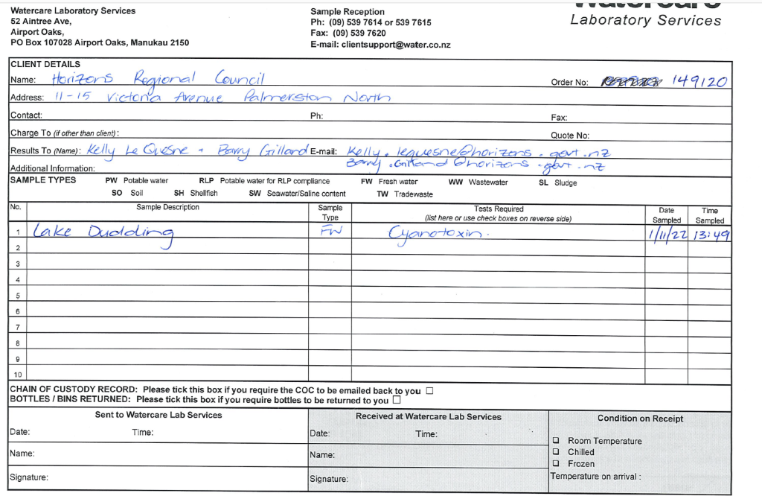

Barry will usually prep the sample and this then needs to be put into a chilly bin with slicker pads and the COC form. Package it up and send it off. Simon should be able to provide you with a courier ticket.

## Erecting Health Warning signs

**Health warning signs**

It is important to note that HRC do not have the authority to 'close' a beach or lake.

HRC are required by MidCentral Public health to put up health warning signs at beaches and lakes when e.coli levels have two consecutive red results. Lakes may also have signs erected if cyanobacteria also reach red alert levels (note: cyanobacteria doesn't require a resample). At some locations, HRC have the help of community groups or camp ground managers to erect signs. These are at Lake Dudding and Waitarere Beach. Information regarding sign procedure for these two groups can be found here: [\\file\herman\E\WQ\03\02\Contact Rec 2022-23\Signage](file://file/herman/E/WQ/03/02/Contact%20Rec%202022-23/Signage)

A stocktake of warning signs occurred in 2022-2023 season to ensure there were enough for everyone. Note that after the 2021-2022 season and the high red activity at Waitarere Beach, there are specific signs identifying Waitarere Beach. These are the LAWA warning signs with the beach name and stream name on them and have been provided to the rate payers association as per the sign procedure document above. The sign stocktake can be found here [file:///\\file\herman\E\WQ\03\02\Contact%20Rec%202022-23\Signage\ContactRecWarningSign%20Stocktake2022.xlsx](file://file/herman/E/WQ/03/02/Contact%20Rec%202022-23/Signage/ContactRecWarningSign%20Stocktake2022.xlsx)

**When signs go out, we are required to notify the relevant TA and public health of the results leading up to the signs being erected. See Resample Email page for details. When sites return to Amber or Green levels, a notification is sent out to the same recipient list noting that the last sample returned x result and the signs will be removed.**

**Cyanobacteria warning signage**

In the past cyanobacteria warning signs were put up at river sites if the site was in the Amber or Red category of cyanobacteria alert, I.e. if coverage is greater than 20%, and/or mats are detaching and/or accumulating at the shore. However from 2022-2023 this is no longer required (approved by Public Health) as new permanent signs showing cyanobacteria and detailing other health and safety messaging have been erected at all swim spot locations.

**Permanent Swim Spot signs**

There are different signs for rivers/streams, lakes, estuaries and beaches. These can be found here [\\file\herman\E\WQ\03\02\Contact Rec 2022-23\Signage](file://file/herman/E/WQ/03/02/Contact%20Rec%202022-23/Signage)

The current site list and location of the new permanent signs can be found here [file:///\\file\herman\E\WQ\03\02\Contact%20Rec%202022-23\Signage\Contact\_Rec\_permanent\_signs\_ALL.xlsx](file://file/herman/E/WQ/03/02/Contact%20Rec%202022-23/Signage/Contact_Rec_permanent_signs_ALL.xlsx)

Photos of new permanent signs at each site can be found here [\\file\herman\E\WQ\03\02\Contact Rec 2022-23\Signage\Photos of new signage at sites](file://file/herman/E/WQ/03/02/Contact%20Rec%202022-23/Signage/Photos%20of%20new%20signage%20at%20sites)

Note that these signs are anti-graffiti and should be able to be washed with multipurpose spray and a cloth.

## Office Jobs

1. Always check sampler first and archive any results that have come in
2. Save any Analytical Results from contact rec emails to this folder. \\file\herman\E\WQ\03\02\Contact rec 2022\_23\E.Coli Emails
3. Check Lawa is up to date and everything is displaying as it should.
4. Build runs for the next week and fill in field books

   5. Upload any photos \\file\herman\E\WQ\03\02\Contact rec 2022\_23\Site Photos

   6. Check science shed for enough bottles and equipment for the next week.

## Old process - Emailing TAs

TA's were previously emailed each week (see details below) however, there is a major drive to get people to check LAWA as this is the quickest way to be notified. Information at the beginning of the 2022-2023 season were sent to relevant TA's, community groups, iwi and any others involved explaining the programme and the process.

Old Procedure below

Each week, the TAs will be sent emails detailing the status of each site affected by cyanobacteria in their district. A list of TAs associated with each site can be found here, along with their contact details:

[\\file\herman\E\WQ\03\02\Contact rec 2021\_22\TA contact details.xlsx](file://file/herman/E/WQ/03/02/Contact%20rec%202021_22/TA%20contact%20details.xlsx)

Each TA will indicate in the above spreadsheet how often they want emails. Each email should follow the format of a table providing site details: (example)

|  |  |  |  |  |  |
| --- | --- | --- | --- | --- | --- |
| Observation Date | Site | District | Cyanobacteria Coverage | Comments | Alert Status |
| 2/11/2021 | Tokomaru at Horseshoe Bend | Horowhenua | 5% | Downgraded from Red | Amber |
| 16/11/2021 | Ohau at Gladstone | Horowhenua | 20% | Detaching | Red |
| 16/11/2021 | Ohau at Muhunoa East Road | Horowhenua | 50% |  | Red |

Note that while the email is sent in the week of the 16th, the downgraded site keeps its original observation date from two weeks ago. The same process is followed for lakes, but you don't need to add in the percentage coverage. You can include a line about when signs will be put out at sites/were put out at sites. The microbial results are not included in the TA emails, as these will be automatically updated on LAWA and do not require signage.

# KiEco instructions

## Where to find instructions

We have a separate Notebook for KiEco instructions which includes information for both the Aquatic Biomonitoring programmes as well as the Biodiversity programmes run by the science team.

The notebook can be found here [KiECO Guide](https://horizonsregionalcouncil-my.sharepoint.com/:o:/r/personal/luke_fullard_horizons_govt_nz/Documents/KiECO%20Guide?d=w5a3adfe634ab4d28afd72d20874fe1c5&csf=1&web=1&e=nbrkVh" \t "_blank)

**Accessing KiEco**

1) Find the WISKI appdata folder:

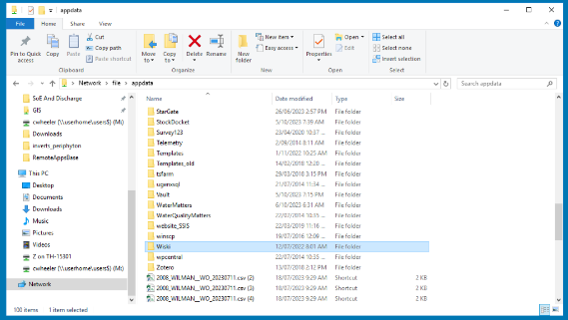

2) Enter the "Live" folder

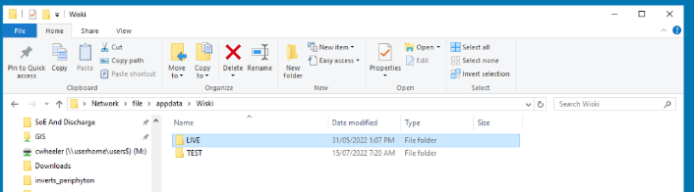

3) Click the app shortcut

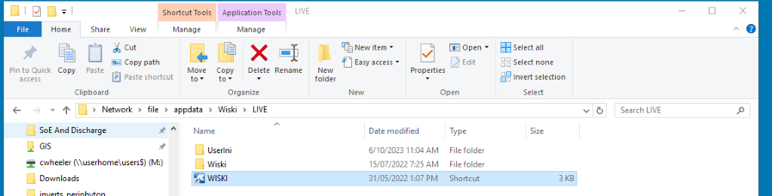

4) Click "Run" on the pop-up window

5) You'll have to configure KiEco the first time you log in. Select "additional options":

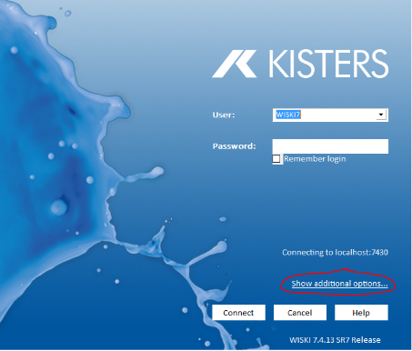

6) Set the host to [wiskiapplive.horizons.govt.nz](mailto:wiskiapplive@horizons.govt.nz) and the port to 7430. Click connect, and accept the security certificate warning.

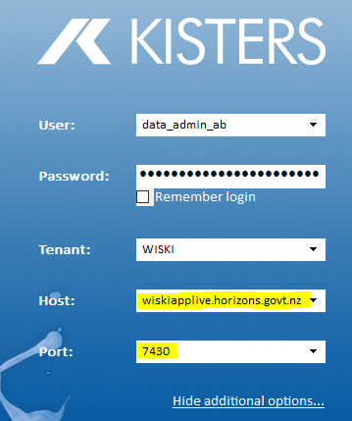

Generating QR codes for samples

With the end of CADDIS, generating QR codes requires using this link: <https://qrcodegenerator.horizons.govt.nz/>

This app looks at KiEco for the selected sampling programmes, so monitoring programmes must be entered into KiEco before QR codes can be generated.

The client code is usually HRC, but can be added if different (e.g. TDC). The survey code can be confirmed with the relevant scientist, and the month is the sampling month rather than the generating month (I.e. making QR codes in January for sampling in February, the month will be February).

The most likely error will be selecting the wrong sampling programme, as it pulls all monitoring programmes from KiEco. Missing sites from a programme will need to be added manually in KiEco. Selecting "print" will print the sticky labels.

Damaged or lost stickers can be replaced by selecting "reprint" in the top-left menu. Re-enter the relevant dates, etc to access the same monitoring programme, and select the sites you need to re-print. You can also select the printing position of the labels in a subsequent page to save using a whole label sheet for only one or two labels.

1. The first is an Aquatic biomonitoring user log in. This one can view everything in the database and (I think) export data at a later date, but cannot edit anything:

**Username:** AB\_user

**PW:** Fish\_are\_Friends\_2022

1. The second is aquatic biomonitoring data admin. This user can view all data but only edit the aquatic biomonitoring data (i.e. they can’t accidentally edit the EcoBase biodiversity data).

**Username:** data\_admin\_ab   
**PW:**2022\_Just\_Keep\_Swimming

# Lakes

## Overview

All info can be found here [\\file\herman\E\WQ\03\04](file://file/herman/E/WQ/03/04)

There are currently 17 lakes sampled as part of the SoE programme on a monthly basis. These are typically grouped in the following groups:

* **Boat** – pauri, wiritoa, dudding, horowhenua (by helicopter until boat ramp is opperational)
* **Helicopter**(coastal lake run) - westmere, kohata, waipu, koitiata, Heaton, William, Herber, Alice, Omanuka Lagood, Pukepuke Lagoon, Koputara
* **Shore**– Papaitonga, hokowhitu lagoon

This programme is primarily led out through the Special Projects team in Hydro.

There are two types of tests that may be performed for lakes:

1) Algal counts for all lakes. This is a standard analysis of full algal counts and biovolumes for any cyanobacteria species present. These samples are sent off on overnight couriers once they have been sampled (sampling is conducted by the Special Ops team in hydro) and the results are emailed through to the Scientist, WQ email, ED team and Lizzie.

2) Cyanotoxin analysis. The samples for cyanotoxin analysis are stored in the freezer until the algal count results come back which have cyanobacteria biovolumes for all cyano species present. Cyanotoxin analysis only takes place for samples that have a cyanobacteria biovolume of 0.5mm3 or greater. Samples with a lower biovolume may be defrosted and tipped out (keeping the glass bottle). We wait until there are 10+ samples for cyanotoxin analysis before sending to the lab.

There are also some other smaller projects that are part of the programme including LakeSPI, weed mapping and bathymetry.

## Scientist Stuff

The Lakes SoE monitoring information can be found here [\\file\herman\E\WQ\03\04\Lakes SoE Monitoring](file://file/herman/E/WQ/03/04/Lakes%20SoE%20Monitoring)

There are currently 17 lakes sampled monthly for WQ and algae (cyanotoxin and general counts).

This programme is currently charged to the groundwater portfolio GMR100\_603

* Hydro Special Ops team organises the sample collection for WQ (sent same day as collection), algae (sent same day as collection) and cyanotoxin (frozen until results come back; they are then defrosted or kept (until there are 10+ samples) in the freezer for cyanotoxin testing.
* The Hydro special ops team also look after the helicopter charges (still from GMR budget) and the invoices are put into our PO tracking spreadsheets. Check this periodically to ensure the charges go into the PO tracking spreadsheet. Current PO is [146938](http://ozoneapplive.horizons.govt.nz/live/ozone.web/default.aspx?cmd=@PO9300&id=146938)
* Science Scientist raises the PO each month (or you can do one big one) for the algae counts which includes for each run:
  + Cell counts
  + Biovolume
  + CSV file
  + Handling fee/postage
  + POs for lakes are
    - Feb [145342](http://ozoneapplive.horizons.govt.nz/live/ozone.web/default.aspx?cmd=@po9300&id=145342)
    - Mar [145343](http://ozoneapplive.horizons.govt.nz/live/ozone.web/default.aspx?cmd=@po9300&id=145343)
    - April [145344](http://ozoneapplive.horizons.govt.nz/live/ozone.web/default.aspx?cmd=@po9300&id=145344)
    - May [145345](http://ozoneapplive.horizons.govt.nz/live/ozone.web/default.aspx?cmd=@po9300&id=145345)
    - June [145346](http://ozoneapplive.horizons.govt.nz/live/ozone.web/default.aspx?cmd=@po9300&id=145346)
* Environmental Scientist will receive count results (as well as [WQlabresults@horizons.govt.nz](mailto:WQlabresults@horizons.govt.nz), Science Manager and currently David Brown from hydro) and will forward them to an RA to determine if cyano samples should be defrosted or sent for cyanotoxin testing. Scientist raises the PO for cyanotoxin analysis as required (wait until there are 10+ samples before sending to ensure we get the 30% discount).

**Procurement and contracts**

NIWA is used for the algal counts and the current contract runs until the end of 2023-2024 FY.

Cawthron is used for the cyanotoxin testing and the current contract runs until the end of 2023-2024 FY.

ELS (Eurofins) is used for the water quality processing. Procurement and contracts are covered as one big WQ contract through a tender process. This contract is up for renewal this FY (2022-2023) with Darren from Hydro leading this out (see WQ section for more info).

NIWA and Cawthron procurement and contract details can be found here;

* [\\file\herman\D\SR\01\01\Procurement\Lakes\Phytoplankton 2021 - 2022](file://file/herman/D/SR/01/01/Procurement/Lakes/Phytoplankton%202021%20-%202022)
* [\\file\herman\O\MS\06\07\2021-2022](file://file/herman/O/MS/06/07/2021-2022)

Previous scientists have provided information in their Handover documentation here.

[file:///\\file\herman\E\WQ\03\04\Lakes%20SoE%20Monitoring\Lake%20Water%20Quality%20Handover%20-Janine-%20June%202019%20(updated%20May%202021).docx](file://file/herman/E/WQ/03/04/Lakes%20SoE%20Monitoring/Lake%20Water%20Quality%20Handover%20-Janine-%20June%202019%20(updated%20May%202021).docx)

**Lake SPI**

This is part of the lake portfolio and is conducted by NIWA usually. Lakes are identified that have not been sampled before. The lakes priority can be decided before approaching NIWA and then NIWA will be able to give indications of timeframes, costs etc.

Procurement documentation for all of these can be found here:

[\\file\herman\D\SR\01\01\Procurement\Lakes](file://file/herman/D/SR/01/01/Procurement/Lakes)

## Creating Labels

The RA's are taking over the label making. This needs to be completed monthly around the middle of the month for the Hydo team. We need to get a PO # for each month, this is done by the environmental scientist. (can be done monthly or do the year in one go)

|  |  |  |  |  |  |
| --- | --- | --- | --- | --- | --- |
| **Project Name** | **Generated** | **Labels** | **Chain of custody** | **Handover** | **Po Number** |
| Lakes SOE July 2023 | y | y | y | y | 1138 |
| Lakes SOE August 2023 | y | y | y | y | 1396 |
| Lake SOE September 2023 | y | y | y | y | 1980 |
| Lakes SOE October 2023 | y | y | y | y | 1981 |
| Lakes SOE November 2023 | y | y | y | Y | 1982 |
| Lakes SOE December 2023 | y | y | y | y | 1983 |
| Lakes SOE January 2024 | y | y | y | y | 1985 |
| Lakes SOE February 2024 | y | y | y | y | 1986 |
| Lakes SOE March 2024 | y | y | y | y | 1987.1 |
| Lakes SOE April 2024 | y | y | y | y | 1988.1 |
| Lakes SOE May 2024 | Y | y | y | y | 1989.1 |
| Lakes SOE June 2024 | y | y | y | y | 1990.1 |

|  |  |  |  |  |  |
| --- | --- | --- | --- | --- | --- |
| **Project Name** | **Generated** | **Labels** | **Chain of custody** | **Handover** | **Po Number** |
| Lakes SOE July 2024 | y | y | y | y | 9880 |
| Lakes SOE August 2024 | y | y | y | y | 10886 |
| Lake SOE September 2024 | y | y | y | y | 11275 |
| Lakes SOE October 2024 | y | y | y | y | 11335 |
| Lakes SOE November 2024 | y | y | y | y | 12581 |
| Lakes SOE December 2024 | y | y | y | y | 13310 |
| Lakes SOE January 2025 | y | y | y | y | 13658 |
| Lakes SOE February 2025 | y | y | y |  |  |
| Lakes SOE March 2025 | y | y | y |  |  |
| Lakes SOE April 2025 | y | y |  |  |  |
| Lakes SOE May 2025 | y |  |  |  |  |
| Lakes SOE June 2025 | y |  |  |  |  |

|  |  |  |  |  |  |
| --- | --- | --- | --- | --- | --- |
| **Project Name** | **Generated** | **Labels** | **Chain of custody** | **Handover** | **Po Number** |
| Lakes SOE July 2025 |  |  |  |  |  |
| Lakes SOE August 2025 |  |  |  |  |  |
| Lake SOE September 2025 |  |  |  |  |  |
| Lakes SOE October 2025 |  |  |  |  |  |
| Lakes SOE November 2025 |  |  |  |  |  |
| Lakes SOE December 2025 |  |  |  |  |  |
| Lakes SOE January 2026 |  |  |  |  |  |
| Lakes SOE February 2026 |  |  |  |  |  |
| Lakes SOE March 2026 |  |  |  |  |  |
| Lakes SOE April 2026 |  |  |  |  |  |
| Lakes SOE May 2026 |  |  |  |  |  |
| Lakes SOE June 2026 |  |  |  |  |  |

**Generating QR codes**

Using the QR code Generator: [https://qrcodegenerator.horizons.govt.nz/](https://aus01.safelinks.protection.outlook.com/?url=https%3A%2F%2Fqrcodegenerator.horizons.govt.nz%2F&data=05%7C01%7CIzzie.Hodgson%40horizons.govt.nz%7C9a6bee09f3574b1aa37308db8973eaec%7C47e86e5354ba4f05b744f7c9d11b4c63%7C0%7C0%7C638254903184641386%7CUnknown%7CTWFpbGZsb3d8eyJWIjoiMC4wLjAwMDAiLCJQIjoiV2luMzIiLCJBTiI6Ik1haWwiLCJXVCI6Mn0%3D%7C3000%7C%7C%7C&sdata=AUmNE26814ef9%2FAVcKr0wC5gW42FEhd49JaW%2BYsuiMU%3D&reserved=0)

In the far left top corner of the App there is 2 options to generate new codes or to re print

This app looks at KiEco for the selected sampling programmes, so monitoring programmes must be entered into KiEco before QR codes can be generated.

The client code is usually HRC, but can be added if different (e.g. TDC). The survey code can be confirmed with the relevant scientist, and the month is the sampling month rather than the generating month (I.e. making QR codes in January for sampling in February, the month will be February).

The most likely error will be selecting the wrong sampling programme, as it pulls all monitoring programmes from KiEco. Missing sites from a programme will need to be added manually in KiEco. Selecting "print" will print the sticky labels.

Damaged or lost stickers can be replaced by selecting "reprint" in the top-left menu. Re-enter the relevant dates, etc to access the same monitoring programme, and select the sites you need to re-print. You can also select the printing position of the labels in a subsequent page to save using a whole label sheet for only one or two labels.

For lakes there are 2 sets of survey codes PHY and WQU

Program is "Lakes Sampling YYYY"

**Create stickers**   
\\file\herman\D\SR\15\02\Lakes Labels   
Create new folder for the new month, copy template in there.   
Copy SampleIDs into stickers. 3 stickers per lake.

Damaged or lost stickers can be replaced by selecting "reprint" in the top-left menu. Re-enter the relevant dates, etc to access the same monitoring programme, and select the sites you need to re-print. You can also select the printing position of the labels in a subsequent page to save using a whole label sheet for only one or two labels.

When printing the stickers scroll to the bottom of the page and hit print



DO NOT PRINT DOUBLE SIDED!

You will need to go into printing preferences select printer either Arena level 2 or science copier (at regional house) in put tray need to be changed to bypass Tray. The stickers need to be loaded face down onto the tray



**Fill out the chain of custody form**   
\\file\herman\D\SR\15\02\Lab Sample Forms (Chain of Custody)\NIWA   
Enter PO   
Enter Sample IDs    
Ensure “Full: is selected for Analysis required.

**Print, double check Sample IDs and give to Brownie**

## Results

Checking samples monthly

When checking to see what samples need to be thrown away or sent, you can look at the date/site combo or check the proper sample ID's. There should be two sample ID's, one for water quality (e.g.HRC2021WQU00754) and there will be another one for Phytoplankton (e.g. HRC2021PHY441). The phytoplankton number will come back on the lab results that are used to determine whether it needs to be thrown or sent. Check this ID with the water quality one to make sure that you get the right sample.

Tracking Spreadsheet

The purpose of the spreadsheet is to keep track of all the samples over the 0.5mm3 biovolume threshold that have been sent for cyanotoxin testing. Each month the spreadsheet will need to be updated, it can be found here:

[\\file\herman\E\WQ\03\04\Algae Samples\Biotoxin Sample tracking\Biotoxin Sample tracking 2021-22.xlsx](file://file/herman/E/WQ/03/04/Algae%20Samples/Biotoxin%20Sample%20tracking/Biotoxin%20Sample%20tracking%202021-22.xlsx)

For June 2022-2023 data:

[\\file\herman\E\WQ\03\04\Algae Samples\Biotoxin Sample tracking\Biotoxin Sample tracking 2022-23.xlsx](file://file/herman/E/WQ/03/04/Algae%20Samples/Biotoxin%20Sample%20tracking/Biotoxin%20Sample%20tracking%202022-23.xlsx)

For July 2023-June 2024 data:

[file:///\\file\herman\E\WQ\03\04\Algae%20Samples\Biotoxin%20Sample%20tracking\Biotoxin%20Sample%20tracking%202023-24.xlsx](file://file/herman/E/WQ/03/04/Algae%20Samples/Biotoxin%20Sample%20tracking/Biotoxin%20Sample%20tracking%202023-24.xlsx)

Referring to the CVS file from NIWA, enter the date, Phyto sample ID, Lake name and Total Cyano (mm3/L) into the spreadsheet.

Under the Recreation Guideline column, copy and paste the corresponding orange or red warning into the column and highlight the entire row the same color.

In the Comments column list the species (found in the CSV file) that are over the 0.5mm3 biovolume.

Columns H, J, K and L can just be copy pasted, they will not change.

## Sending Samples

Lake samples get sent for cyanotoxin analysis when it is over the threshold of 0.5mm3 biovolume (this is the Amber threshold for contact recreation). Environmental Monitoring scientist will send us the results of samples and any that are under the threshold need to be defrosted and thrown away. Any that are equal to or over that threshold we send off for analysis.

When we send lake samples we wait for 10 or more samples (bulk analysis discount) before we send them off.

Sending samples: Filling out Forms

PO (on the form it says order #) is 139557

When filling in the form:

* Customer name is Horizons RC
* Email to Ian, David Brown, and [WaterQuality@horizons.govt.nz](mailto:WaterQuality@horizons.govt.nz).
* Postal address is regional house (15 Victoria Avenue, Palmerston North 4410)
* Ask Ian for a new PO
* invoice to [accounts@horizons.govt.nz](mailto:accounts@horizons.govt.nz)
* Reference Lake SoE cyanotoxin samples
* phone # 0212277423 (Kelly's number)
* samples collected by David Brown and Amy Feck
* tick CSV Report
* Enter site info stuff for the samples being sent (sample type water, don’t worry about the other comments)
* Under Biotoxin tests tick microsystin/nodularin Bloom water and the anatoxin boxes and the yes its frozen.

Sending Procedures

Sending the samples is similar to sending the periphyton samples (i.e. package them in chilly bin and put the address on then hit up Simon to put courier tags etc on).

Print out a copy of the testing/submission form and put that in the chilly bin as well.

Make sure to email the lab with the form so they know the samples are on the way and cc Kelly into the email as well.

Samples@cawthron.org.nz

Form Links

Link to the submission form to fill out:

<file://file/herman/D/SR/15/02/Biotoxin%20Sample%20tracking/2025_CawthronBiotoxinSubmission_CoCform.pdf>

More space here if you have more than 6 samples being sent:

\\file\herman\D\SR\15\02\Biotoxin Sample tracking\supplemental2025\_CawthronBiotoxinSubmission\_CoCform.pdf

This form only goes along with the main submission form above; it cannot be sent alone

Save your submission form in month/year format here:    
\\file\herman\D\SR\15\02\Biotoxin Sample tracking\2025SubmittedBiotoxinSamples

Postal address:

\\file\herman\E\WQ\03\04\Lakes SoE Monitoring\2021-2022\Appendix

FW9-Freshwatermicroalgaesampleform.docx

[file:///\\file\herman\E\WQ\03\04\Lakes%20SoE%20Monitoring\2021-2022\Address%20to%20send%20samples.docx](file://file/herman/E/WQ/03/04/Lakes%20SoE%20Monitoring/2021-2022/Address%20to%20send%20samples.docx)

Should look like this with the PO number from Ian as the Order No.:

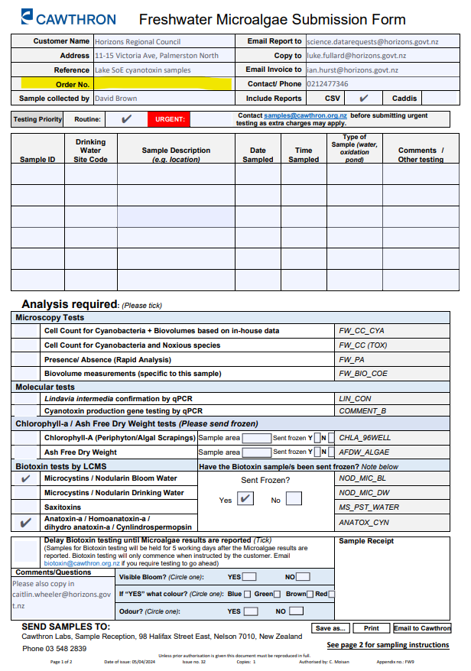

# Coastal and Estuary

## Scientist stuff

Information about this portfolio can be found here [\\file\herman\E\WQ\03\05\Coastal and Estuary](file://file/herman/E/WQ/03/05/Coastal%20and%20Estuary)

A small portion of the Coastal and Estuary portfolio is made up of monthly WQ sampling (read more in the Water Quality section).

A larger portion is made up by Estuary sediment and macrofauna monitoring. This includes broad scale monitoring, fine scale monitoring, synoptic surveys (often used to initially decide what further monitoring should be conducted) and sedimentation plates. A list of the surveys that have been conducted and ideal timeframes for the next round of survey types can be found here:

[file:///\\file\herman\E\WQ\03\05\Coastal%20and%20Estuary\Estuary%20habitat%20mapping%20and%20ecological%20monitoring\LTP%20Estuary%20mapping%20of%20horizons%202023.xlsx](file://file/herman/E/WQ/03/05/Coastal%20and%20Estuary/Estuary%20habitat%20mapping%20and%20ecological%20monitoring/LTP%20Estuary%20mapping%20of%20horizons%202023.xlsx)

# Health and Wellbeing

## PLB checks

Personal locator beacons (PLB) should be checked every 3 months during the off week to ensure they are still in working condition. Make sure to log these checks in the Vault Check app. To undertake a PLB check, follow these instructions:

* [\\file\herman\E\WQ\03\05\Supplies\PPE\PLB manual Inspec procedures.pdf](file://file/herman/E/WQ/03/05/Supplies/PPE/PLB%20manual%20Inspec%20procedures.pdf)

## Check-ins

Check-ins (or Science Duty Officers outside of normal working hours) are used when staff go out of the office (typically for field work) as a health and safety measure to ensure that everyone one who is out and about gets home safe and that someone in the office knows where they are, what they are doing and when they should be back.

Check-ins will receive a txt from the staff member heading out as they leave with their destination and expected return time. They should also be able to see their active GHS. Once the staff member returns they will turn off their GHS and txt the check-in saying they have returned. Check-ins must respond to both txts (this is important if someone GHS goes off or you are check-in for multiple people as sometimes its hard to keep track of if you did see a person when they came back or not)

Requirements:

* 'Supervisor' status on Get Home Safe.
  + This allows the check-in to see the GHS status of the staff member in the field and allows the check-in to receive notifcations/alerts if GHS is activated.
  + This can be organised through the group PA.
* Access to ERoad and the vehicles they are using (usually the science vehicles but sometimes pool vehicles are regularly used.
  + This allows you to GPS track the vehicles as a back-up if GHS fails to track.
  + Access can be organised through Kristy in Assets
* Must understand the requirements of the overdue persons procedure.
  + This can be found here <https://horizonsregionalcouncil.sharepoint.com/ControlledDocuments/Forms/AllItems.aspx?id=%2FControlledDocuments%2FHMP%2024%20%2D%20Remote%20or%20Isolated%20Work%20%28Version%202%2E6%29%2Epdf&parent=%2FControlledDocuments>
* Must understand the requirements of a Science duty officer.
  + SOP can be found here [file:///\\file\herman\D\SR\01\01\Duty%20Officer%20SOP\20221206\_Science%20and%20Innovation%20Duty%20Officer%20SOP.docx](file://file/herman/D/SR/01/01/Duty%20Officer%20SOP/20221206_Science%20and%20Innovation%20Duty%20Officer%20SOP.docx)

## PFD checks

PFDs should be checked once a month during the off week to ensure they are still in working condition. Make sure to log these checks in the Vault Check app. To undertake the PFD check, follow the instructions in this document or the instructions on the Vault Check app:

[\\file\herman\E\WQ\03\05\Supplies\PPE\PFD Inspection Procedures.pdf](file://file/herman/E/WQ/03/05/Supplies/PPE/PFD%20Inspection%20Procedures.pdf)

Annual checks are completed by David Brown from the ED team.

## GetHomeSafe App

Start the GetHomeSafe App to track your location throughout the day. Select a preprogrammed run or custom run and how long this will take you. Start tracking and remember to finish tracking when you return to the office. Log into [GetHomeSafe](https://www.gethomesafe.com/" \t "_blank) to see your activities.

Along with setting up GetHomeSafe, take an InReach unit with you. InReach units help to track your movements more accurately when you are out of cellphone coverage. At the end of setting up your GetHomeSafe activity a prompt screen will appear (image on the right) asking if an external GPS device is being used today. Select the device you are using (e.g. NRP 9) or simply click no. Currently Regional House carries two Inreach units, NRP9 and NRP10, so your selections of InReach unit will probably be one of these options. There is a booking Calander which is used to book the units on email, you will have to ask Maria Burgess to get permission to edit this document so you are able to make bookings for when you are in the field.

Both of these units are kept in Maria Burgess's office, on the far side of her computer. They stay plugged into her computer for the time they are not being used in the field. When taking one of the units, you can take the charging cord as well, as the science ute has an adapter which can be used to charge the unit if its battery is running low.

This should be taken on all runs where we know there is no cellphone coverage. These include nearly all periphyton runs, in which many of them have patchy coverage. There is a guide on how to set up the InReach unit (images below), but it is pretty simple as you just need to turn it on and the GetHomeSafe app will pick it up automatically. You are able to complete the training module here: <https://rise.articulate.com/share/HYpnWSW4wwHck_kvT8iTInSixaXDAExb#/>

This gives context on how the external devices work and how you are able to send messages and alerts to the check ins.

Another app, Earthmate can be downloaded alongside the InReach units, which can be used to send messages to people to let them know you are ok or alternatively not.

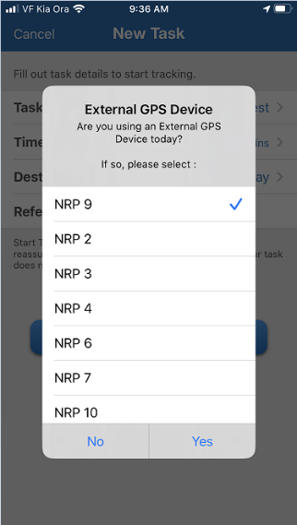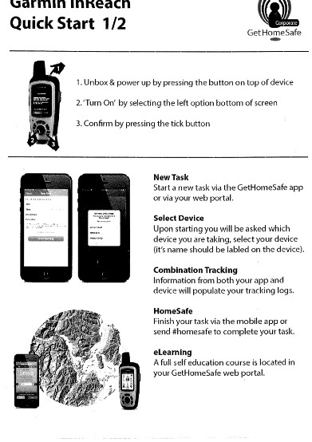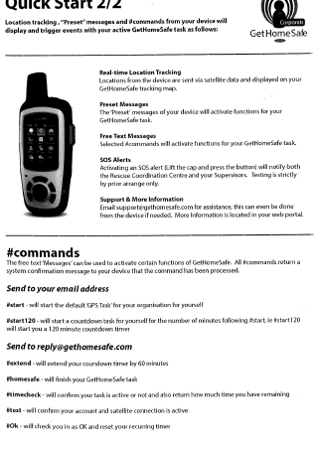

## Required training and PPE

**PPE**

* Waders – we get custom waders from Safety and Apparel. Generally we only require thigh/hip waders.  in which case it is a good idea to go in-store to try the gumboots and then measurements A and F would need to be filled in. Order the waders online via your HRC log-in and then send in the custom wader form. These are $428.50+GST.
  + <https://www.safetyandapparel.co.nz/Magnum-Thigh-Wader-with-Bata-Safety-Gumboot-Custom-Make>
  + [orders@safetyandapparel.co.nz](mailto:orders@safetyandapparel.co.nz)
* High viz – Safety and apparel also supply high viz rain jackets ($110.70 + GST) and vests ($28.57 + GST) <https://www.safetyandapparel.co.nz/Bisley-3M-Taped-Hi-Vis-Stretch-PU-TTMC-W17-Jacket> and <https://www.safetyandapparel.co.nz/TTMC-W-Taped-Hi-Vis-Polyester-Open-Mesh-Vest-With-Horizons-Logo>)
* Sun protection – wide-brimmed hats can also be sourced from Safety and Apparel for $15.90 + GST <https://www.safetyandapparel.co.nz/Headwear-Wide-Brim-Sun-Hat>

**External courses**

River safety – working in and around water requires us to have undertaken a Workplace River Safety Staff Training Seminar <https://www.mangaweka.co.nz/river-safety-programme>.

* Price is $240 +GST p/p but a minimum of 4 people are required so they may be able to go along to another seminar. This is a full day training which involves hazard and risk identification, and practice with self-rescue techniques. These are usually run between Dec and Mar each year while the weather is suitable.
* You need to contact Evan Lloyd (H&S advisor) from People & Capability to organise a time (usually there are specific HRC sessions)

First aid – a comprehensive first aid course is required.

* HRC does this through Red Cross which both a classroom component (1.5days) and an online component (approx. 4hrs). This is $235 incl GST. Courses and times to book can be found here [https://first-aid.redcross.org.nz/book-course/comprehensive-first-aid?\_gl=1\*1lqgdar\*\_ga\*MzQ0MDU1Njc3LjE2MzMyOTczOTk.\*\_ga\_S1VQRYM2H2\*MTY3MTE1ODg3Mi4xMi4xLjE2NzExNTg5OTEuNTcuMC4w](https://first-aid.redcross.org.nz/book-course/comprehensive-first-aid?_gl=1*1lqgdar*_ga*MzQ0MDU1Njc3LjE2MzMyOTczOTk.*_ga_S1VQRYM2H2*MTY3MTE1ODg3Mi4xMi4xLjE2NzExNTg5OTEuNTcuMC4w)
* You need to contact Evan Lloyd (H&S advisor) from People & Capability to organise a time and book a session (usually 1.5-2 days).

For those doing E-fishing they will also need to attend an E-fishing course run by NIWA prior to operating the EFM. This can be organised directly through NIWA

# GIS

## GIS Intro

The Bio Monitoring Login is as below

Username :    ScienceBioMonitoring

- Password:     Fish\_are\_Friends\_2022

A geographic information system (GIS) is a framework for gathering, managing, and analyzing data. Rooted in the science of geography, GIS integrates many types of data. It analyzes spatial location and organizes layers of information into visualizations using maps and 3D scenes. With this unique capability, GIS reveals deeper insights into data, such as patterns, relationships, and situations—helping users make smarter decisions.

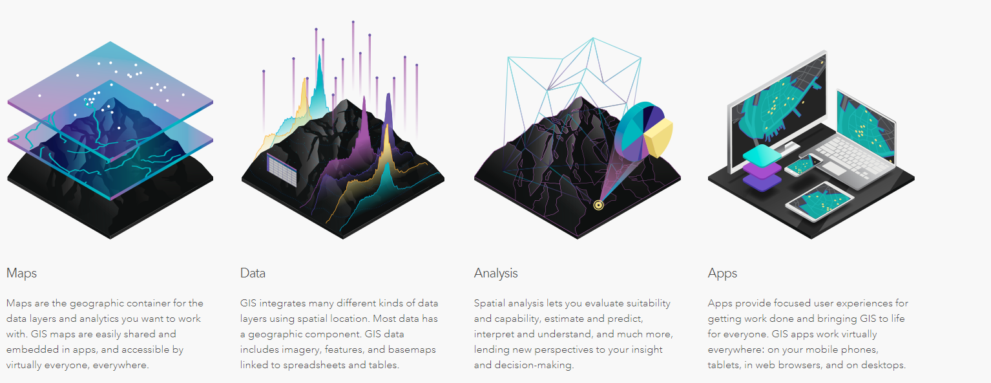

**GIS at Horizons**

GIS at Horizons is looked after by the Catchment Information team.

To access and use GIS at Horizons we use the ESRI suite of programs. The most relevant programs for this job are ArcMap and Arc GIS Online (AGOL). Arc map cab be found through "Remote Apps" ([\\file\appdata\Desktop\RemoteApps](file://file/appdata/Desktop/RemoteApps)) and AGOL through the internet browser of your choice at <https://horizonsrc.maps.arcgis.com/home/index.html>

ArcMap

<https://www.esri.com/en-us/arcgis/products/arcgis-desktop/overview>

Arc GIS Online

<https://doc.arcgis.com/en/arcgis-online/get-started/what-is-agol.htm>

## GIS Data

GIS data at Horizons is stored in a number of spots. Luckily for us the Catchment Information team has already created a fantastic guide that helps us find, understand, and access data. The guide can be found here - http://geoportal/

For Water quality and bio-monitoring the relevant data sites mainly in 2 points

1) The water and One Plan database connections

2) The GIS data folder connection - \\gisdata\gis\Department\Research\Biodiversity\Aquatic Biodiversity

**Data Structure within Aquatic Biodiversity**

Currently there is no real structure to the data within the except sticking data where you feel is relevant.. And Rember where it is...

In saying that there is an ongoing attempt to better document and clean up the GIS data.  Below are some guidelines that should be followed in order to maintain the structure

* Superseded data should be placed in the archive folder.
* Data should always be placed in a folder with a relevant name. Please do not put mxds or shapefiles in the root folders.
* Files should all be named appropriately.
* Try to limit the overuse of mxds (this will be majorly reduced when we move to arc gis pro)
* Use the base layer provided by CI rather than making copies in our folders.

Working folders

There are folders within [\\gisdata\gis\users](file://gisdata/gis/users) that can be used to store personal GIS files or working files.

Base maps

Catchment information have created some good mapping templates for us to use. They can be found here: [\\gisdata\gis\MapTemplate](file://gisdata/gis/MapTemplate)

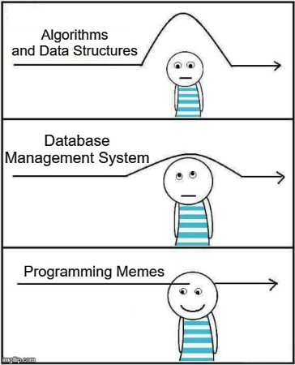

## Local Maps Public and Internal

Internal and external local maps is a powerful tool. Local Maps can be found here [\\file\appdata\Desktop\TSFARM Horizons Desktop Apps](file://file/appdata/Desktop/TSFARM%20Horizons%20Desktop%20Apps)

## Learn ArcGIS

There are some useful (and free!) courses to help with ArcGIS

<https://www.esri.com/training/catalog/search/>

<https://learn.arcgis.com/en/projects/get-started-with-arcgis-online/>

<https://learn-arcgis-learngis.hub.arcgis.com/>

# eDNA

## Intro

**General overview of environmental DNA**

Living organisms constantly release, slough or otherwise loose  organic material to their surrounding environment. This can be in the form of skin cells, scales, hair, faecal material, reproductive material, or other organic matter, all of which contains DNA. Advances in genetic technologies allow samples of this collected organic material to be analysed in such a way that it is possible, under appropriate circumstances, to ascertain the taxa of origin of the material, even when there is a vast array of material present.

In practise this allows samples of water to be collected and analysed against a database of known taxa DNA sequences.

Lotic environments such as rivers and streams are ideal environments for the collection of eDNA. High energy flowing water entrains organic material in the water column, transporting it potentially great distances downstream. This allows for water (and its associated organic material) at a given location to be sampled, with all species that may have shed DNA into the waterway upstream of this point having a chance of being detected. However, increased volumes of shed DNA and proximity to the sample site increase likelihood of detection.

 eDNA was historically sampled within the fishing programme, however as technology progresses, it is becoming a programme in its own right.

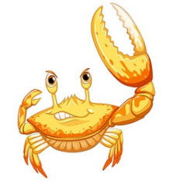

## Sample collection

**Collecting samples**

Equipment for standard sampling:

* 3 x eDNA sampling packs from Wilderlab - each pack should include: 1 x 60mL syringe, 1 x pair of gloves, 1 x ziplock bag with ID label containing 1 x syringe filter and 1 x preservative syringe
* GPS record sampling location (if available)
* Pencil
* Caulking gun(s) - to use if when your arms get weak
* Chilly-bin or box to store samples out of the light until they are posted.
* Spare nitrite gloves and eDNA kit

**Before Leaving the Office**

Double check you have all the right gear before you leave.

Make sure you have a check-in buddy that knows what run you are doing/sites visiting (and where to access the run guide) and what time you will be back. Please remember to txt them when you return safely.

Also start the GetHomeSafe App to track your location throughout the day. Log into [GetHomeSafe](https://www.gethomesafe.com/" \t "_blank) to see your activities. Along with setting up GetHomeSafe, take an InReach unit with you. Another app, Earthmate can be downloaded alongside the InReach units, which can be used to send messages to people to let them know you are ok or alternatively not.

**Sample collection:**

Aim to carry out sample when water level is low and ideally not within two weeks of bed movement/3 x median flow. No not carry out sampling if water is noticeably discolored or swollen following rain fall.

At each site three samples (replicates) should be collected

AVOID CONTAMINATION: make sure you handle the kit with gloves and sample upstream of where you and others are standing. Note any possible contamination sources if seen e.g. people swimming upstream.

1. Put gloves on
2. Draw 50mL of water into the syringe from just below the surface in a well-mixed area of the river upstream of where you are standing
3. Screw filter onto syringe and push water out
4. Unscrew filter and redraw water
5. Repeat until 1 L of water has been filtered or it is no longer possible to push water through the filter
6. With the filter detached, draw 50mL of air into the syringe, re-attach the filter and push all the air through.
7. Unscrew black tip of preservative syringe and screw onto the base of the filter. Remover filter from the  60mL syringe and attach to preservative syringe. Pump preservative through filter a few times, give it a tap. Place into the ziplock bag. Label with site name, collector and volume filtered.
8. Store out of light.
9. Repeat for the other two eDNA sampling packs.

AND If it all gets too hard use the caulking gun

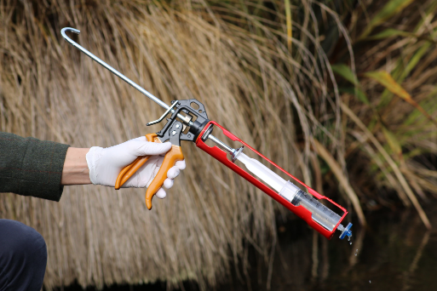

NOTE: samples do not need to be stored in the fridge or freezer, just keep in a dark place

Instructions from Wilderlab can be found here:

[\\file\herman\E\WQ\03\05\Fish monitoring\eDNA\eDNA sample collection and submission instructions.pdf](file://file/herman/E/WQ/03/05/Fish%20monitoring/eDNA/eDNA%20sample%20collection%20and%20submission%20instructions.pdf)

**Sending Samples**

NOTE: Samples do not need to be send immediately. Store in a dark dry place until sent.

1. Fill out the eDNA analysis request form at <https://www.wilderlab.co.nz/submit-samples>

NOTE: if sending multiple sites at once from different rivers etc., it is easier for the lab and to view the results if a submission form is done for each site.

AccountName: Horizons Regional Council

AccountNumber: leave blank

ContactName: Your name or Mike's

Contact Email: Yours or Mike's

Contact Phone: yours or Mike's

PurchaseOrder: 129929

Job Reference: name of stream and purpose e.g. Species confirmation Ohau River at Gladstone Reserve

JobNotes: general notes from site that are worth mentioning

Are the samples funded through the Wai tuwhera o te Taiao programme? No

Default sample selection is "Fish and insects" leave it as this unless specified elsewhere

Do you want them made public? Yes

When you select submit a pop up box will appear saying "your job number is..." Copy and paste the job number into the excel spreadsheet and safe under job notes in case you need it in future (you shouldn't need it but just in case

1. Save a copy of the sample submission excel spreadsheet here:

[\\file\herman\E\WQ\03\05\Fish monitoring\eDNA\Samples sent](file://file/herman/E/WQ/03/05/Fish%20monitoring/eDNA/Samples%20sent)

Re-name spreadsheet with date collected (YYYYMMDD) followed by site name

1. Print a copy of the sample submission spreadsheet – send this with the samples to Wilderlab
2. Courier samples to:

Wilderlab NZ Ltd

Level 2, 129 Park Road

Miramar

Wellington, 6022

Here is a link so you don’t have to type the address:

[file:///\\file\herman\E\WQ\03\05\Fish%20monitoring\eDNA\Samples%20sent\Courier%20Address%20WilderLab%20NZ%20Ltd.docx](file://file/herman/E/WQ/03/05/Fish%20monitoring/eDNA/Samples%20sent/Courier%20Address%20WilderLab%20NZ%20Ltd.docx)

**Saving results**

1. When results come through rename date collected (YYYYMMDD) followed by site name and save them into this folder:

[\\file\herman\E\WQ\03\05\Fish monitoring\eDNA\All eDNA results](file://file/herman/E/WQ/03/05/Fish%20monitoring/eDNA/All%20eDNA%20results)

1. Record in the result register:

[file:///\\file\herman\E\WQ\03\05\Fish%20monitoring\eDNA\All%20eDNA%20results\Result%20register.xlsx](file://file/herman/E/WQ/03/05/Fish%20monitoring/eDNA/All%20eDNA%20results/Result%20register.xlsx)

**Extra admin for certain eDNA Projects**

***2021 Summer eDNA project***

1. Record collection date and whether samples have been sent/results received and fish species detected from eDNA sampling results here:

[file:///\\file\herman\E\WQ\03\05\Fish%20monitoring\eDNA\2021%20summer%20project\20210311%20%20eDNA%20site%20list%20and%20species%20list.xlsx](file://file/herman/E/WQ/03/05/Fish%20monitoring/eDNA/2021%20summer%20project/20210311%20%20eDNA%20site%20list%20and%20species%20list.xlsx)

Other useful information for the summer project:

Maps of sites and  fish species distributions can be found here:

[\\file\herman\E\WQ\03\05\Fish monitoring\eDNA\2021 summer project\eDNA species distribution maps](file://file/herman/E/WQ/03/05/Fish%20monitoring/eDNA/2021%20summer%20project/eDNA%20species%20distribution%20maps)

There is also a set of shp. files by species based of the NZFFD in arcGIS in this file:

[\\gisdata\gis\Department\Research\Biodiversity\Aquatic Biodiversity\Fish files\Fresh Water Fish Database 2020\Fish distribution files NZFFD Mar2021](file://gisdata/gis/Department/Research/Biodiversity/Aquatic%20Biodiversity/Fish%20files/Fresh%20Water%20Fish%20Database%202020/Fish%20distribution%20files%20NZFFD%20Mar%202021)

**At some point very very soon all of Horizons eDNA data and all other eDNA data that is  public will be available here**<https://www.wilderlab.co.nz/explore>

# Survey123 Connect

## How to use Survey123 Connect

**What is Survey123 Connect?**

Survey123 Connect is a software that lets you design surveys for use in the Survey123 app. You can design surveys on Survey123 online, however the survey design options are limited. The periphyton and macroinvertebrate surveys that we use for our biomonitoring are Survey123 forms that have been made in Connect.

**How to download Survey123 Connect**

You can only download Connect on a PC, not a thin client as this does not support the software. To download Connect follow this link and select 'get in store app', alternatively you can open the Microsoft store and search for Survey123 Connect

<https://apps.microsoft.com/store/detail/arcgis-survey123-connect/9PMST5C0DLST?hl=en-nz&gl=nz&rtc=1>

**How to download a survey into connect**

You will need to get IM to set permissions for you to be able to download, edit or create new surveys in Connect. To edit a specific survey you will also need to ask IM to change ownership of the survey to you. Once you are in connect, sign in using your ArcGIS details.    
  
Click on '+ New Survey' in the top left corner.

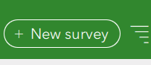

A window will pop up, If IM changed the survey ownership to you, the survey you are looking for will be under the 'My surveys' tab. Otherwise look under 'My organisation' and search for the survey name.

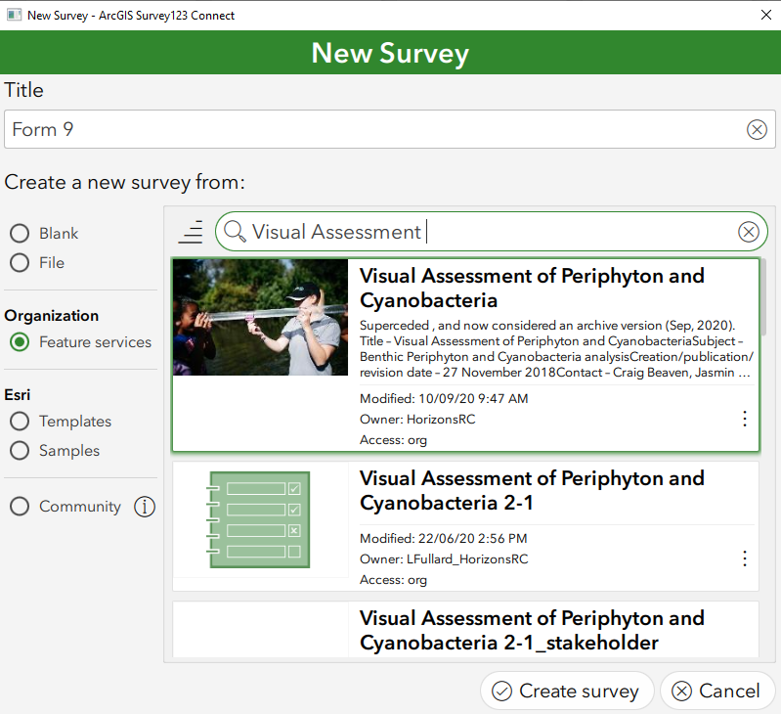

Once you have chosen the survey, you can change the excel form in the top bar under 'Title' this doesn’t really matter, but It can be useful to name it something you will remember.

Once you have the survey you want to edit click on 'Create Survey'

**How to add a name into the 'collected by' option (this is the same process for all of the forms):**

You cannot change an exisiting survey123 form unless you are the owner.

Open Connect and open the survey that you want to change

In the top left corner click on 'XLSForm' this will open an excel file.

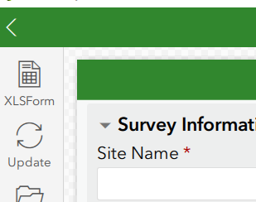

In the excel file go to the second tab called 'choices'

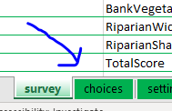

Here you can change the options for the questions that require you to choose between multiple options.  To add, remove or change who can collect surveys find the 'CollectedBy' section in the first column. To add a name, make a new row below the other 'CollectedBy' rows and add the name into the second and third column. Note that the words in the seconds column cannot have a space.

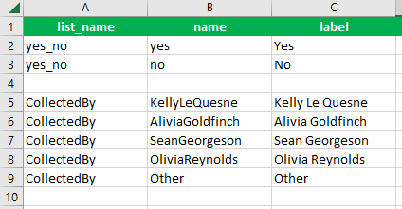

Once done, save the excel file (Don't save it anywhere else or it won't update the form on Connect)

Once you save it the form will update in Connect. It's good to double check to make sure your changes are in the form. If not try clicking on the 'update' button

Click on 'Publish' in the bar on the left, a window will pop up

Because you have only changed information in the 'choices' bar, Connect should tell you that the survey can be updated without affecting existing data.

Click on 'publish survey' and then click 'OK' under publishing complete

**Making a new survey or other edits**

Only certain edits can be made to the existing surveys, otherwise they will publish as a completely new survey and past entries could be deleted. So be careful and double check before publishing anything!

If you are making a new survey here a link to help you get started:

<https://doc.arcgis.com/en/survey123/desktop/create-surveys/xlsformessentials.htm>

Essentially there are three main columns in the excel sheet to create a new survey

These are type, name and label

'Type' defines the kind of questions you are asking, for example it could be a multichoice, a text answer question, date, time, an image etc.

'Name' is how the survey will refer to your question, in this column the name you enter should be relevant so you remember what you are asking. The name can't have any spaces, but you can use an underscore to separate words. Names must also be unique or Connect will get confused between them.

'label' is what will show on the survey, so you want the label to state your question or heading.

You can use the 'hint' column to further define the answer you are after.

If you question is multichoice you will need to put the options in the second tab.

# Annual Review

## Things to check off

|  |  |  |  |  |
| --- | --- | --- | --- | --- |
| **Section** | **Date last updated** | **Staff member** | **Date last updated** | **Staff member** |
| Introduction | 01/09/2021 | Kelly Le Quesne | 30/05/2022 | Alivia Goldfinch |
| Periphyton |  |  | 30/05/2022 | Alivia Goldfinch |
| CADDIS | 26/07/2021 | Kelly Le Quesne | 30/05/2022 | Alivia Goldfinch |
| SoE Bio-monitoring | 26/07/2021 | Kelly Le Quesne | 30/05/2022 | Alivia Goldfinch |
| Fishing | 26/07/2021 | Kelly Le Quesne | 30/05/2022 | Alivia Goldfinch |
| Didymo | 26/07/2021 | Kelly Le Quesne | 30/05/2022 | Alivia Goldfinch |
| Water Quality | 26/07/2021 | Kelly Le Quesne | 30/05/2022 | Alivia Goldfinch |
| Health and Wellbeing | 26/07/2021 | Kelly Le Quesne | 30/05/2022 | Alivia Goldfinch |
| Contact Rec | Nothing currently in 26/07/2021 | Kelly Le Quesne | 30/05/2022 | Alivia Goldfinch |
| GIS | 26/07/2021 | Kelly Le Quesne | 30/05/2022 | Alivia Goldfinch |
| Data Requests | 26/07/2021 | Kelly Le Quesne | 30/05/2022 | Alivia Goldfinch |
| Back up copy saved to Herman | 26/07/2021 | Kelly Le Quesne | 30/05/2022 | Alivia Goldfinch |

Log any checks and changes in this document:

[\\file\herman\E\WQ\03\05\Handbook\Check and Change log.xlsx](file://file/herman/E/WQ/03/05/Handbook/Check%20and%20Change%20log.xlsx)

## Backup process

How to save a OneNote as a PDF

**1.** Launch OneNote. - <https://www.onenote.com/hrd> or in the web browser.

**2.** Open the notebook you want to share by clicking the currently selected notebook and choosing the correct notebook from the drop-down menu.

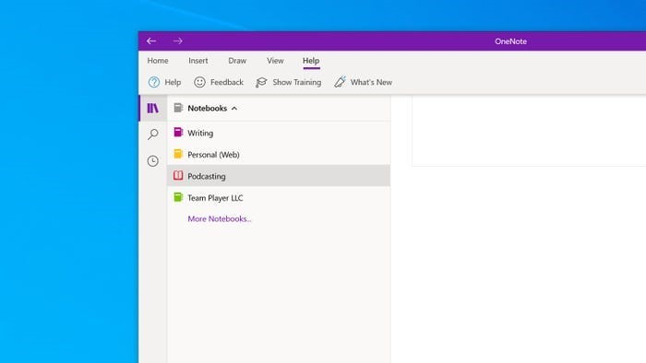

**Choose the notebook you want to share as a PDF**

**3.** If you are sharing the entire notebook, go to the next step. Otherwise, navigate to the part of the notebook you want to share. Note: depending on the version of OneNote you might not be able to save the whole notebook and have to do it by page instead.

**4.** Click the three dots at the top right of the window and choose "Print.". If doing this in the web browser (as opposed to desktop app), select file and then print.

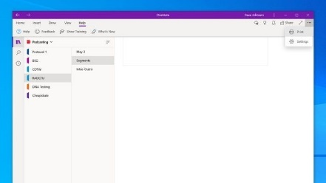

**Choose Print because we will be printing the document as a PDF file.**

**5.** In the Print window under the Printer section, click the currently selected printer and then, in the drop-down menu, select "Microsoft Print to PDF.". If using the web browser version select 'save as PDF' and ensure that it is in a landscape orientation (otherwise it will cut the pages off).

**6.** In the Pages section, click the menu and choose whether you want to turn the current page, section, or notebook into a PDF. Note: depending on the version of OneNote you might not be able to save the whole notebook and have to do it by page instead.

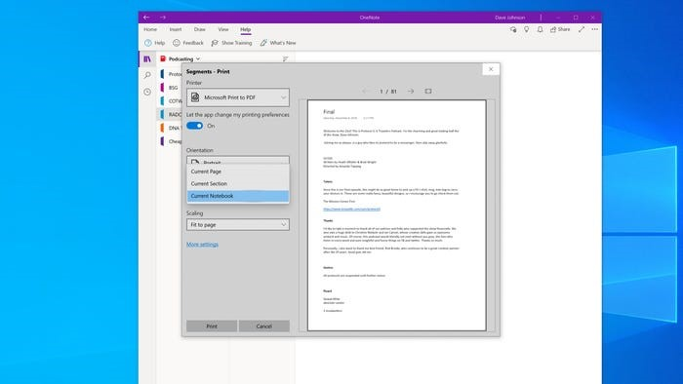

**Select the section of the notebook you want to print.**

**7.** Click "Print."

**8.** In the Save Print Output As dialog box, choose where to save your new PDF. The pdfs should be saved here with a file name of 'yyyymmdd\_section\_name of page'.

[\\file\herman\E\WQ\03\05\Handbook\Back up handbook](file://file/herman/E/WQ/03/05/Handbook/Back%20up%20handbook)